

Jamie-Lee gordon

candidate number: 14080

Centre name: All Saints catholic school london

‘Post it diary’ A-Level Programming Project

***Jamie***

CONTENTS

**Analysis2**

Problem identification2

Research & Findings2

Reasoning for computational solution ………………………………………………………………………………………2

Stakeholders ……………………………………………………………………………………………………………………………..2

Success Criteria …………………………………………………………………………………………………………………………3

Existing solutions …………………………………………………………………………………………………………………….. 4

Limitations and measurability of success ……………………………………………………………………………….9

**Design10**

Type chapter title (level 2)5

Type chapter title (level 3)6

**Analysis**

**Problem identification**

Throughout a normal day, people will have about 60,000 to 80,000 thoughts a day, these thoughts could be made up of many ideas and things you’d like to remember, however people have a tendency to forget things, but a computer wont. Microsoft have approached me to create an app using Python to create a solution to this in which will allow a user to take virtual notes to remember things. The application will have multiple functions and operations such as asking the user what they have been up to during the day, what’s their mood and also allowing verbal and written notes to be made. The app will guarantee user security and privacy as I will implement a username and password verification system in which will securely hold all data such as the usernames and passwords onto a database by using either csv files or SQL.

**Research & Findings**

Researching online on [trisent.com/so-who-writes-a-diary,](https://trisent.com/so-who-writes-a-diary/) I have found out that a survey was taken in 1996 in the United States in which Ruth Folit Of Life Journal calculated 50% of people interviewed, kept a diary and additionally Statista published data for the UK in 2014 that showed that over 21% of children and young people regularly wrote diaries in which a third of girls do so. In the Trisent article it also says that many more people have attempted to keep a diary but often for not very long and the reason for this is because these people found keeping a diary extremely time consuming and most importantly had their concerns about their privacy and being guaranteed that no one else would be able to access their notes. However, these people definitely saw the value of keeping a diary and if it weren’t for the privacy concerns many more people would own one. It is said that there could be up to a billion people globally that keeps diaries regularly and this is a clear market my ‘Post it Diary’ would enter and would succeed due to being user-friendly and efficient, but most importantly by the fact that my app can guarantee privacy and security due to having a username and password system to access the app and their notes.

**Reason for computational solution**

This idea will require a computational solution because it is an application designed to be user friendly in which a graphics user interface (GUI) is required where the program will would be a sequential process of inputs from the user and outputs from the program where users will be able to input data into a computer. Additionally, with the use of csv files or SQL code I will be able to achieve user security through the use of a database which will enable user data to be stored.

**Stakeholders:**

Many different types of people will find a use for this app from children to adults where there can be specific uses for these people:

* Students – students may have a project or presentation that’s needed to be made and throughout the day they may be having many ideas, so they may use this app to take note of any ideas or use an image to remind them of something or use the microphone to create a voice note. They may also use this app for remind themselves about any homework that is due. It can also be used for lectures for university students as they would be required to take many notes and this can be more suitable to people rather than writing notes on a piece of paper.
* Young children – many kids, particularly young, like to have a diary where they will write down what has gone on in their day, each day and this is popular with many girls, the app will allow kids to write down their diary in the form of notes by saving their notes to the current date and by keeping the graphical user interface simplified, it will make younger children find the app easier to interact with and use.
* Office workers – those who are at work, particularly people who work in an office, will need many reminders such as meetings and deadline dates and this app can be used as a reminder tool for example someone may use it to remind themselves to make a phone call to someone or to send an email to someone.
* To do lists – the app could also be used as a to-do list or shopping list where the user can use the text boxes to write down their shopping list or list of things to do.

**Success criteria/system requirements**

* R1 User verification – the app will require a username and password to access their data where I will create a database (SQL) which will contain all usernames and passwords. I will have a feature which allows the user to create a new account and will do this by whenever a new username or password is created; a new record is added to the database. The login system will allow 3 attempts. This external database is an essential part of this application.
* R2 Encryption – this solution requires a computational approach as it will allow me to program an algorithm that will encrypt all passwords and I’ll either use Caesar cipher or vernam cipher
* R3 Allows the user to also add pictures (JPEG, GIF) which can be imported from documents or the camera roll of a phone and also any videos (MP4).
* R4 Allows the user to add voice notes into the app – this is one of the main features and unique features to other ‘note’ apps where, using the access of a microphone, allows the user to input their voice to create a verbal note into the app.
* R5 A feature that allows users to categorize their notes and I’ll need to create an algorithm that separates the notes e.g. people will have different notes for: random thoughts, reminders for work, reminders for school etc.
* R6 This app will not only be a ‘remember’ app but can also be used as a virtual diary where I will use python to add the current date which saves your notes in a diary format.
* R7 The most important feature will be a graphical user interface (GUI) where the user will be able to interact with buttons and text to allow them to create these notes. The interface will need to be user friendly, so by making it simple to use it can be suitable for many students and young children but for also adults.
* R8 A ‘mood’ feature which will ask the user daily how they feel each day and an average is automated every week which the user can track their mental wellbeing during a week on a scale of 1-10.
* R9 A ‘what have you been up to’ feature which will use checkboxes for the user to tick the activities they have participated in that particular day which could be more efficient than typing it. This feature will also be used to tell the user how healthy they are being and will do this by the algorithm assigning a certain value to each of these activities which will add up to give a certain value and if the value is low, there are being towards more unhealthy and if its high they are on track on a healthy lifestyle.
* R10 The app would be able to track the exact time and date for when the user decides to enter text in diary form and would do this done by importing the time module.

**Already existing solutions**

1. Apple Notes app <https://www.icloud.com/notes>

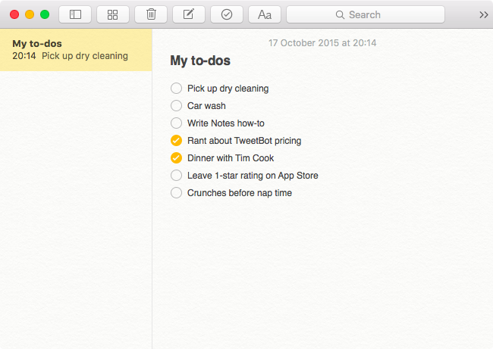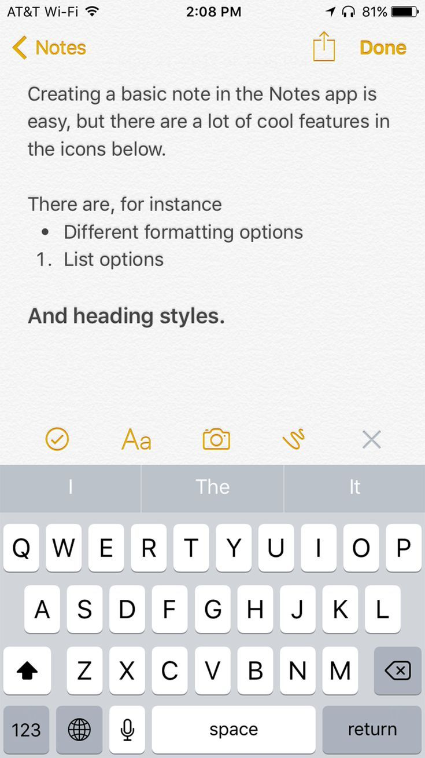

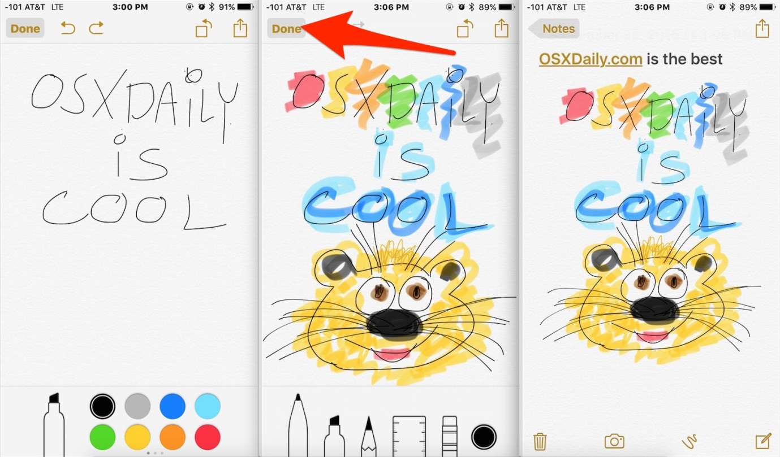

1. Penzu: Free online diary <https://penzu.com/>

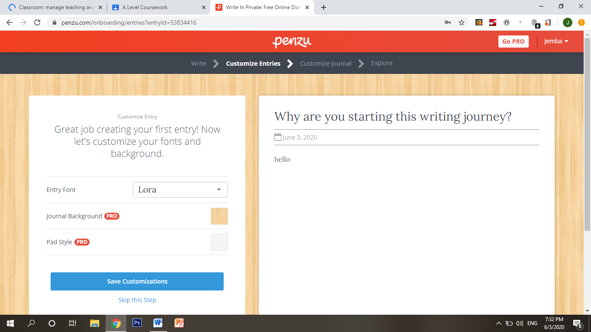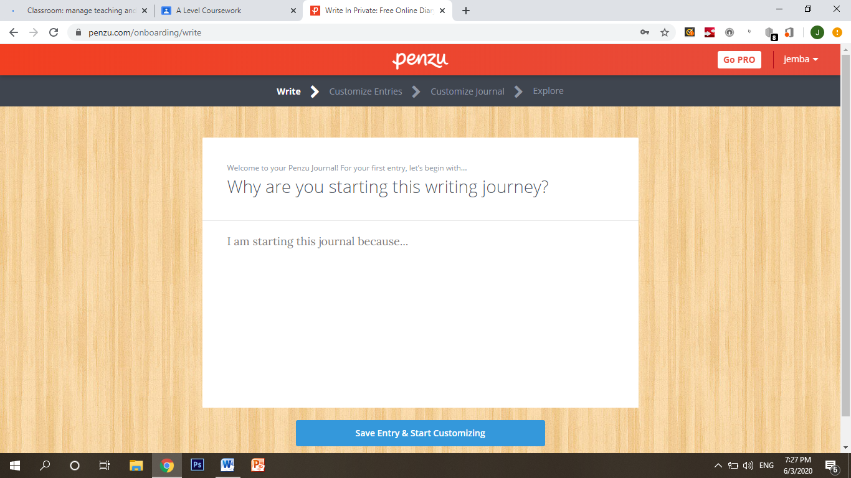

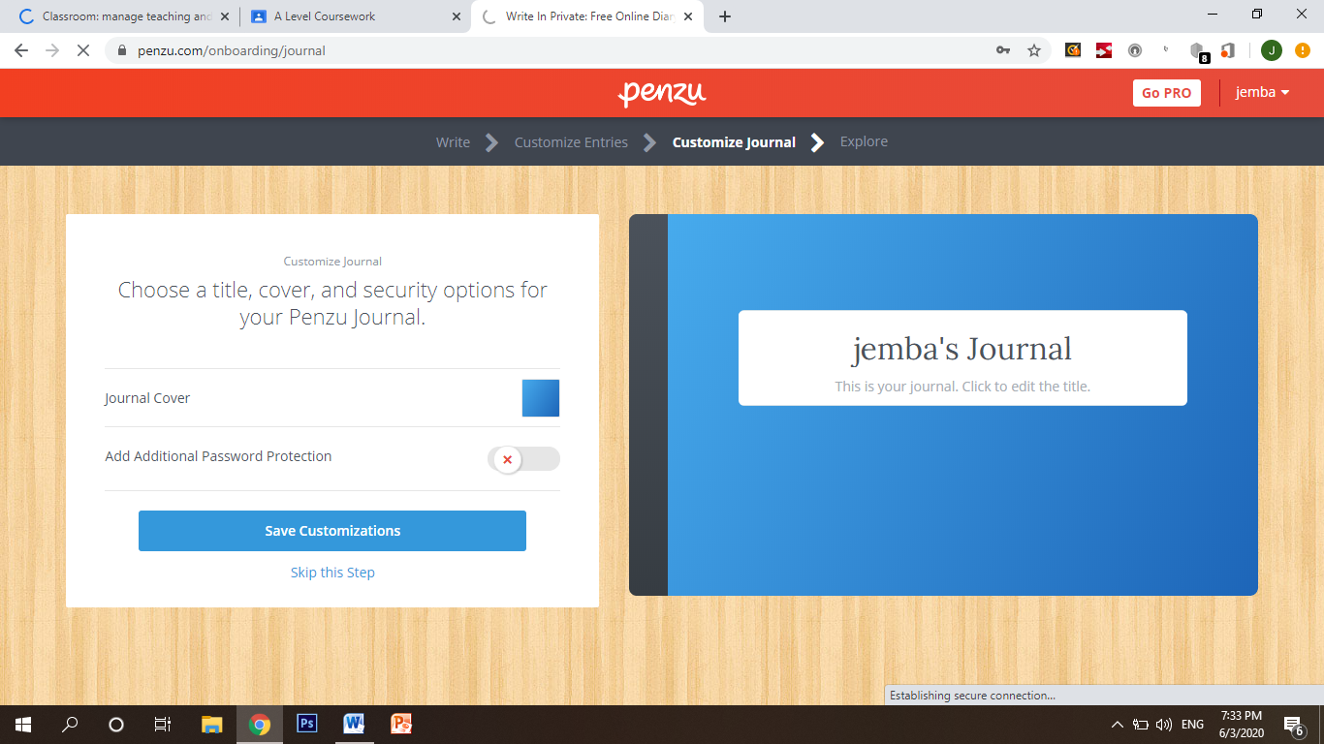

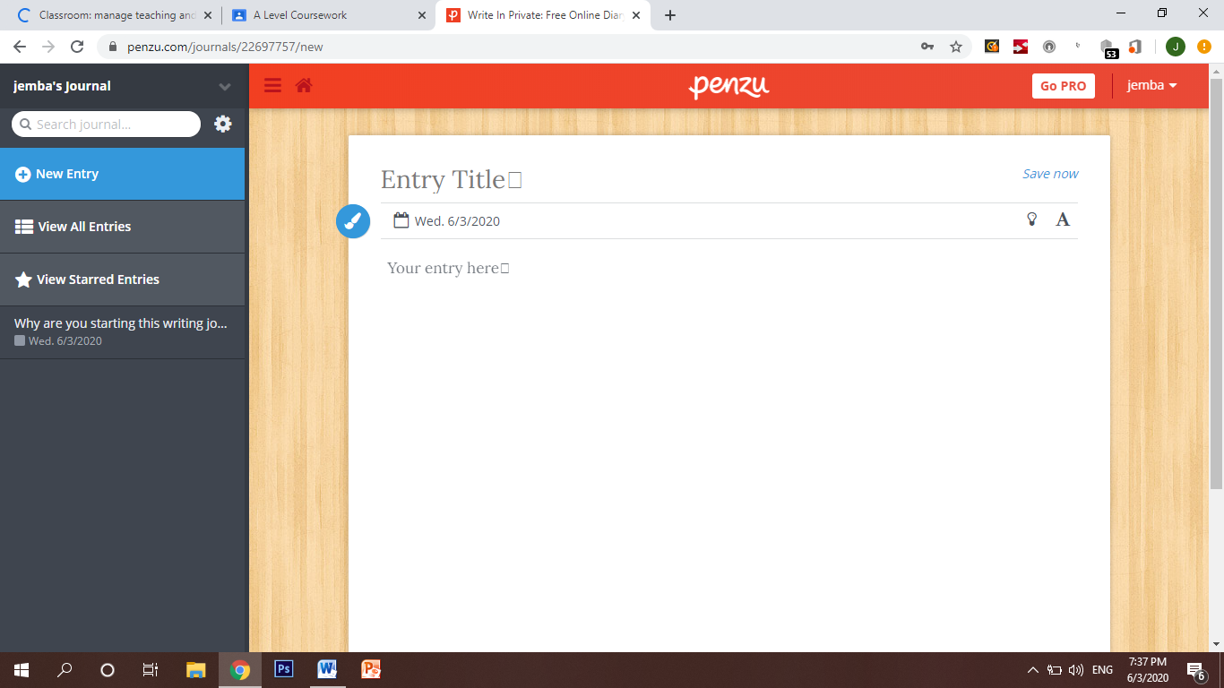

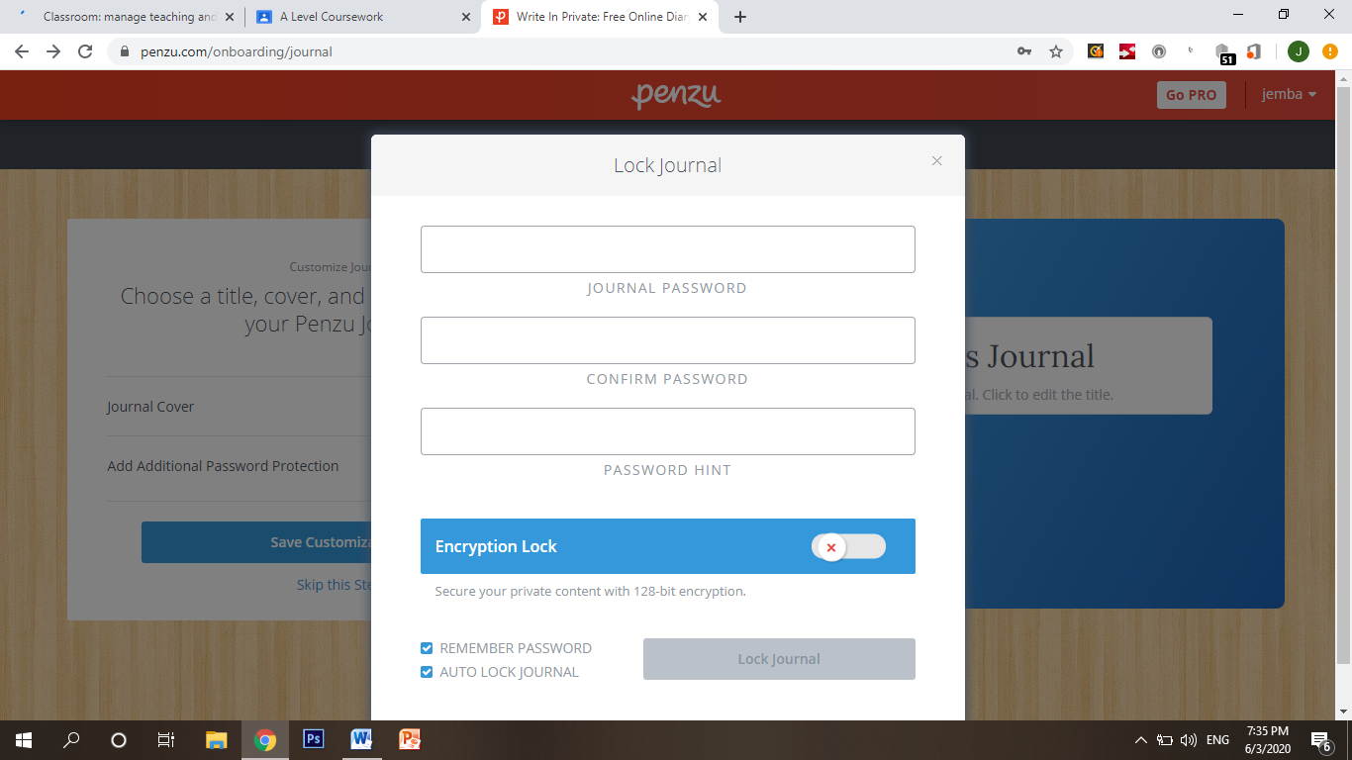

1. 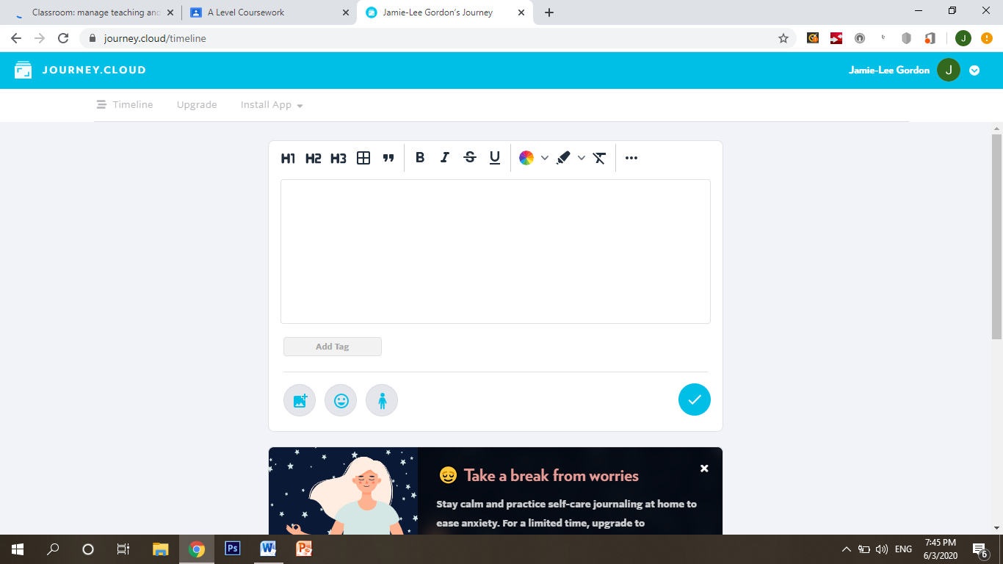Journey cloud <https://journey.cloud/>

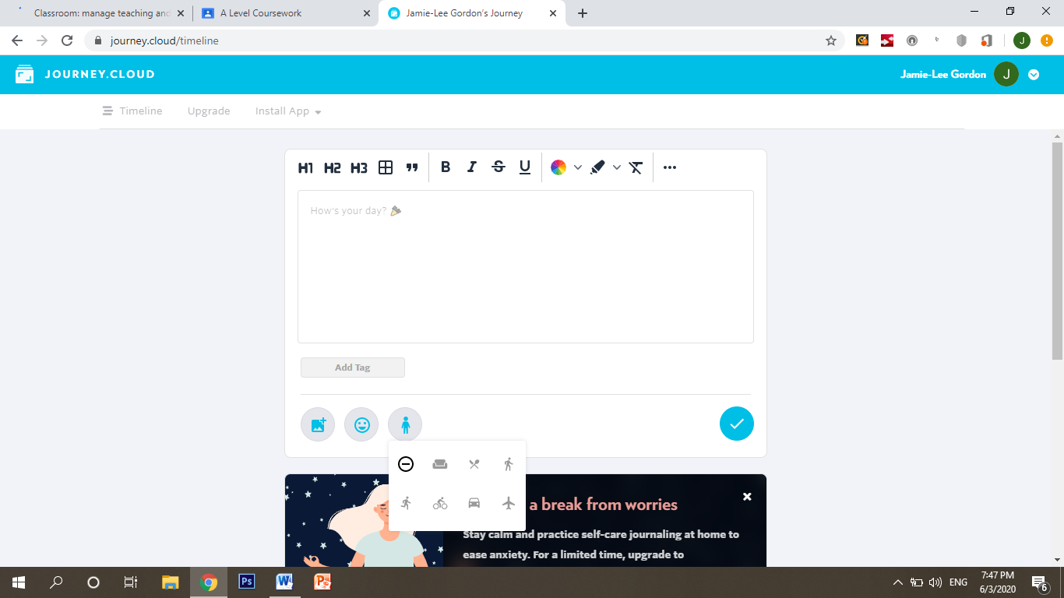

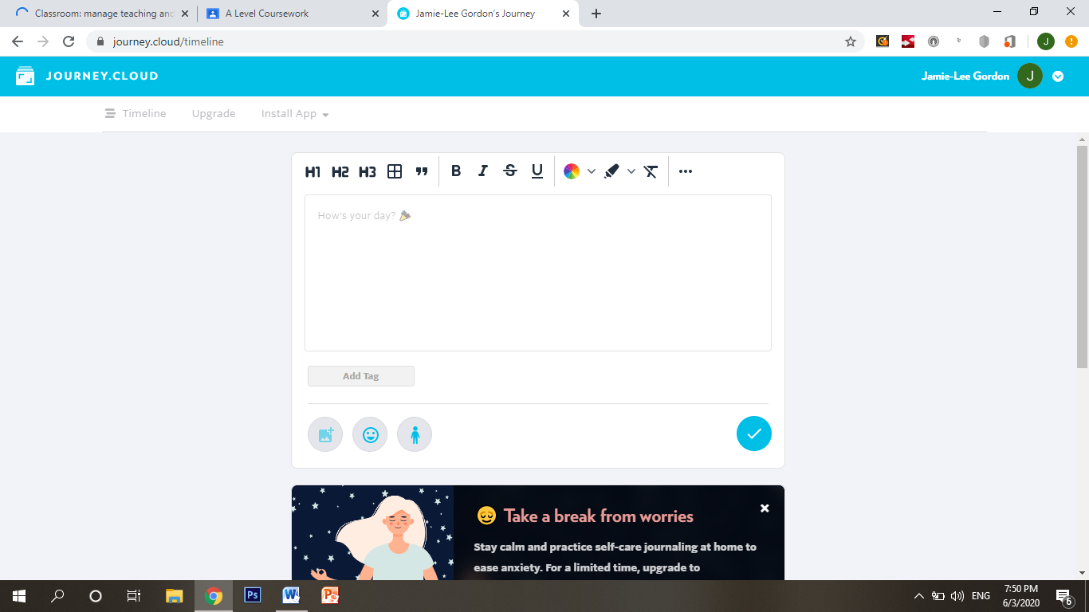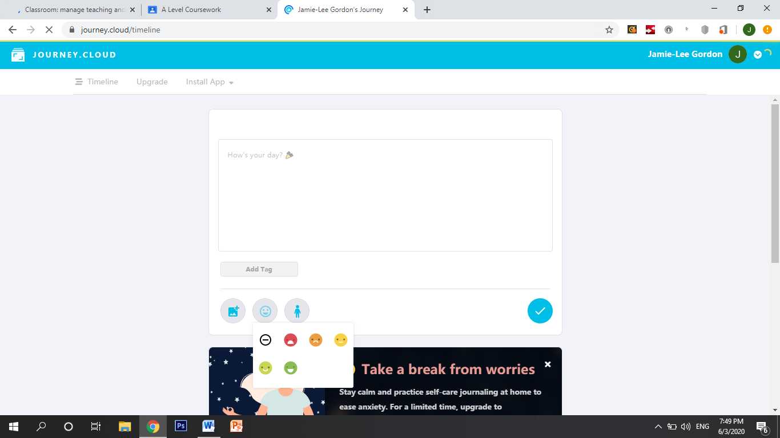

**Notes on similar existing solutions**

**Apple notes App**

The Notes app, on iOS, is built in once you own an apple product and is a basic tool used for people to use for notes, reminders, and lists. It is most commonly used for producing lists and checklists such as shopping lists full of groceries or a to-do list. It has many functions such as being able to add pictures from your camera roll and being able to draw. The applications does allow voice notes to be added, however it is more complex in which it requires an external (voice note) app to record the voice note, which can then be imported into the Notes app. The main issue with this app is privacy, due to being an app on your phone, the application won’t ask the user for a username and password and this can attract certain issues such as if someone were to borrow your phone, they would be able to access your notes, due to this, there is less incentive for apple users to be using this app as a ‘diary app’ as there are concerns over privacy and security.

|  |  |
| --- | --- |
| Advantages | Disadvantages |
| Multiple functionality | Only available on iOS |
| Allows voice notes and pictures | Security/privacy |
| Ideal for checklists |  |

**Penzu**

Out of the 3 examples, Penzu provides the best security in which it will require the user to create an account using their email to create a username and password for themselves, additionally, Penzu gives the option for an ‘encryption lock’ in which will encrypt the password with 128 bit encryption in which can’t be read by anyone. There is a massive trade-off between security and functionality where Penzu will have fewer functions to that of Apple Notes as Penzu have focused heavily on the aesthetics of the journal such as allowing the user to customize a journal background and also being able to customize a personal journal cover for the user’s diary. Penzu misses out on the ability to add pictures, voice notes and drawings etc.

|  |  |
| --- | --- |
| Advantages | Disadvantages |
| Best security (has 128 bit encryption on passwords) | Functionality |
| Good aesthetics and customizable options for the user | Can’t add pictures or voice notes |
| Available on the web for free with an internet connection | More complex GUI for younger children where they are making passwords which will be encrypted and remembered and too many options may overwhelm someone young |

**Journey Cloud**

Journey cloud has the most simplistic user interface out of the 3 so this is best suited to a younger market such as children as it is the most user-friendly and easy to follow. Journey Cloud is also very secure in which it requires the user to log in or register using their Google account. The main drawbacks of Journey Cloud is the lack of functionality as you are restricted to typing text and to adding pictures from gallery. A unique feature of Journey Cloud is that you are able to add your mood which can be represented by a choice of emoji’s/faces and this is much less time consuming to typing your mood and this is good for younger children who would like the aesthetics of the smiley faces. You are also able to add activities which the user has participated in through selecting from a bunch of given images that will correlated to certain activities.

|  |  |
| --- | --- |
| Advantages | Disadvantages |
| Simple GUI – easy for user interaction | Too simplified for an older user |
| Emoji feature | Lack of functionality |
| Mood and activity symbol feature | Can’t add voice notes |
| User customizability |  |

**Solution requirements**

There will be certain hardware and software requirements for me to have in order to produce the solution:

Hardware:

* Monitor
* Keyboard
* Mouse
* Processor – Intel Atom processor or Intel Core i3 minimum
* RAM – minimum of 2GB 64-bit or 1GB 32-bit to run windows
* Hard Drive – a required disc space of 2GB-3GB
* A microphone will be needed to be used to input sound and to create voice notes.
* A computer or laptop which can run python to allow me to create the algorithm

Software

* An operating system of Windows 7 or above.
* Python versions 2.7 or 3.6 will be used to create the app.
* Tkinter within Python will be used to create the graphical user interface (GUI) which will allow the user to interact with the app.
* SQLite or Excel will be used to create a database of usernames and passwords and to amend records if a new user is created.

**Essential features:**

* The login system using a username and password is vital to this solution including the secure database storing all security data as user privacy is the number one priority of the task.
* Being able to enter text which is assigned to the exact current date and time so that the user can take notes which is the main feature of any diary application.

**Limitations**

* I will need a microphone to create voice notes or this feature won’t work
* It is a stand-alone system and it is not web based so can’t be accessed anywhere or through the internet.

My app would still be successful and fully functional despite not meeting these bonus requirements as these limitations may limit the variety of functions the user may have at their disposal, however they would still have a functioning diary app which provides security and still able to record their activities and things to remember in other formats from typing text into entry boxes or using the checkbox and mood system.

**Measurability of success**

I will be able to know that my solution is successful if it is able to meet the basic requirements that a user would expect and prioritise which would be that the app is able to securely hold all usernames and passwords on a database and that the login and verification system is fully functional, allowing the user to login successfully and allow new users to register and create an account. For this to be successful the user must have a form of recording whether that be a fully functional checkbox system which tracks their health and wellbeing, or to being able to allow the user to enter notes in which they can edit and see.

**Decomposition**

I will definitely need to use decomposition when implementing my solution as I cannot concentrate on a whole solution at once. I will therefore break the solution down into smaller modules and features such as the login system or diary mode.

**Prototyping**

As I am adding features after features and putting my modules together, after evert feature added, I am creating a prototype and improvements will be made after every stage review to then go on to producing a final prototype and final solution

**Design**

**Structure of the solution**

The solution will be made up of two parts: the python algorithm and the database.

***The database:***

The database will hold all the usernames and passwords of existing and new users systematically with given ‘First Name’ and ‘Last Name’ which are the primary and secondary keys and indexes. By using simple and clear labels in the database, this would allow for easy searches by making it easier to identify the entity and searching for particular users in a query. The database would not just hold first and last names, but also the user’s username and passwords and additionally the encrypted version of the password. It is very important to use a database because it is the most suitable approach for holding private data such as usernames and passwords and is also suitable for allowing users to write and read data off the database such as checking a password or a new user creating a new username and password and storing this data into the database.

***Database design:***

***Entity descriptions:***

*This is a design for the database using an entity descriptive format where I will show the entity (category) and also the appropriate attributes that are included within each entity and the relationships between them.*

User (Username, First name, Last name, Date of birth, Phone number, Email address)

User-login (Username, Password)

User-verification (Password, encrypted password)

***Foreign key relationship diagram:***

*The foreign key is an attribute that creates a connection between two entity tables and this is a design for how my database will join the entities together using their foreign keys.*

***User User-login User-Verification***

***Username\****

**First name**

**Last name**

**Date of birth**

**Phone number**

**Email address**

**Encrypted password\***

***Password***

***Password\****

***Username***

***Entity relationship modelling:***

*The entity relationship diagram will visually show a way of representing the relationships between all the required entities in the database.*

One-to-one

One-to-one

**User-verification**

**User-login**

**User**

*The database would consist of only one-to-one relationships as each USER will each have* ***one*** *USER-LOGIN and for every USER-LOGIN they will have* ***one*** *USER-VERIFICATION.*

***The design of the database and structure:.***

***Database example:***

|  |  |  |  |  |  |
| --- | --- | --- | --- | --- | --- |
| Username | First name | Last name | Date of birth | Phone number | Email address |
| Bobby123 | Bobby | Thompson | 1/06/05 | 07281928371 | B123@yahoo.com |
| Jimmy008 | Jimmy | Williams | 8/01/03 | 07985376897 | J008@hotmail.com |
| happyCat5 | Tara | Scott | 27/08/11 | 07985235768 | happyC5@gmail.com |
| Sch00l555 | Isabella | Roberts | 12/04/03 | 07889765442 | Sch0555@yahoo.co.uk |

|  |  |
| --- | --- |
| Username | Password |
| Bobby123 | Ghyu910 |
| Jimmy008 | Williams567 |
| happyCat5 | Jj_89?? |
| Sch00l555 | Ilovesch00l789 |

|  |  |
| --- | --- |
| Password | Encrypted Password |
| Ghyu910 | Hjia809 |
| Williams567 | Uakkagr456 |
| Jj_89?? | Kk-78!! |
| Ilovesch00l789 | oOklrsfg11a678 |

The database will be split up into three separate tables which represent each entity (“User”, “User-login” and “User-verification”). This will make the database more organised and easier to search and query specific data and allow appropriate attributed to follow each primary key such as the “Encrypted passwords” being next to “Passwords”.

For the encrypted passwords, the main program in python will contain an algorithm which encrypts the password and then the result (the encrypted password) would be written into the database and stored under the “Encrypted password” label.

When a user is to create and register a new account, they will enter their details into the program and create a secure password, after doing this the data inserted by the user will be written into the database and accordingly store the data under the appropriate labels by creating a new record.

I have also taken into consideration my colour palette with the database and have used blue and white which are the house colours and theme for my post it diary graphic user interface and have kept the same colours with my program and my database to keep graphical consistency.

***Algorithm design***

The algorithm will be constructed using python and there is a huge focus on subroutines and modular programming by using many functions and procedures. By using subroutines and modular programming techniques, this will also keep it small enough to understand each unit of code and therefore make it easier to debug and maintain as each part of the program is defined. Another benefit of me incrementing the program using subroutines is that during the testing of my code I will be able to test subroutines independently and makes it much easier to find specific problems that need solving and is less time consuming than testing large amounts of code at once. I’ll also be able to reuse blocks of code such as having multiple buttons in my graphic user interface without repeating the block of code as this is important as I would want to keep the size of my solution as small as possible.

Modular programming will allow decomposition of the solution and for me to split up the program in achievable small modules such as:

* Tkinter: buttons, labels, text boxes, checkboxes, information boxes and more which would compose the graphical user interface for the post it diary solution.
* A module which would allow the user to register a new account and will take the input of the user and store it into the database by reading and writing into the file.
* A function used for encrypting the password.
* A function which will open a text box within the GUI that will allow the user to enter large amounts of text just like a diary or notes program.
* A function created which will read and write into the csv file and add data to the database when creating a new record.
* A function that will verify the user login by comparing the password they enter with the password in the database.
* A function that will allow the user to enter their username and password into the GUI.
* A module that will contain all the check boxes and buttons that the user will select which contain all the activities and their allocated values.
* A function which will calculate the average score from the allocated values of the activities to show the user how “healthy” they have been.

***Hierarchy chart design:***

Hierarchy charts are a great way of demonstrating the logical structure of a program and how each module relate and connect to each other to form the final solution and algorithm.

I have constructed a design for a possible approach for my solution by procedural abstraction where I have identified the components of the solution and determined the order of the steps needed to complete the solution and the diagram which will put together the modules and visually show how the program will work in the simplest way possible to make the design easy to understand and follow:

Main program

Registration()

Verification()

Confirm()

Registration()

NewRecord()

TextBox()

Activities()

Password()

NewUser()

SaveText()

AverageScore()

Encrypt()

PrintAverageScore()

WriteCSV()

Confirm()

I have used a hierarchy chart to split up the program into two flows: one where the user is to create a new account and register, and one where the user already has an account. The flow in which the user is to register a new account shows a clear flow where the user is to enter their user details in **NewUser()** and where the password is created using the **Password()** function and is encrypted. The new record data is then written into the csv using **WriteCSV()** and the **Confirm()** function will lead to the main part of the program and allow access for the user where they can use the capabilities of the post it diary solution such as the **TextBox()** and **Activities().**

***Flowchart designs:***

Flowcharts are a good way of showing the sequences, selections and iterations of an algorithm so I’m going to use a flowchart to demonstrate a design for my computational solution.

INPUT NewUsername

INPUT FirstName

INPUT LastName

INPUT DOB  
INPUT PhoneNumber

INPUT Email

Yes

New user?

No

INPUT Username

INPUT Password

No

***Login and registration module:***

I have used abstraction to decompose my solution into smaller modules that will make it easier for me to implement so I have also decomposed the flowchart into multiple smaller flowcharts that represent each module rather than one large flowchart which may be difficult to follow. This is the first module in the solution where the user will have to either log in with an existing account or register a new one. When registering a new account, the flowchart shows how the user will input all their details and will create a username where all their inputs will be written into the database. When a password is created the user will have to confirm the password by typing it again and when it’s TRUE, the password will be encrypted and stored in the database and the user will finally gain access.

PRINT Welcome to POST IT DIARY

Encrypt NewPassword

Open database

Write password into database

IF NewPassword = Password2

Open database

Create new record

Write user input into database

Yes

IF username=username AND password=password

INPUT Password2

INPUT NewPassword

No

INPUT Password

For c in plaintext

num = ord(c)

randomNumber = random number BETWEEN 1 AND 26

num = num + randomNumber

If c is in the alphabet

Yes

num = num—randomNumber

ciphertext = ciphertext+chr(num)

If num > ord(“z”)

Yes

No

Open database

Write passsord and encrypted password into the database

Ciphertext = ciphertext + c

***Encryption module:***

I have decided to use **Caesar cipher** as it is easy to implement and I have used a random number as a key, created by the computer, rather than a user-created key that the user has to make as the random number will be hard to find as the user won’t know this number and the user can’t share the key. I have included into the flowchart a scenario where if **num** is greater than z, it will wrap around by subtracting 26.

Once encrypted, both the password and the encrypted password will be written into the database.

Checkboxes for:

Sleeping

Sports

Relaxing

Eating

Shopping

Etc.

Checkbox values:

Sleeping = 6

Sports = 10

Relaxing = 3

Etc.

Average=add up values of the selected checkboxes and DIVIDE BY the amount of checkboxes selected

Print “your average score of how healthy you are today is” + average

***Activities module:***

The activities module is linear in which there are no other iterations or selections, where the user will have multiple activities to choose from in which they have taken part in during their day which they will select, each checkbox will contain a value between 1 and 10 which shows how healthy each activity is with 1 being the lowest and 10 being the highest and the solution will print them their average score out of 10 using the formula which will calculate their mean result.

Large textbox

***Textbox/diary notes module:***

The notes module is the part of the solution and program in which allows the user to add text into a textbox just like a usual diary. The text box will update the current date and time for whenever the user logs in and the program should save the user’s inserted text for so that it appears again when the user logs in again at a later date.

Save text inserted by the user

Import current time into textbox

***Key variables***

This is a table of key variables that will need to be implemented in the implementation of my solution:

|  |  |  |
| --- | --- | --- |
| Name | Data type | How it will be used |
| myUsername | string | Once the user enters their username it will be stored in this variable |
| myPassword | String | Once the user enters their password it will be stored in this variable |
| username | String | The database is read and the username from the database is stored in this variable which will then be used to compare with myUsername |
| password | string | The database is read and the password from the database is stored in this variable which will then be used to compare with myPassword |
| newUsername  newPassword  firstName  lastName  emailAddress  phoneNumber  dateOfBirth | String  String  String  String  String  Integer  Integer | These variables will be part of the registration module where these variables will hold all the information that the user enters which will then be accompanied by following code which appends this as a new record into the database |
| Key (random) | Integer | The random module will produce a random number 1-26 and store it in this variable which will be used as the key when encrypting using Caesar cipher |
| currentTime | Date | I will import the current time module and store the time inside this variable, this will later be used to put inside the entry boxes of my post it notes |
| Checkbuttons:  sportButton  friendsButton  sleepingButton  eatingButton  readingButton | Tkinter | These variables will be for the checkboxes in the activities module which the user can select multiple |
| sportsValue  friendsValue  sleepingValue  etc | Integer | These variables will each hold values 1-10 that is a score of how healthy each activity is |
| numBoxes | Integer | This will be used to increment the number of boxes selected by the user which will later be used to calculate the mean average score |
| totalValues | Integer | This will be used to increment the total value of all the boxes selected by adding them up and used later to calculate the mean average score |
| averageScore | Integer | This will be used to calculate the mean average of the activities module by using the mean formula (totalValues/numBoxes) |

***Method of testing***

*Throughout development each module and function will be tested to ensure that it works in the way it is designed to work. This will ensure that once the solution is fully complete each function works as if I were to test and review at the very end of the solution it will be much harder to go back and make changes. I will do further testing which will highlight any bugs, errors and any necessary improvements on any features.*

*When testing the modules, I must consider the user and what they will think and how they want to use the application. I need to ensure that the solution meets the success criteria and meets the requirements of the user by making sure the solution serves its purpose of a diary and post it note app.*

*I need to continuously review every stage to make sure the graphic user interface is user friendly and easy to use for children as I will need to keep the GUI simple and easy to navigate through.*

*The testing will include more detailed tests such as not just if the password is encrypted but also if it can encrypt numbers and other characters such as exclamation marks and question marks.*

*After completion I will require a feedback and review from stakeholders and users to ensure it meets their requirements and to see if any improvements need to be made after receiving recommendations and feedback.*

***Decomposition and development***

*All tests will be decomposed by breaking down the solution into smaller individual tests which need to be carried out. This means that after every process and stage, there will be tests conducted and the solution will be constantly prototyped where features are continuously being added after reviews and tests*

*The tests will help myself understand what went wrong and what went to plan as I need to evaluate if and how I have met user requirements and met the success criteria to find out if my solution was successful in meeting its purpose.*

***Graphical user interface design (GUI)***

*As I have previously stated, I will be using tkinter to implement my graphical user interface and these are designs for possible solutions:*

Diary mode

Post it notes

New user

Login

POST IT DIARY

Dear diary,

Diary mode

Post it notes

Sports

Sleeping

Friends

Reading

shopping

New user DIARY

Login DIARY

POST IT DIARY

Diary mode

Post it notes

New user

Login

POST IT DIARY

*I have designed three examples of interface designs which I may refer to, to implement my solution. With the first example, I have used less buttons and used up the space more as all the functionality is set out without having to navigate through other buttons. However, the other two designs use more buttons and require more navigation from the user as the buttons such as ‘post it notes’ and ‘diary mode’ will be used like a menu interface where only the requested function such as the user only wanting to use the diary mode will work when they press the associated button.*

*I have decided to merge these three designs in terms of using buttons which hide functionality but also using a similar format to the first GUI design as I have to take into consideration my target user, which needs to be usable for children. Children won’t particularly want to be navigating through menus and buttons as younger children may find it confusing and overwhelming. I will have particular functionality such as the post it notes and activities module displayed on the screen and other functionality such as the diary mode and registration module needing to be selected through a button.*

***Abstraction***

*These GUI design examples are of course abstraction by generalisation as I have abstracted the GUI and created a diagram which will represent the whole solution, by ignoring other details such as the code or any other boxes and smaller buttons that will be included in the solution as the designs only focuses on the main functionality and layout of the graphical user interface.*

***Pseudocode:***

Pseudocode is the best way of showing the complete and full solution with all the modules put together and for the code to be represented in English so that I can understand it well and follow it when implementing and constructing my computational solution.

START

INSERT large LABEL (“Post it diary”)

alreadyRegistered = INPUT (“Do you have an account?”)

IF alreadyRegistered == “yes” THEN verify()

*This block of code will ask and display to the user of the program if they are already registred with an account and have an existing username and password.*

FUNCTION verify():

Found = FALSE

File_r = open ( name of file.csv )

readCSV = csv.reader(file_r)

myUsername = ENTRY BOX (“Enter username”)

myPassword = ENTRY BOX (“Enter password”)

FOR row in readCSV:

username = row[0]

password = row[1]

IF username == myUsername:

Found = TRUE

IF password == myPassword:

Found = TRUE

INFO BOX (“Welcome”)

Else:

PRINT (“Incorrect username or password, please try again”)

*This verify() function will be used to open and read the csv file called usernames which is a database containing all of the existing user’s usernames and passwords. The function will ask the user to insert their username and password and the algorithm will compare the username and password inserted with the corresponding username and password in the database and if neither/or username or password match, ‘Incorrect username or password’ will be displayed to the user where they will have to retry. If the username and password match, the program will grant access to the user and display ‘Welcome’.*

IF alreadyRegistered == “no” THEN newUser():

FUNCTION newUser():

Create NEW RECORD in database

myUsername = ENTRY BOX(“Enter username:”)

WRITE myUsername into database

myFirstName = ENTRY BOX(“Enter first name:”)

WRITE myFirstName into database

myLastName = ENTRY BOX(“Enter last name:”)

WRITE myLastName into database

myDOB = ENTRY BOX (“Enter date of birth:”)

WRITE myDOB into database

myNumber = ENTRY BOX (“Enter phone number:”)

WRITE myNumber into database

myEmail = ENTRY BOX(“Enter email address:”)

WRITE myEmail into database

myPassword = ENTRY BOX (“Enter password:”)

confirmPassword = ENTRY BOX (“Re-enter password:”)

IF myPassword == confirmPassword THEN

WRITE myPassword into database

Encryption()

This newUser() function will allow the user to register an account through inserting details into the GUI. When creating a password, the program will ask the user to re-enter the password as confirmation, like many other existing login solutions do so. The program will finally open the database and append it accordingly by inserting all the data inserted by the user and putting it under the corresponding keys in the database.

FUNCTION encryption():

Plaintext = myPassword

Plaintext = plaintext.lower()

Ciphertext = “”

FOR c IN plaintext:

IF c in "abcdefghijklmnopqrstuvwxyz":

Num = ord(c)

randomNumber = IMPORT random number BETWEEN 1 AND 26

num = num + randomNumber

IF num > ord (“z”):

Num = num – randomNumber

Ciphertext = ciphertext + chr(num)

EncryptedPassword = ciphertext

Else:  
 ciphertext = ciphertext + c

EncryptedPassword = ciphertext

Encryption() is the encryption function in which uses Caesar cipher to encrypt user passwords. The pseudocode above implements the cipher into the code so that any new password created will be encrypted. I have decided to use a random number as a key instead of allowing the user to create one for themselves as this creates more security as users cant be socially engineered or manipulated into giving away their key to unauthorized users or hackers.

LABEL (“What have you been up to today?”)

Sleeping = CHECK BUTTON (value = 5)

IF sleeping == TRUE THEN

numberOfBoxesSelected = numberOfBoxesSelected + 1

sumOfValues = sumOfValues + value

playingSports = CHECK BUTTON (value = 10)

IF playingSports == TRUE THEN

numberOfBoxesSelected = numberOfBoxesSelected + 1

sumOfValues = sumOfValues + value

relaxing = CHECK BUTTON (value = 3)

IF relaxing == TRUE THEN

numberOfBoxesSelected = numberOfBoxesSelected + 1

sumOfValues = sumOfValues + value

friends = CHECK BUTTON (value = 6)

IF friends == TRUE THEN

numberOfBoxesSelected = numberOfBoxesSelected + 1

sumOfValues = sumOfValues + value

Studying = CHECK BOX (value = 8)

meanAVG = sumOfValues/ numberOfBoxesSelected

PRINT (“Your health score is”, meanAVG)

This module above will be used to implement the activities module which I have designed to mean calculate an average score for how healthy the user’s lifestyle has been during the week by analysing the activities they have taken part in. This module will have a check button system which is why it requires a computational solution where the user will select what activities they have been up to by selecting a variety of check boxes. These checkboxes will each contain a value score up to 10 which represents how healthy each activity is with 10 being the highest and 1 the lowest, the algorithm will then calculate a mean average by adding up the sum of the values through the incrementation of a sum variable and divide the given value by the amount of boxes the user has selected. The calculated average is then displayed to the user including a table which explains what each value shows.

FUNCTION notesSection():

ENTRY BOX

IMPORT current date into entry box

BUTTON (“Press for diary”, TEXT EDITOR)

This notesSection() function is used to create entry boxes in which would be used in the way of post it notes which will allow the user to add small notes. Additionally, these post it notes will include the current date and time as I have imported it and placed it into the entry boxes as if it’s a diary.

There will then be a button which when pressed will display a text editor which will allow large amounts of text to be inserted by the user and this is the main diary function of the solution whereas the entry boxes will only be small post it notes as tkinter in python has a size limit for the entry boxes and have to remain small, so this is perfect for entering quick and small notes from the user of the program.

*This is my pseudocode where I have designed and demonstrated how my computational solution would be implemented by putting all the modules together such as encryption and I have used GUI terminology for tkinter such as the checkboxes and entryboxes to demonstrate how I will use the GUI of tkinter to display to the user the solution. In the actual implementing of the python programming I will be using geometry by using the grid system rather than just packing buttons on the screen as it will make the GUI more organised.*

***Functionality***

|  |  |
| --- | --- |
| ***Functionality*** | ***Explanation*** |
| ***Database*** | *The database will of course include all user data and information including usernames and passwords. The database will also be used for querying and to compare values for the login system such as (If username == UserName) and (if password == PassWord) then the user will be granted access to the application.* |
| ***Login*** | *Each intended user will have an account registered on the database in which the login system will entail entry boxes in which the user will enter their username and password like a traditional login system and the values within these entry boxes will be used to compare with the associated username and password in the database to grant or deny access to the application.* |
| ***Remember me*** | *The ‘remember me’ function will be used in the form of a tick box in which the user will tick in order to stay logged in for when they run the application again.* |
| ***Registration*** | *If the user doesn’t exist, they may wish to register a new account. A dropdown menu of entry boxes will appear in which the user will enter their details and create a password. The password will be encrypted and all of the data entered by the user will be appended into the database so that when they try to login, the values will be there to compare with to login and grant access.* |
| ***Activities*** | *This module will be a dropdown of multiple checkboxes which will be activities such as ‘sport’ or ‘shopping’. These checkboxes will each hold values 1-10 depending on how ‘healthy’ each activity is. The user will select every activity that applied to them during their day of login.* |
| ***Score*** | *A mean average will be accumulated using the scores within the checkboxes on the activities module. It will increment the number of boxes selected and the total score of the buttons selected and use the formula TotalScore/numBoxes to calculate the score. The score is then displayed to the user.* |
| ***Score analysis*** | *This is an analysis of the score as the user will most likely not know what the score means. An information box will display telling the user what their score means e.g. ‘4-6 – room for improvement’ or ‘8-10 – you’re doing well! Keep it up’*  ***Weekly average***  *During a week, the user will supposedly login 7 times, each daily score will be saved and across the 7 days, a new average is accumulated to represent a ‘health score’ for the week.* |
| ***Post it notes*** | *The post it notes module will be where the user will input small notes and reminders just like a traditional physical post it or sticky notes. This will be in the form of an entry box and can be used for example ‘Remember to buy some milk on the way home’* |
| ***Current time*** | *The entry boxes of the post it notes will include the current time as diaries and reminders are well accompanied by the date it was written for referencing. I will do this by importing the current time module on python.* |
| ***Diary mode*** | *This is the diary mode in which the user will be able to enter large amounts of text such as ‘Dear diary …’ where this module is best suited to a traditional diary form. This will be implemented using a text editor in which, where large amounts of text are entered, the user is able to use a scrollbar.* |
| ***Voice notes*** | *This module will allow the recording of a voice through a microphone to be inserted into the app.* |
| ***Insert Picture or video*** | *A JPEG or MP4 file can be added to the application, either displaying the picture or video.* |
| ***Save*** | *Notes and diary will be saved by pressing a ‘save’ button so it is saved for when the user again logs in. This will be done by writing the notes into a csv file and then retrieving it back for when the user logs in at a later date.* |

**Developing the coded solution**

To produce the best outcome for my coded solution of the ‘post it diary’ I first must choose a methodology which works best such as either a waterfall, spiral or agile model of software development. I have decided to use **agile modelling** where there is an iterative process of development involved as I don’t believe my program will be developed in a linear sequence as I have many different modules in which need to be prototypes and reviewed many of times and to make sure they all function together. When developing the solution, I will act as if I’m the user or customer where I will use the program and see where the improvements need to be made and I will give rapid feedback for myself which I will use to make another prototype using the feedback now that I understand my user requirements.

**Database implementation**

*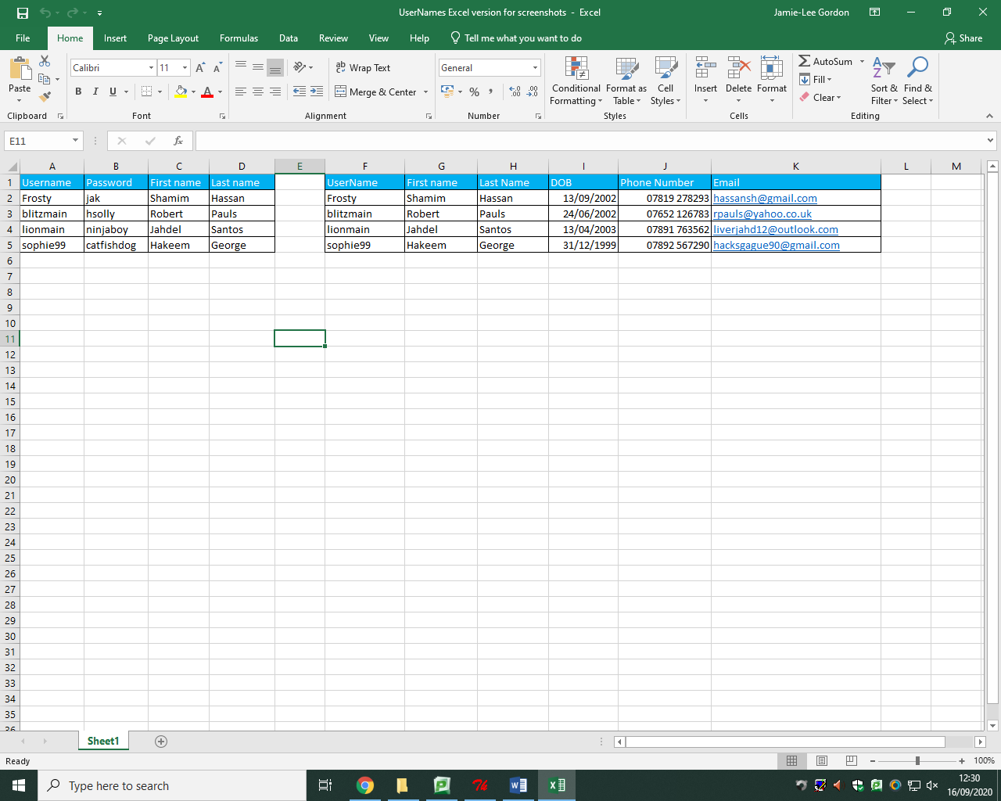The first thing I did was to of course design and create the database in which I will use for the user login module in which I will compare the usernames and passwords to grant access for the user. The username will act as the primary key for this entity with first name and last name being attributes of the record*.



*I have then created another table which contains information and data of each user that has registered with the program as it will include further details of the user (Date of birth, phone number and email address). These further bits of data will be extremely useful in any query I need to make, for example if I want to find the username of a user and I only have limited data of my knowledge such as their phone number, I can search for their phone number and their whole record will be available and I can cross map their username.*

*I have then customized the database to make it easier on the eye and easy to interact with as I have included borders on the tables and used a house colour scheme of blue for the name of the attributes in each entity of the table.*

*Now that whenever a new user gets registered to ‘post it diary’, the database will be amending inserted database from the main program and create a new record.*

*Stage review – database*

***Implementation***

*I first needed to create a database on Excel by using the designs I have previously made which will hold all information about existing users. The database will hold the usernames and passwords of each user in records and tables which will be used to compare with the username and password which the user will insert in the solution to allow access. The database is in a csv format where it makes it easy to use file handling techniques such as reading individual records or cells.*

*I have implemented two tables – one for usernames and passwords and one for further information such as user phone number and date of birth etc.*

***How I have met user requirements***

*With my main criteria being security, the database is vital in the solution as I will use for holding user data and for my login and registration system.*

***Criteria met***

* *Database*
* *User records*
* *Two tables*

***Prototype***

*Now that I have implemented the database I will now be able to start producing the main program and prototyping.*

***Keys, referential integrity and normalisation***

*The user username is the primary key, this will act as a unique identifier for the user record as each user has a unique username for their account. The user first name will act as the secondary key as if someone forgets their username, which tends to happen, it will be possible to query using their actual name. The username will also act as a foreign key between the two tables which will link these entities together.*

*I want to implement referential integrity in my database in which for example a user is deleted from the database, their records and the associated attributes will be deleted along with it across all tables and entities.*

*I have ensured normalisation where:*

* *No data is unnecessarily duplicated*
* *Data is consistent throughout the database*
* *Queries are able to be conducted*

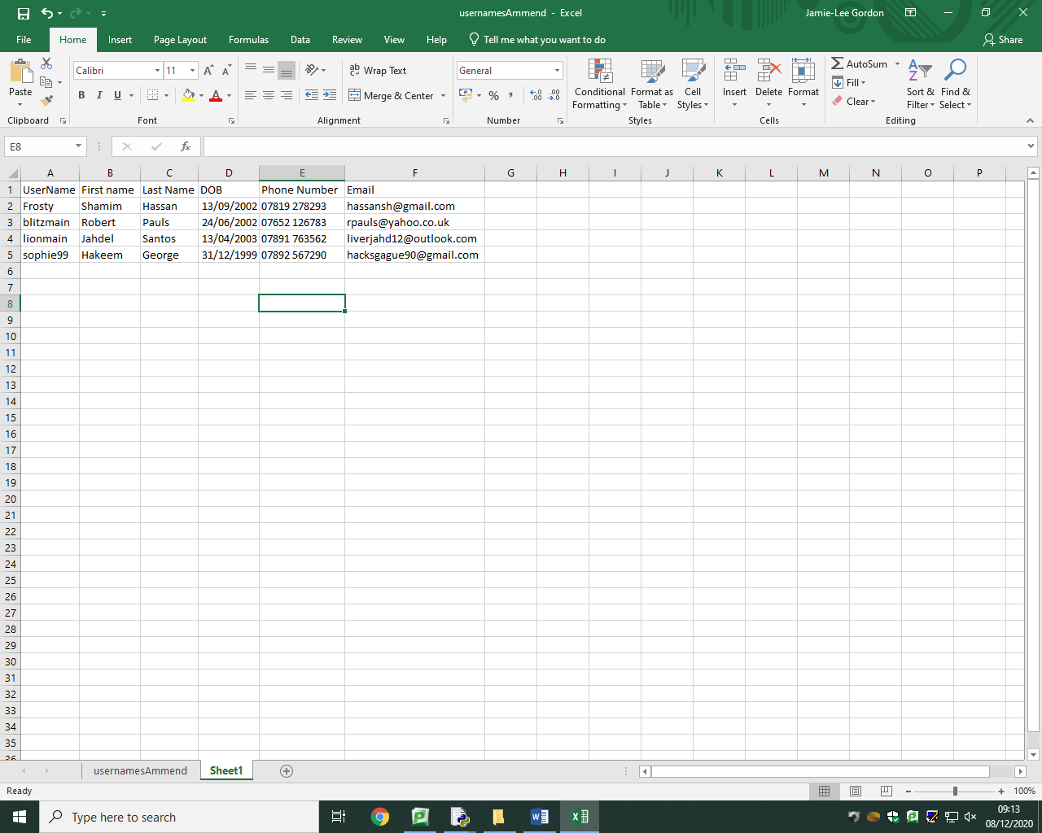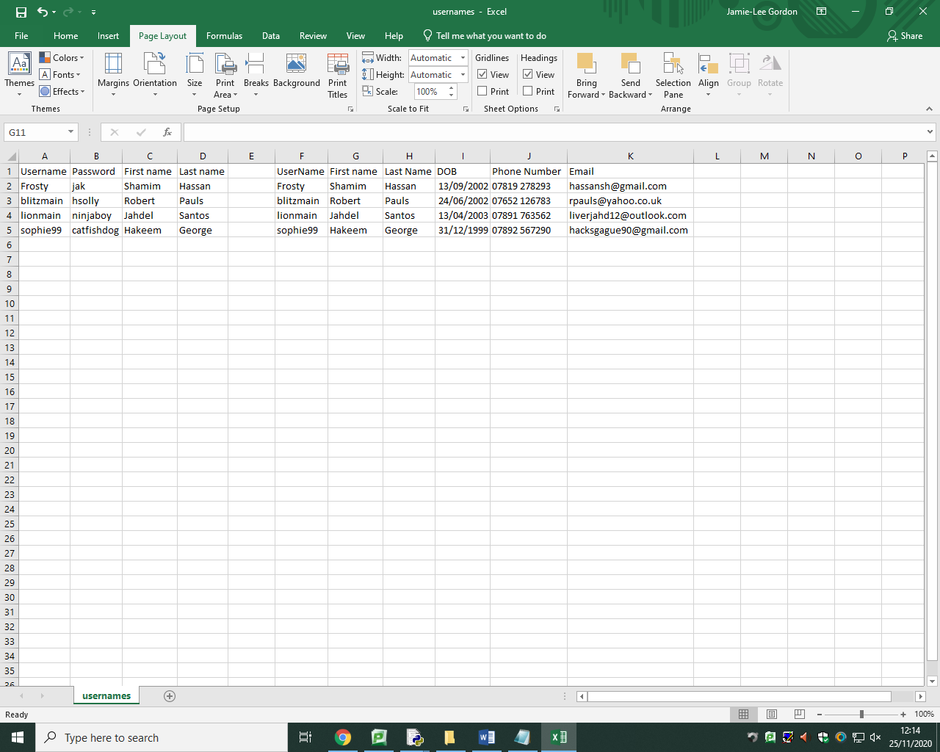

***Normalisation***

***First normal form –*** *I have ensured that the data is in first normal form by first making sure that data is atomic and can’t be broken down any further for example the users name is broken down into first name and last name. Data is also not repeated in the entities. The entities also have a primary key which uniquely identifies each record (user).*

***Second normal form –*** *I can test that the database is in second normal form by first making sure it is in first normal form, which it is. There isn’t a composite key as the username is the only attribute acting as the primary key and there are no partial dependencies involved as for example the phone number isn’t dependant on the date of birth of the user.*

***Third normal form –*** *the database is in first normal form and second normal form. There needs to be no non-key dependencies in the database to be in third normal form; the database is therefore in third normal form as I have no composite key and attributes aren’t being dependant on each other.*

*By normalising the database, I have ensured there’s no data redundancies. I have ensured there are no unnecessary duplications of data and allowed faster sorting and searching as the data is organised and no data is redundant or inconsistent.*

**Main program development**

*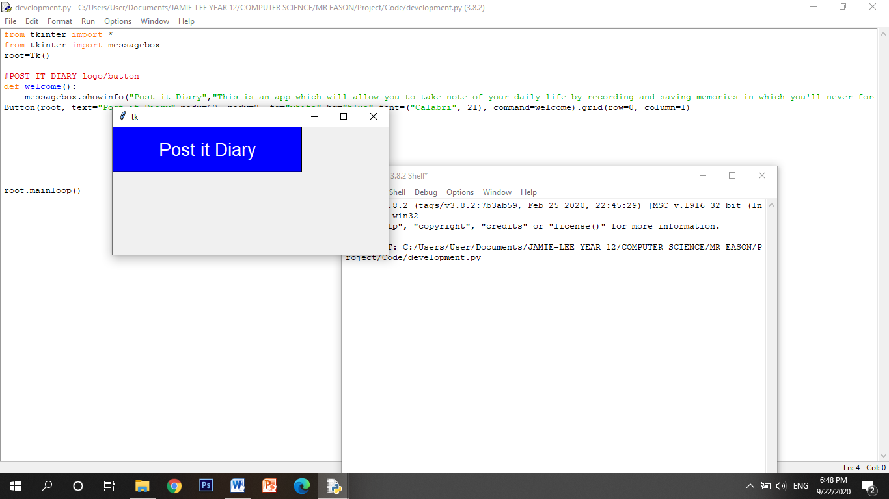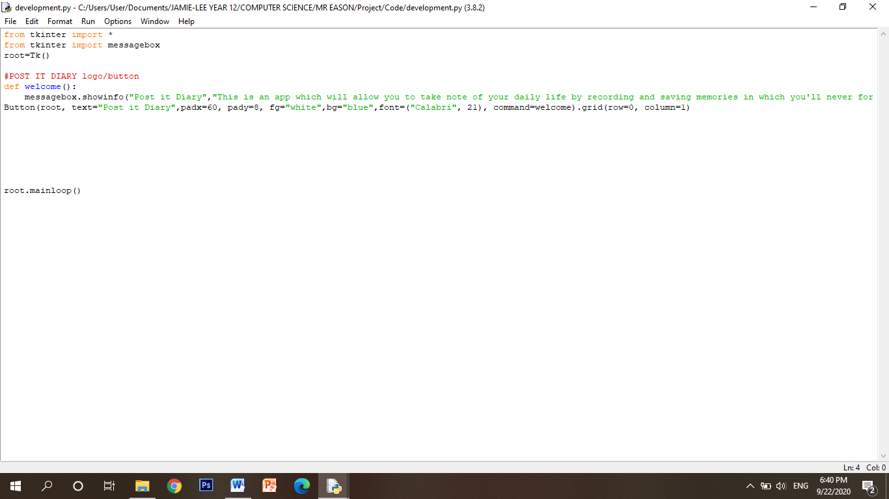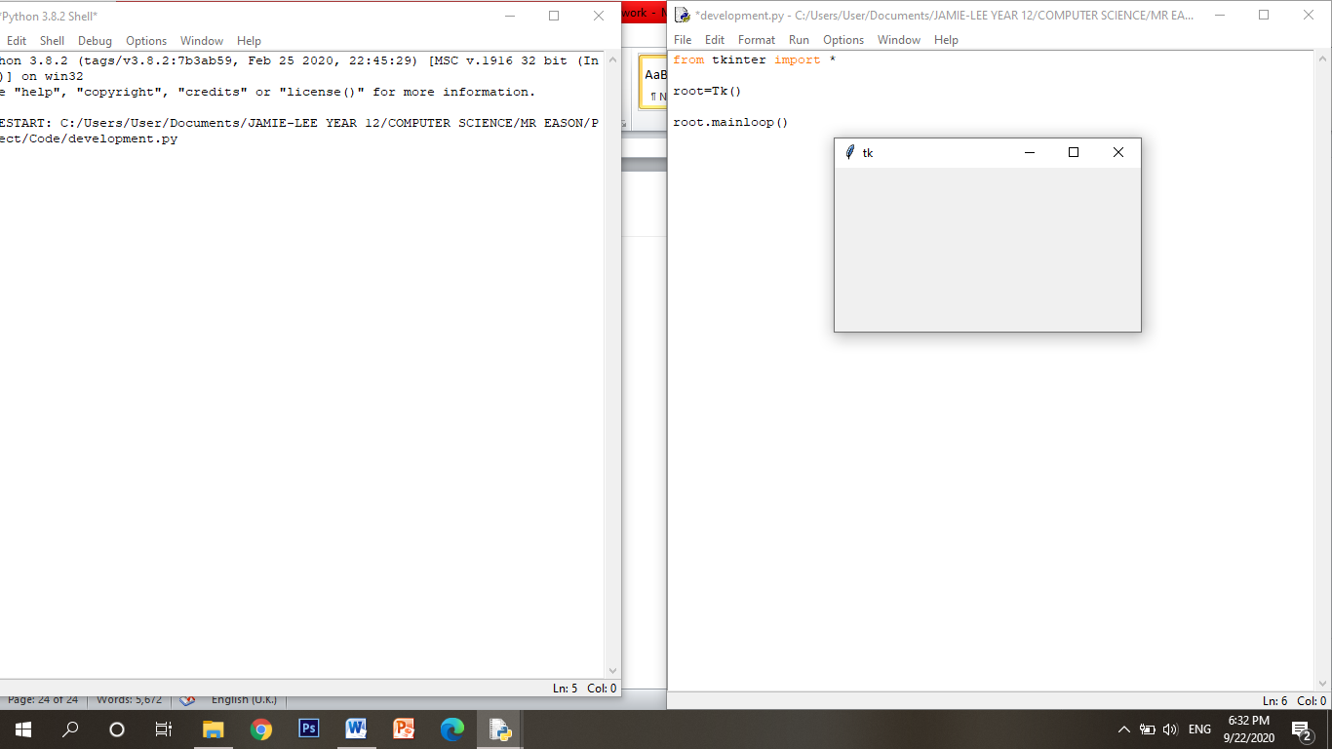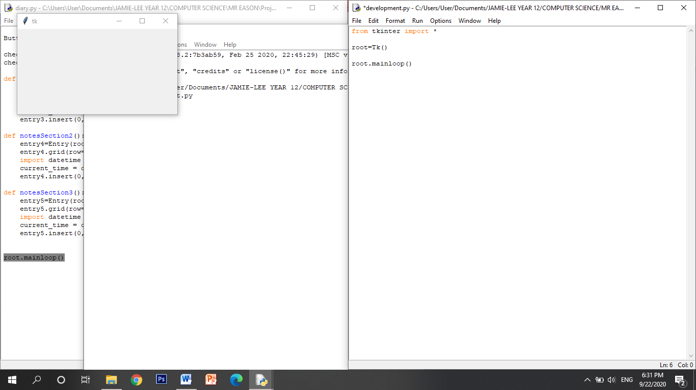The first thing to implement is of course to import the tkinter module which I will use to develop my GUI. The code on the left is the required and basic start up to open a blank tkinter GUI window as shown on the left which I am also able to expand like any other window.*

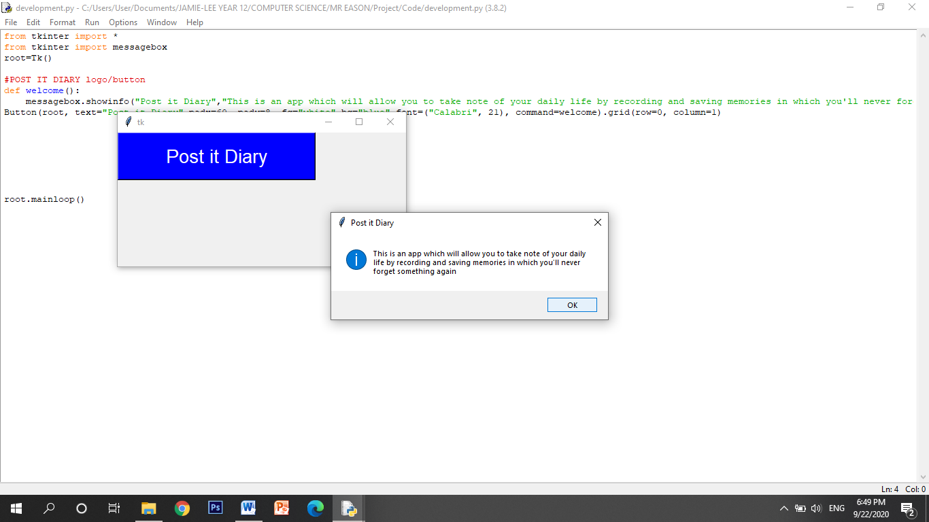

*This block of code will be used to create the aesthetic of the GUI by making it more appealing as I have played around with the button such as with the size, colour and font. It is important to note that throughout my development of the code I will be using the grid geometry system which is used in tkinter similar to coordinates where rows and columns will be used to position buttons and labels etc on the GUI interface, making the GUI much more user-friendly and organised where users will find it easy to navigate. I then created a function which will be used to create a command for when the button is pressed, the command I have created is implemented through the function welcome() and I have used a message box in the showinfo format which displays to the user information regarding what the post it diary application does and the purpose of it.*

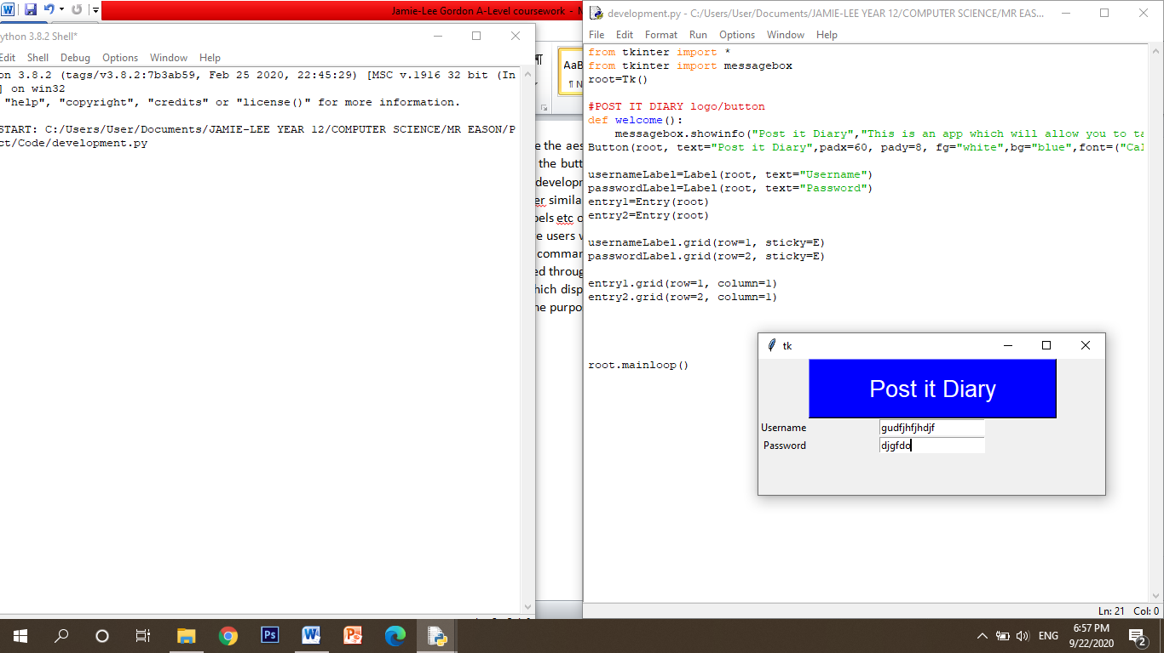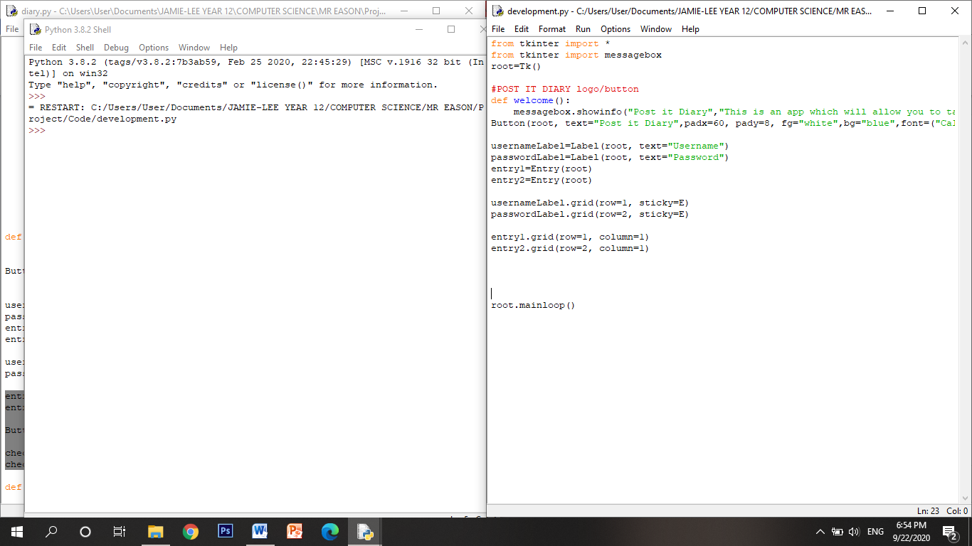

*The verification module is of course the most significant part of my solution in which I will need to ask the user to enter their username and password. The code above will create two labels: “Username” and “Password” and again I have used the grid system to position the labels. I then used entry boxes next to the labels which allows the user to enter text, in this case their username and password. The screenshot on the right shows how the user can use this 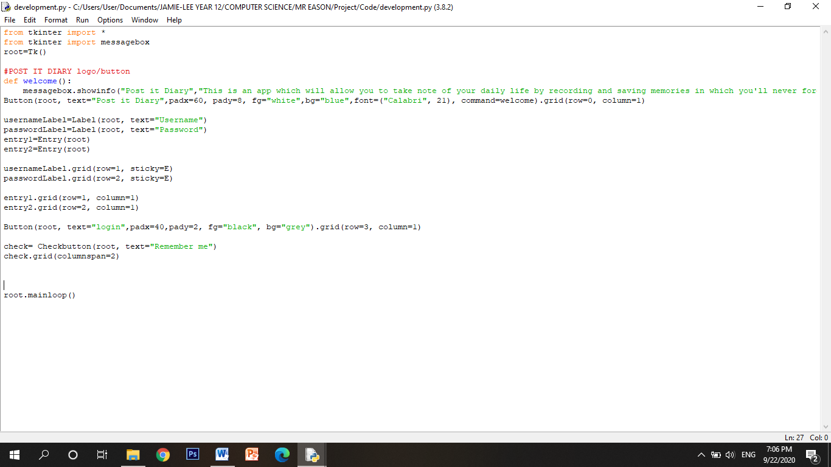to enter their username and password.*

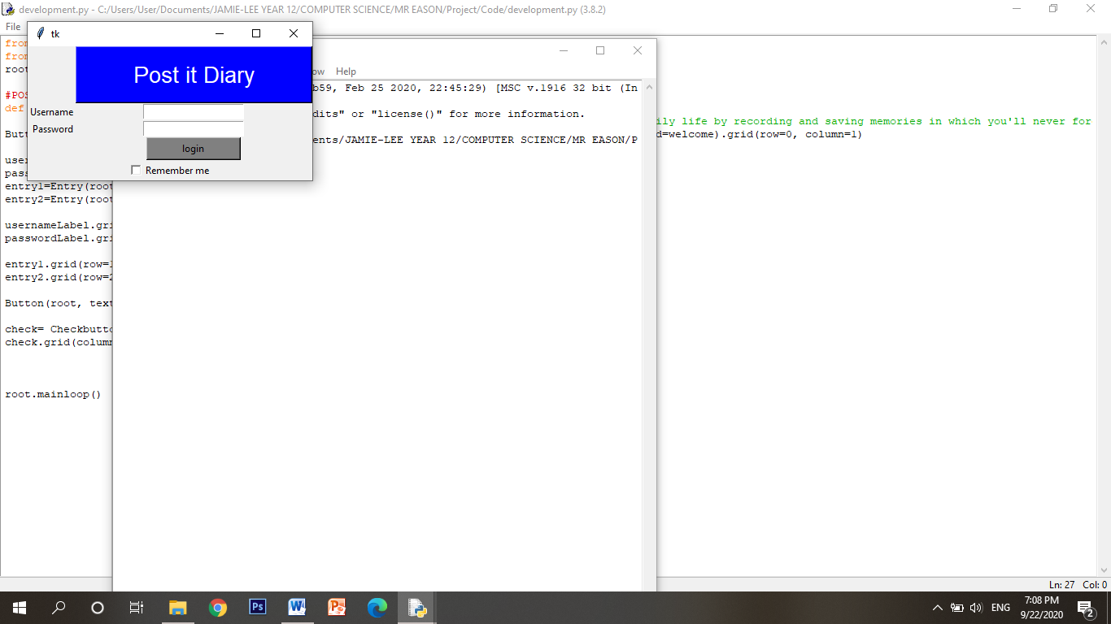

*This block of code will be used to create the ‘login’ button and also the ‘remember me’ checkbox where now that when the user has finished entering their username and password into the entry boxes, they can select ‘remember me’ and also then press login to verify their login to grant access to the program and all its functions.*

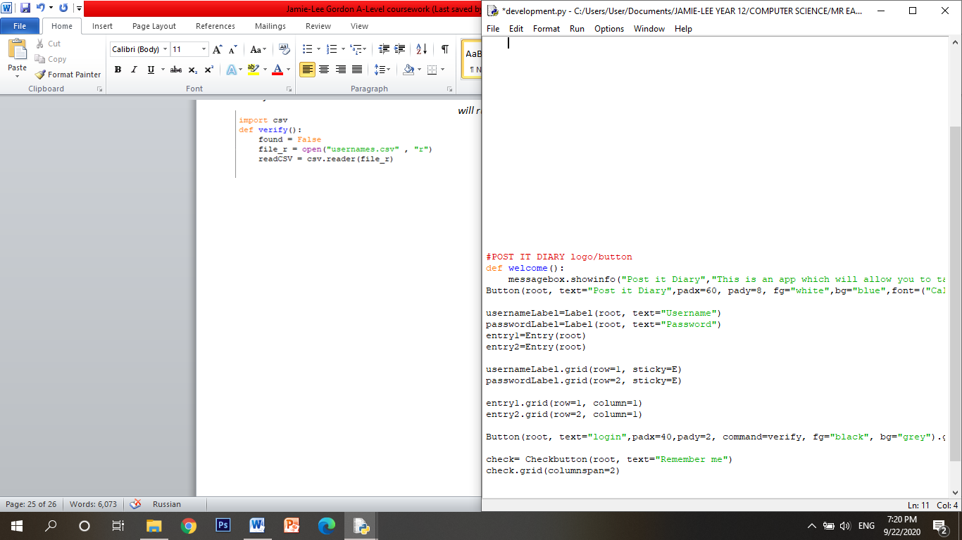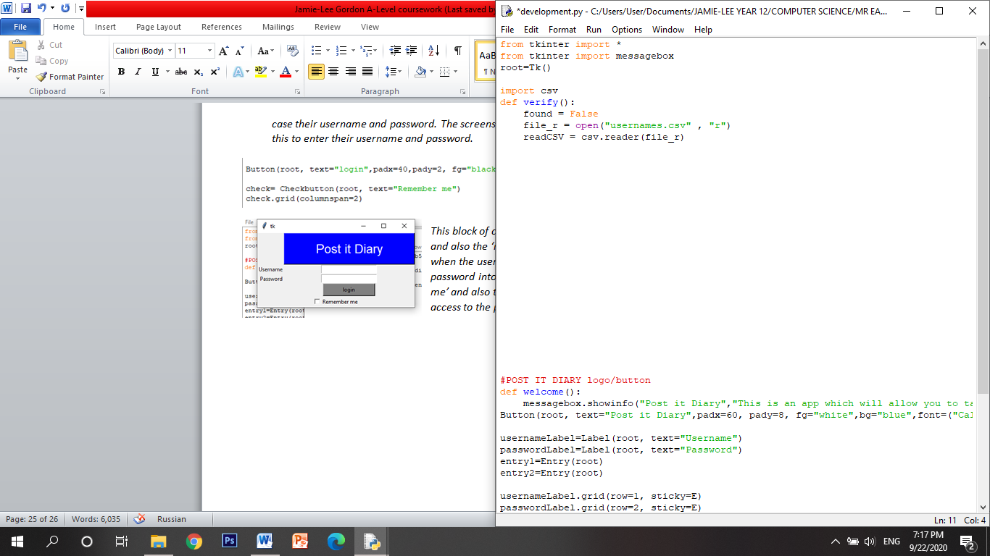*I have imported csv. The first thing I had to do is adjust the login button by adding the function command which means that when the user presses the login button, the program will run the verify function. This is the code that will allow file handling of the database and main program as it will open the database csv file and read it. The found Boolean is used to show if the username and password is the same as the username and password in the database where it needs to start as false as we can’t assume the username or password has already been found.*

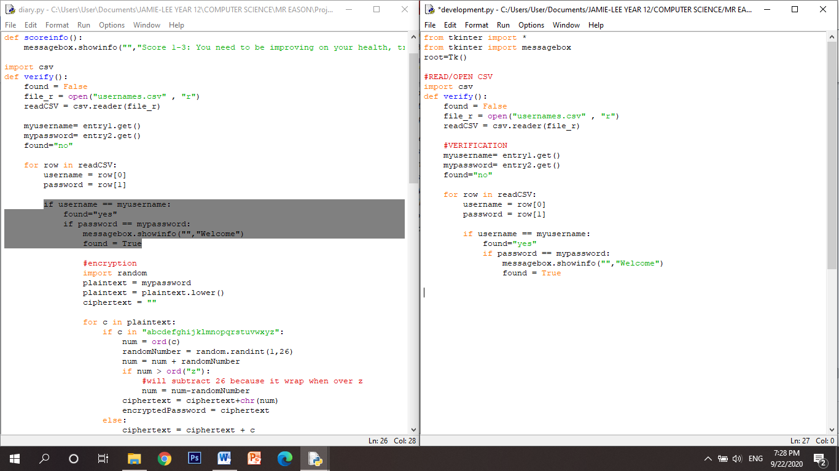*The myusername and mypassword variables will be used to compare the username and password of what the user has entered in the entry boxes with the appropriate username and password in the database. To get the text that the user has entered I must use the getter function by using ‘.get’ and it will take what the user has entered and then put the text into the variable.*

*The for loop is used to iterate through the database rows with the row[0] and row[1] showing what data is needed to be compared as the 0 and 1 index holds the usernames and passwords in the database.*

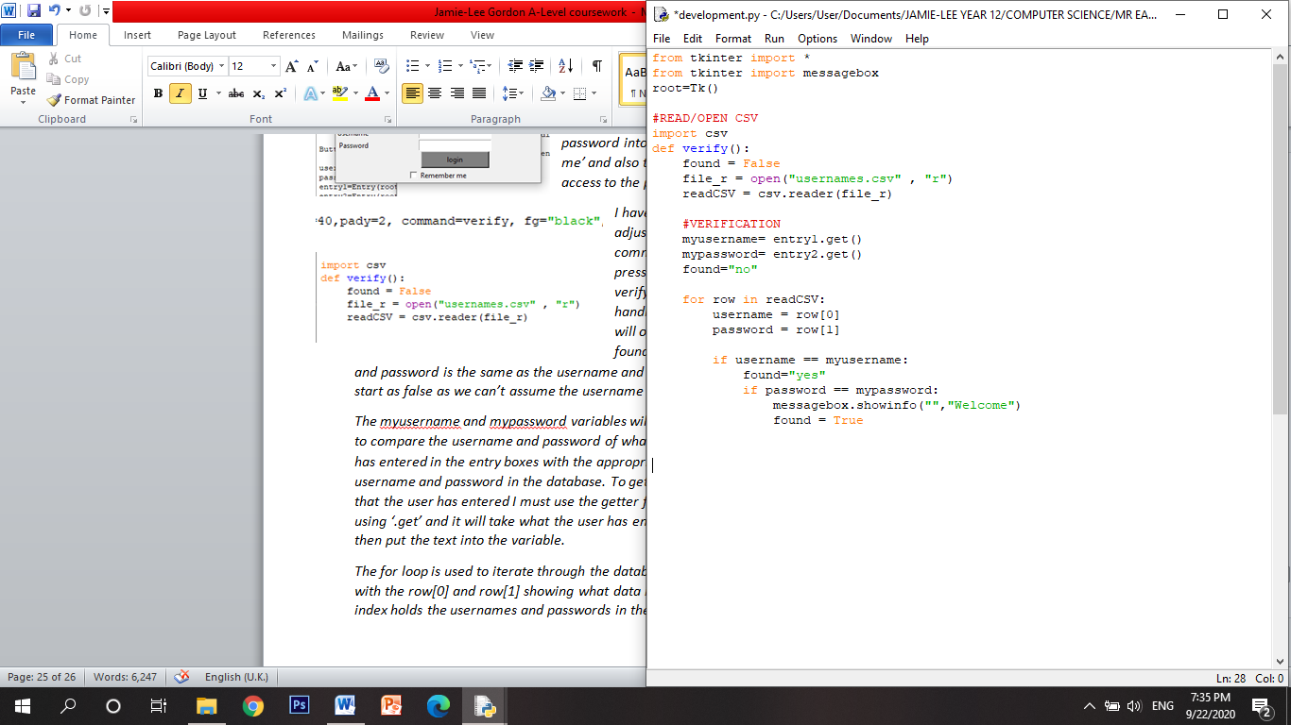*I have used nested if statements and found Booleans to find and compare the usernames and passwords entered with the username and password in the database and when found, the found Boolean will be ‘true’ and a message box will show welcome to show the user that they have entered the correct username and password.*

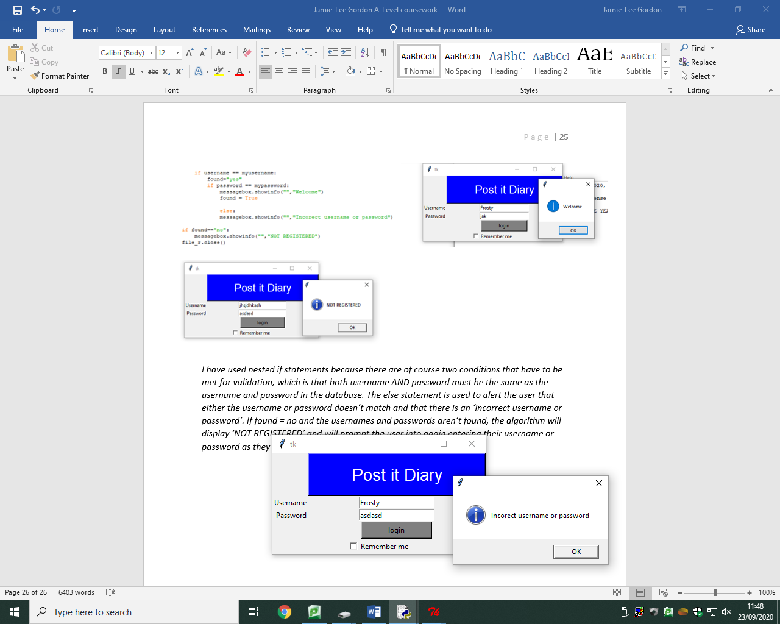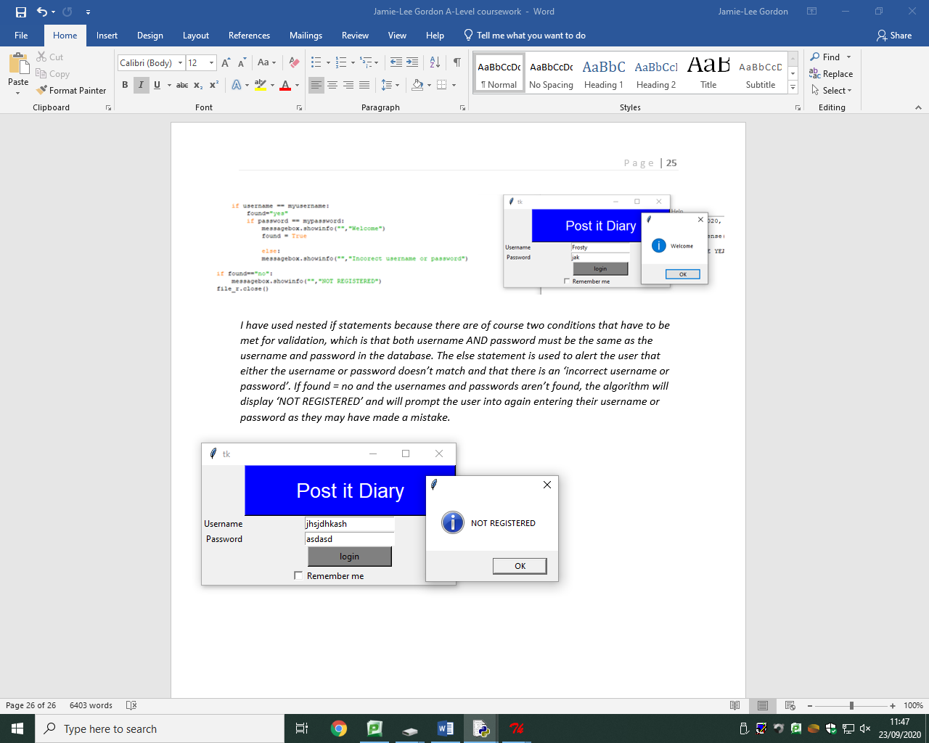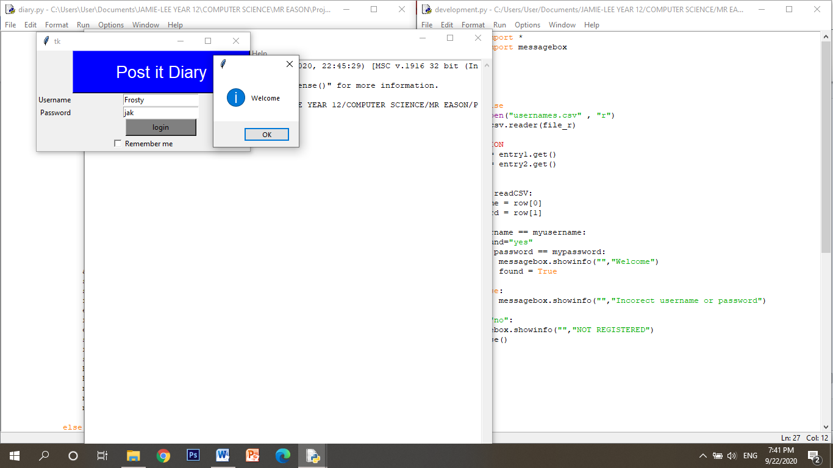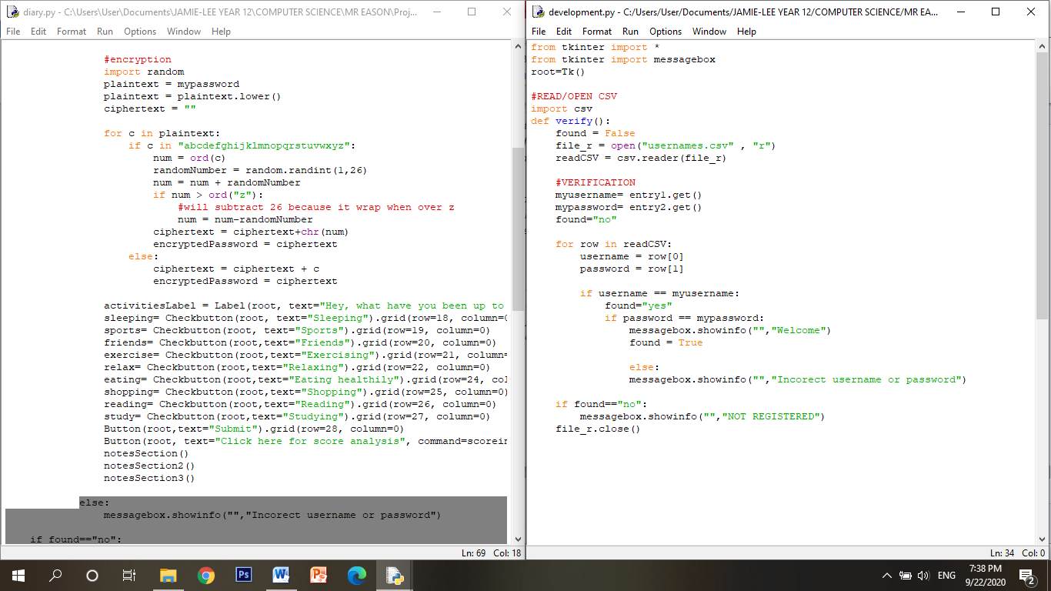

*I have used nested if statements because there are of course two conditions that have to be met for validation, which is that both username AND password must be the same as the username and password in the database. The else statement is used to alert the user that either the username or password doesn’t match and that there is an ‘incorrect username or password’. If found = no and the usernames and passwords aren’t found, the algorithm will display ‘NOT REGISTERED’ and will prompt the user into again entering their username or password as they may have made a mistake.*

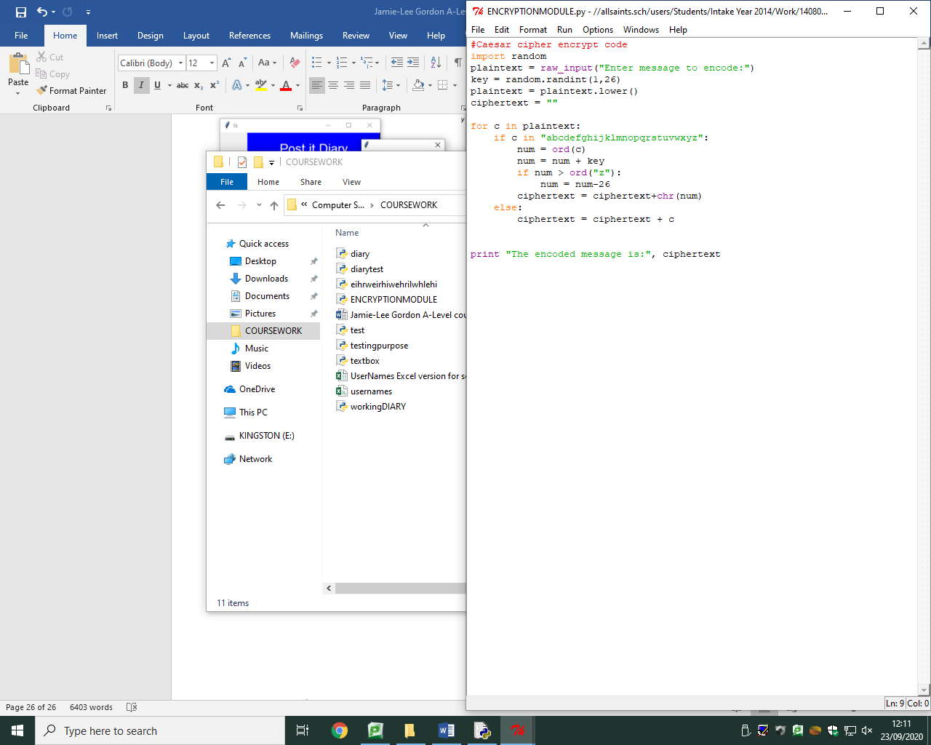*As I have previously stated, I will be using a Caesar cipher to encrypt user passwords and I have used a random number as a key for security reasons so the user doesn’t have to choose a key for them selves and risk sharing it to an unauthorised user. I use a random number by importing the random module and using random.randint(1,26) which will randomly generate a number between 1 and 26 as there are only 26 different letters in the alphabet.*

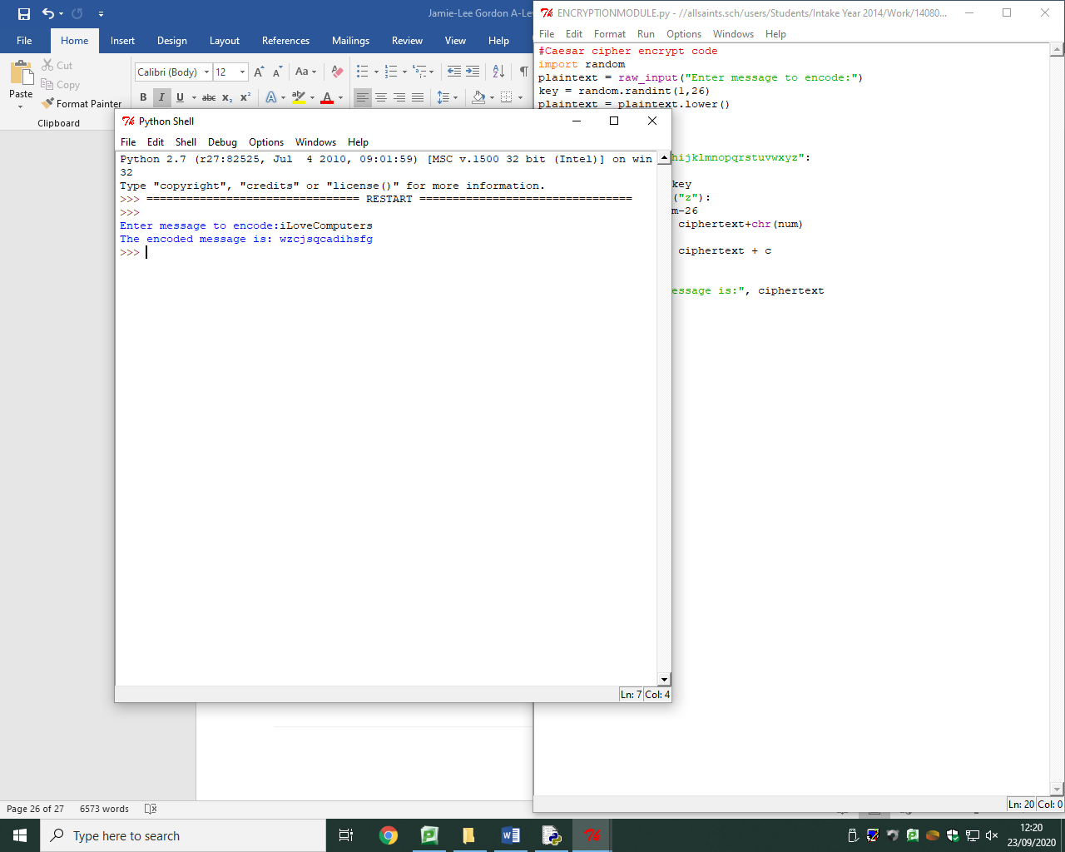*This is the main code for the encryption module. The code will take what the user has entered (plaintext) and the for loop will iterate through every character in the password and use ‘ord’ to translate the letter into its ASCII value. It will then take the ASCII value of every character and add the key (which is the random number). If the value is greater than the equivalent of ‘z’ then of course the algorithm will need to wrap around and I achieved this by using ‘-26’.*

*The example on the left shows how this will work and as you can see, each character has changed.*

*Stage review – Login*

***Implementation***

*I have initially implemented my graphical user interface using tkinter, and I have created a login system using file handling techniques and the created csv database on Excel by reading the appropriate data on the database.*

***How it has been tested***

*The entry boxes were tested by using different user inputs such as testing if the program will grant access when both username and password matches what is in the database. I have also tested that when I enter the correct username but incorrect password, that a message is displayed telling the user that they have an incorrect username or password and that if both username and password is incorrect that a message displays saying ‘not registered’.*

***How I have met user requirements***

*My main success criteria were to ensure user security through the login system and the use of a username and password, I have successfully produced a fully working solution of security using the GUI and file handling by reading from a csv database on Excel.*

***Criteria met***

* *Graphical user interface (GUI)*
* *Login system*
* *User verification*
* *Usernames and passwords*

***Prototype***

*This is the first prototype of my solution where I have implemented the first few features where I will now go on to add features and make improvements creating more and more prototypes until I reach the final solution.*

*Stage review – Encryption*

***Implementation***

*I have implemented the code for encryption of user passwords with the use of a Caesar cipher as previously stated and have used a random key to increase the levels of security.*

***How it has been tested***

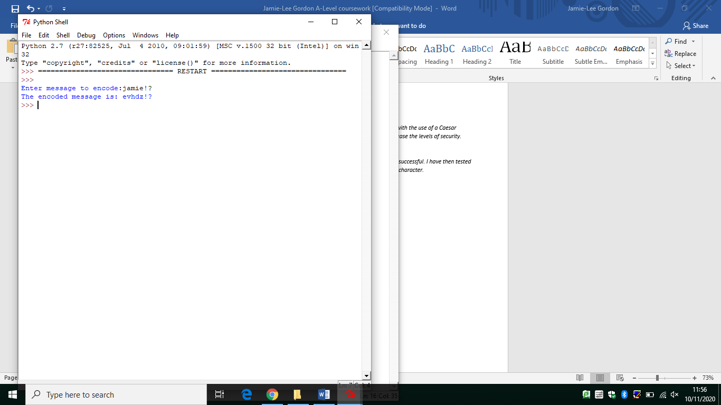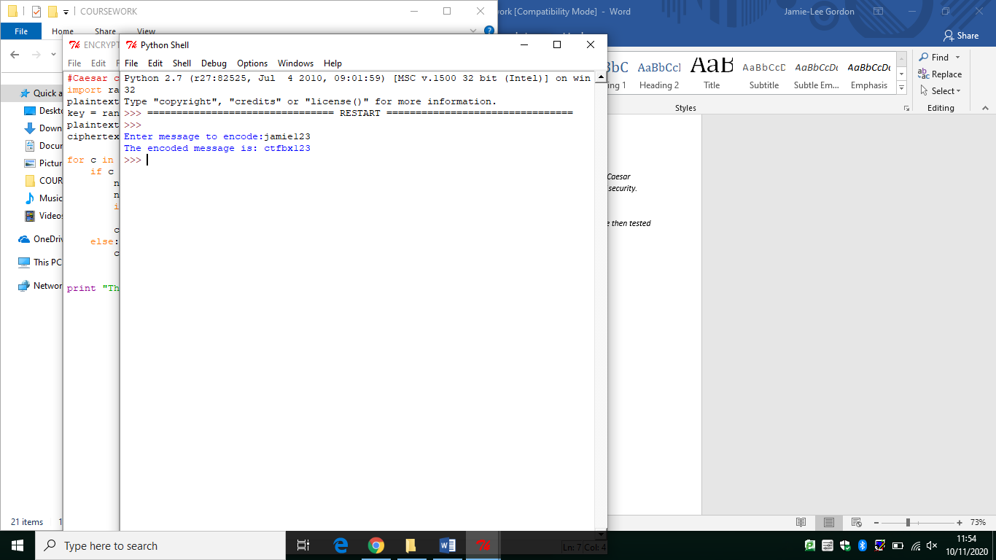*I have made several tests of encrypting a password which were successful. I have then tested the encryption of passwords which contain a number or special character.*

*As shown above, I have tested an example password with numbers and special characters, I have not been able to encrypt these characters. I have been unable to find a solution to this.*

***How I have met user requirements***

*Another thing on my criteria were to make sure user passwords are encrypted. I have successfully been able to implement code in which encrypts user passwords through the implementation of a Caesar cipher using a random key (1-26) however, have not been able to encrypt numbers and special characters.*

***Criteria met***

* *Encryption*
* *Caesar cipher*
* *Use of random key*
* *Security*

***Prototype***

*This is a further improvement and development on my initial prototype where security isn’t just guaranteed by usernames and passwords but also though encryption and the random key makes it unknown to the user where they cannot be forced to tell anyone it.*

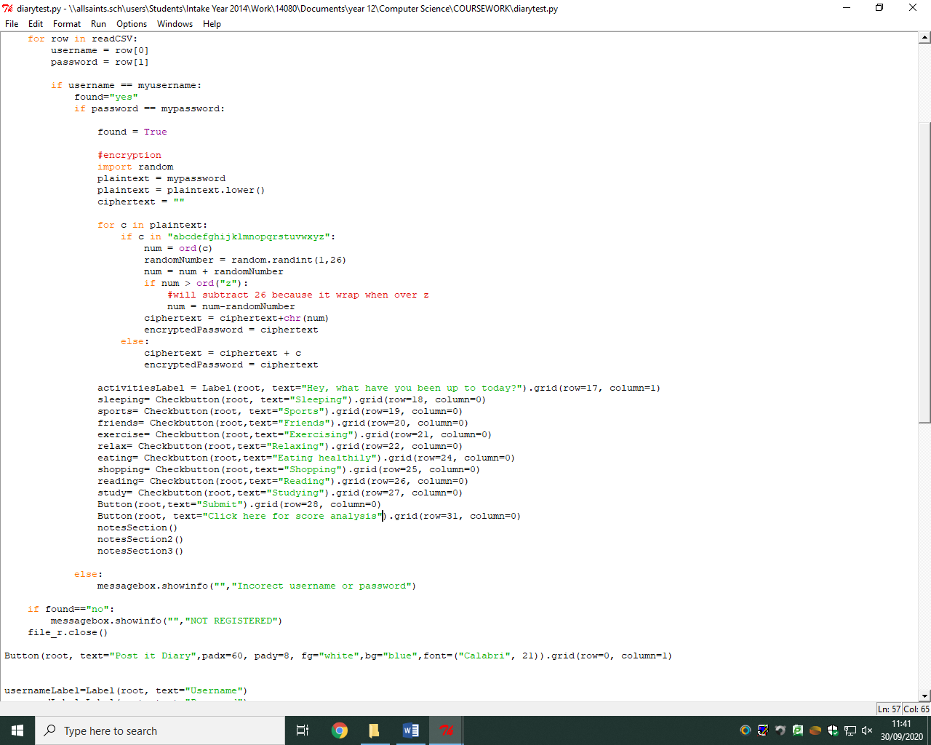

*This is the activities module. Once the user is granted access, the user is presented activities. I have implemented this with the use of check buttons where users can select an activity they have taken part in during the week. I have of course given the checkboxes appropriate names (for example ‘sports’) so if the user has done any sports they will tick the check box.*

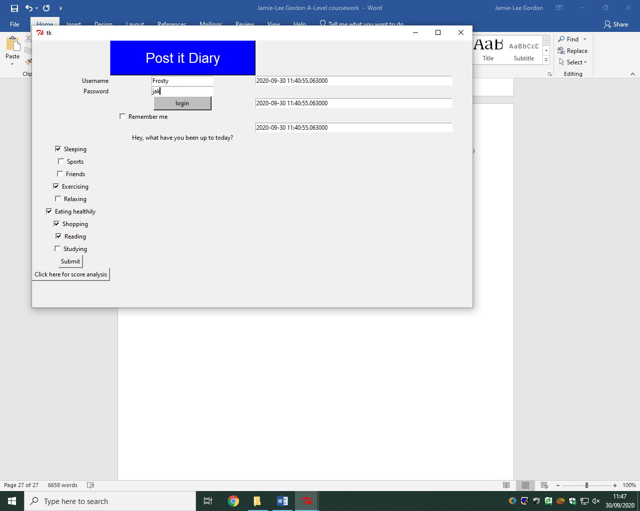As you can see there is a message displayed to the user that asks what the user has been up to and the user is able to tick appropriate boxes by clicking on the boxes using their mouse.

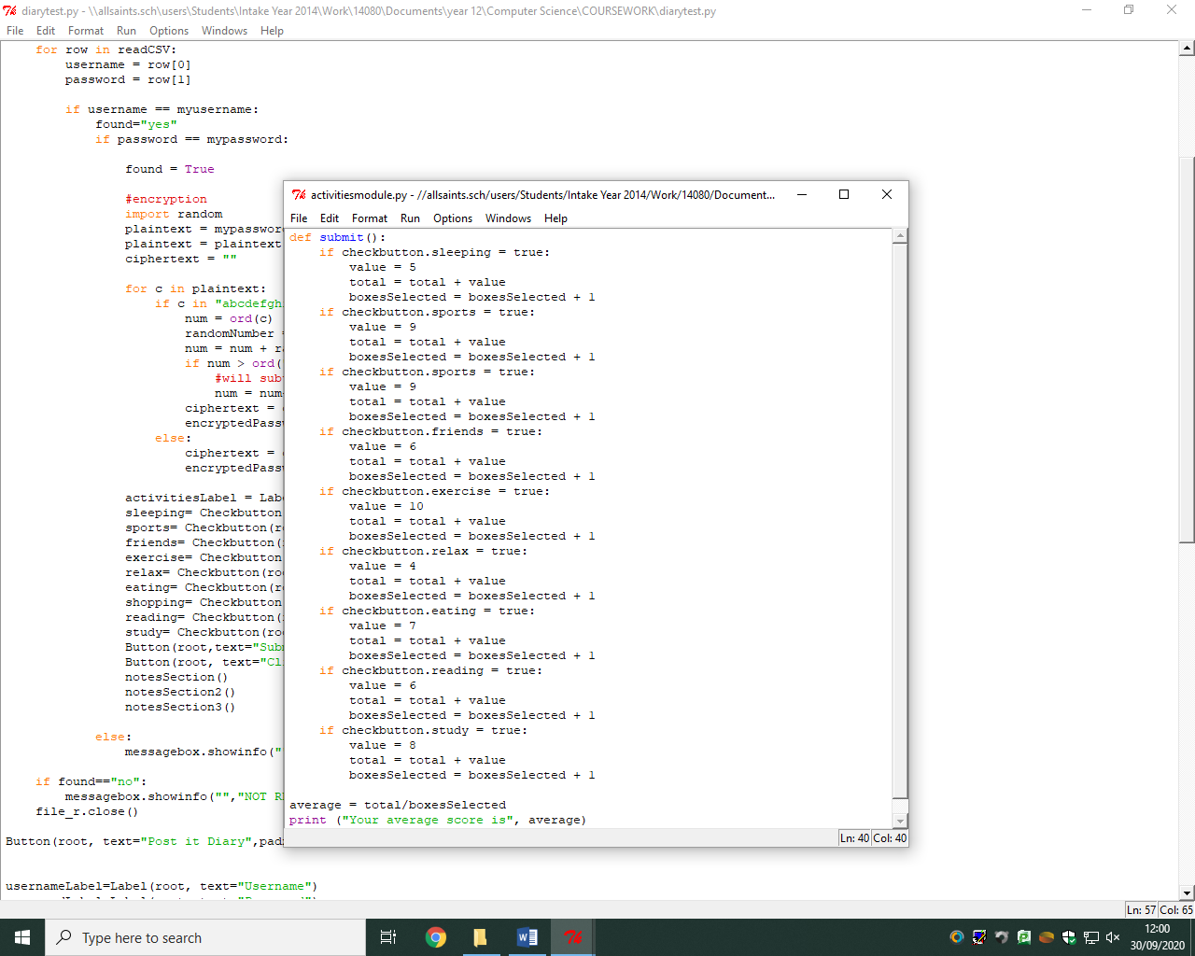

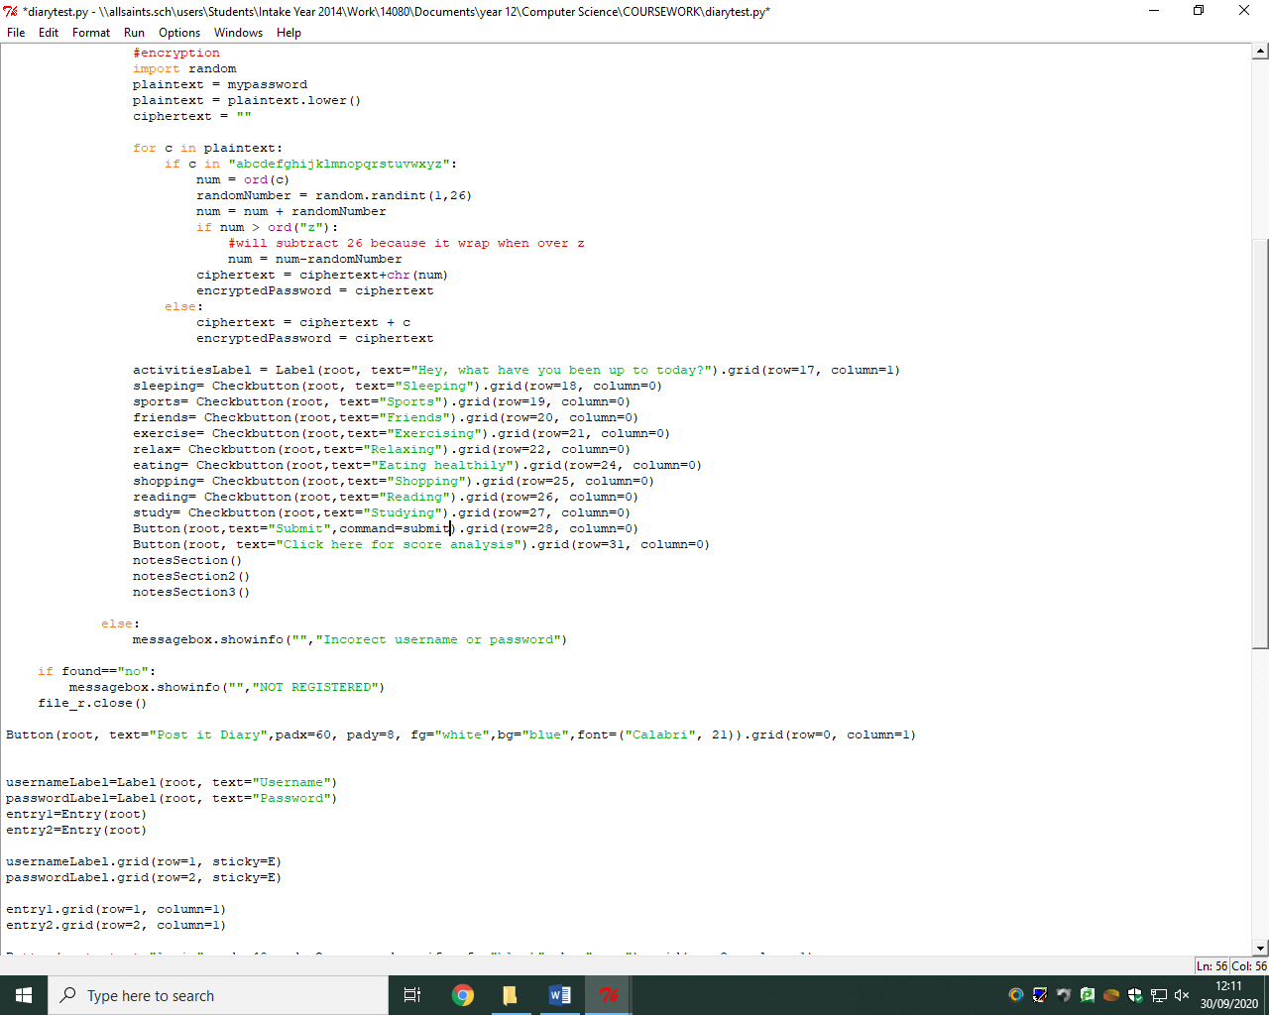*This is the submit sub routine which is used to calculate the average score for the activities module when the user presses the ‘submit’ button. For each button that is true, it will contain a health value and the value is incremented using the total variable because when you calculate the mean average you need to add all the values and divide by the number of boxes selected which is what the boxesSelected variable does.*

*REVIEW: this sub routine doesn’t work, however I have the correct logic for how I want it to work but I am now aware that I am not assigning commands to the checkboxes correctly as the checkbutton = true line is incorrect.*

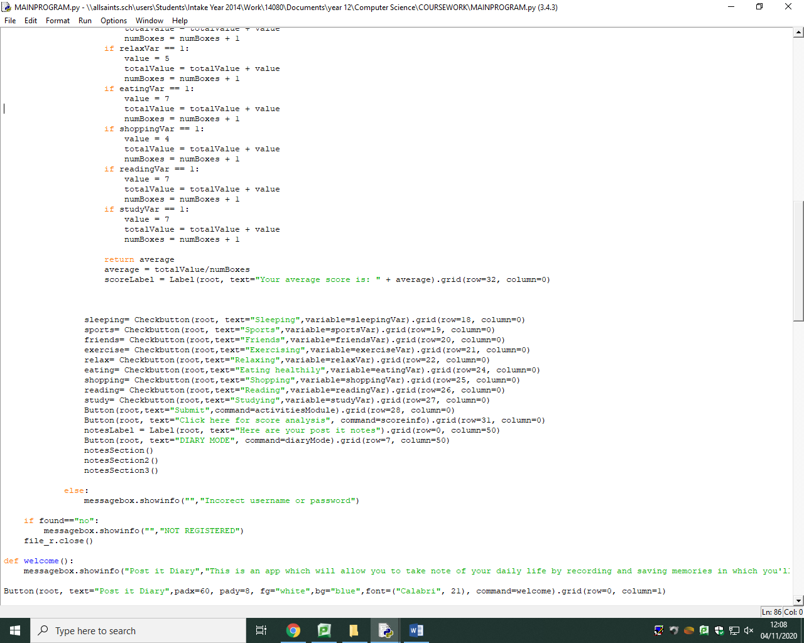*I have then found out that I need to add a variable to the checkbuttons which will then give the checkbuttons an off and on value so I added variables to each checkbox with an appropriate name.*

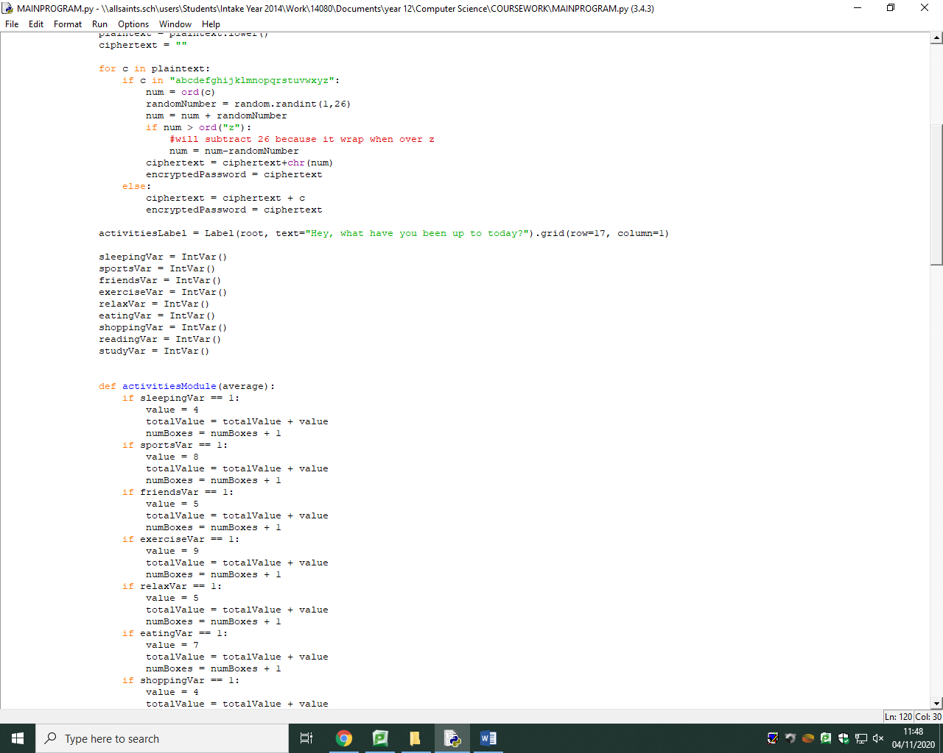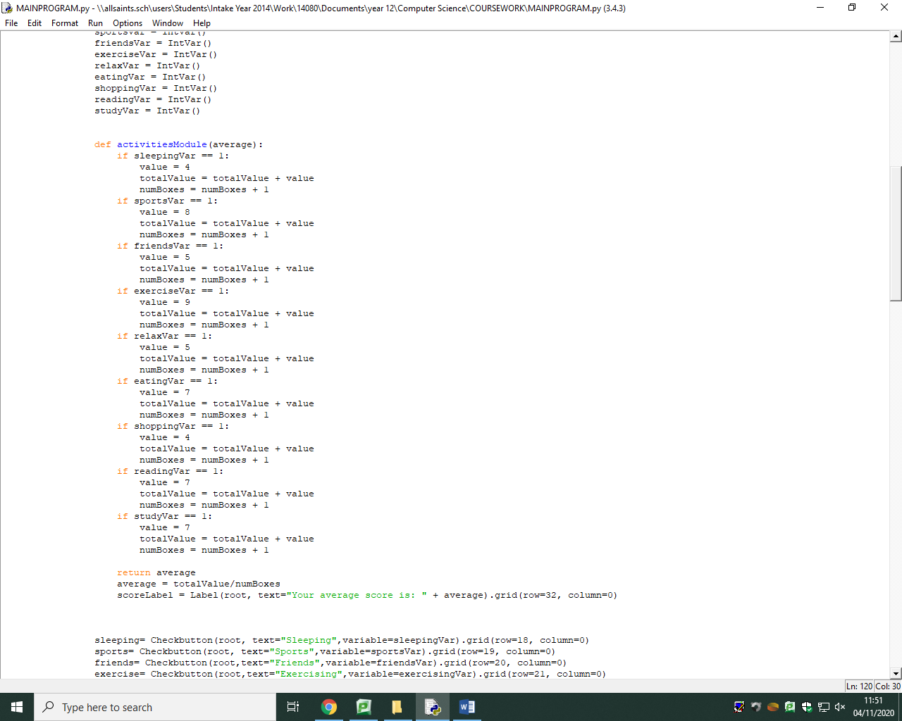*With the variables I have created for each checkbutton, I will have to give them on and off values so I have used* ***IntVar()*** *where if the checkbutton is pressed, the value is 1 and if the checkbutton isn’t pressed, the value is 0. I will now use these values so that I can give these buttons commands when selected. I will use the logic of ‘if the button has a value of 1, execute this command’.*

*I now need to create a subroutine which will increment values in order to calculate an average score for this module so I defined the function as* ***activitiesModule*** *and I’m passing through the average. I have used IF statements for each checkbutton where the value of the variable has to equal to 1 to be selected. I have incremented the total value and the number of boxes selected to calculate my mean average.*

*The above line of code is used to calculate the average score and display it to the user. I return the average and calculate it using* ***totalValue/numBoxes.*** *The average score is displayed to the user using a label on the user interface by again using the grid system.*

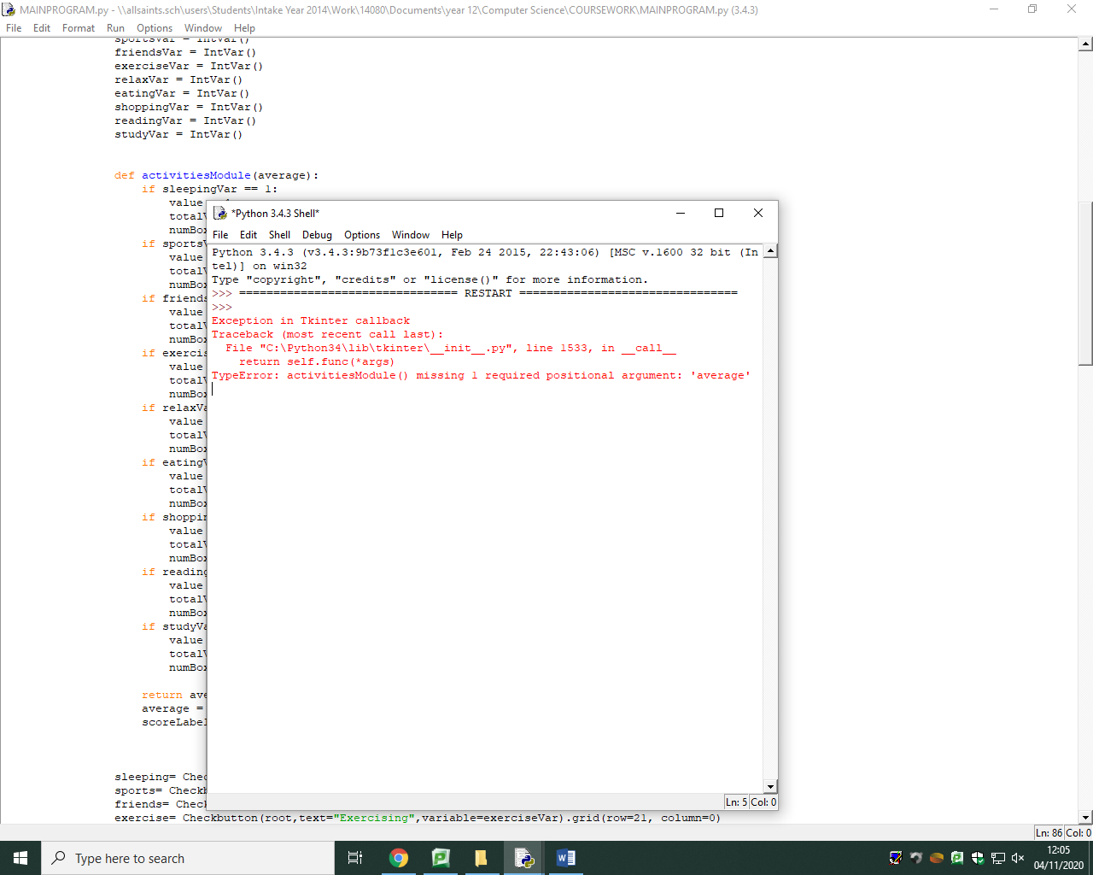

*I have however run into an error stating that I’m missing an argument. I cannot seem to figure out what was wrong with it and my only assumption is that it requires the instantiation of a class however I am unsure how using object orientated programming Is necessary in this module.*

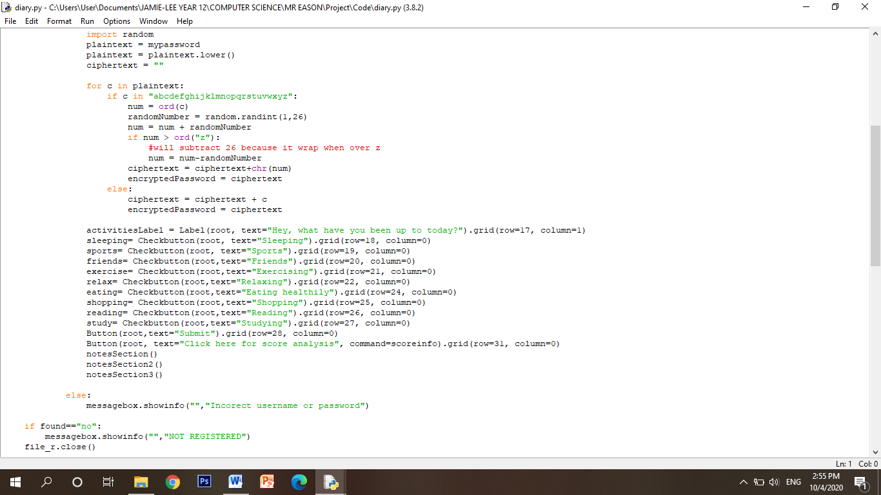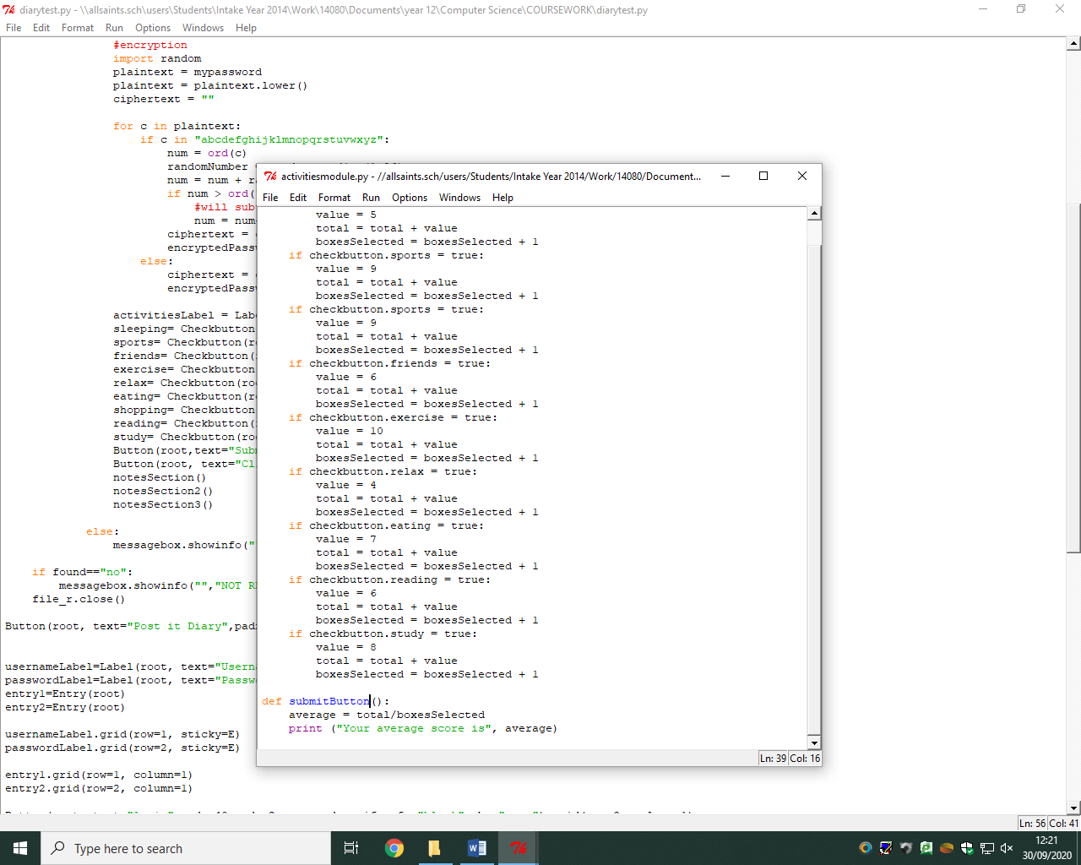*This is the function that is used after the boxes are selected and the user presses ‘submit’. The average variable is used to calculate the mean average of the health scores using the incremented total and boxesSelected and dividing it. The user is then presented a message showing their average score. Of course this wasn’t able to work due to the activities module not initially working as these two modules come hand in hand.*

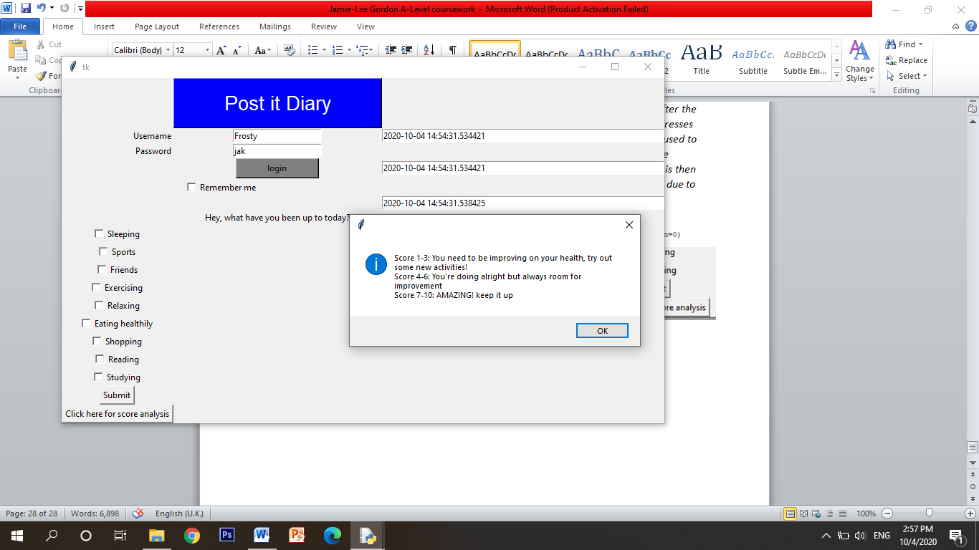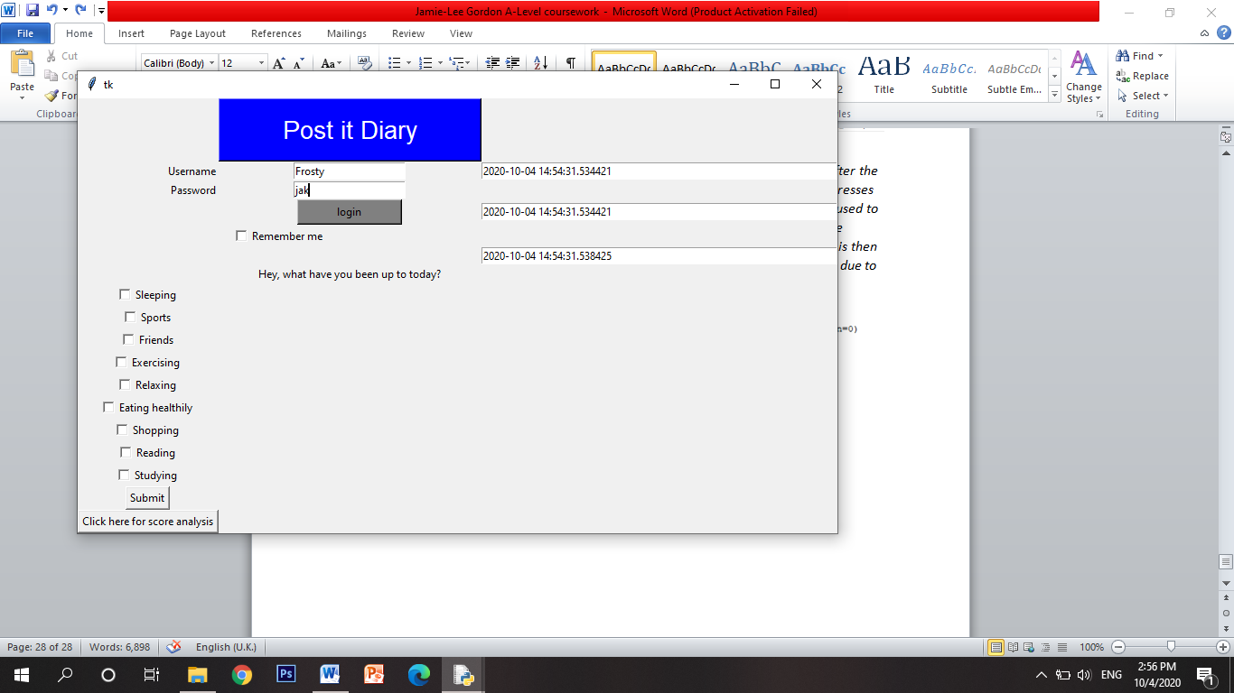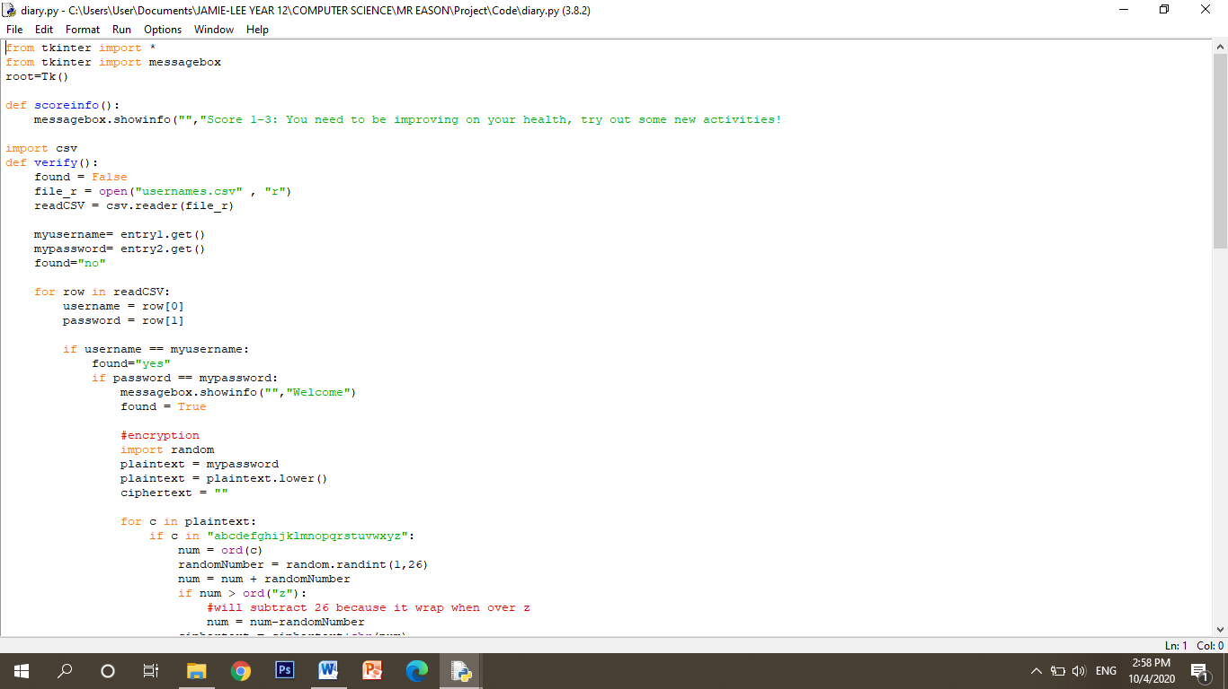*I have reviewed this module and also asked others to look at it and was told that they wouldn’t know what the numbers and scores actually mean, so I went over it and added the extra functionality of the analysis button. I have placed the analysis button right underneath the ‘submit’ button so that once the user submits their score they will be able to press the analysis button to better understand what it actually means. I did this by again creating a tkinter button using the grid geometry system and made it display ‘Click here for score analysis’ on the button so the user knows what the button does. I have added a command function to the button so when pressed it runs the ‘scoreinfo’ function which is used to display a messagebox in the form of an information box and it displays to the user what each mean score means. Scores 1-3 would of course be extremely low so I have displayed to the user that they need to improve and work on ticking more boxes. Scores 4-6 would then be reasonably average so I displayed to the user that they need slight improvements. And finally, for scores 7-10, being high, I have displayed that they’re doing amazing and should keep it up.*

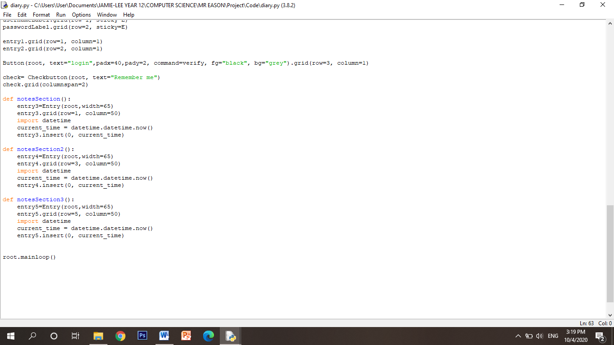*For my notes module, I need to create, again, entry boxes which will be used to allow users to enter their post it note messages and reminders by typing them in.*

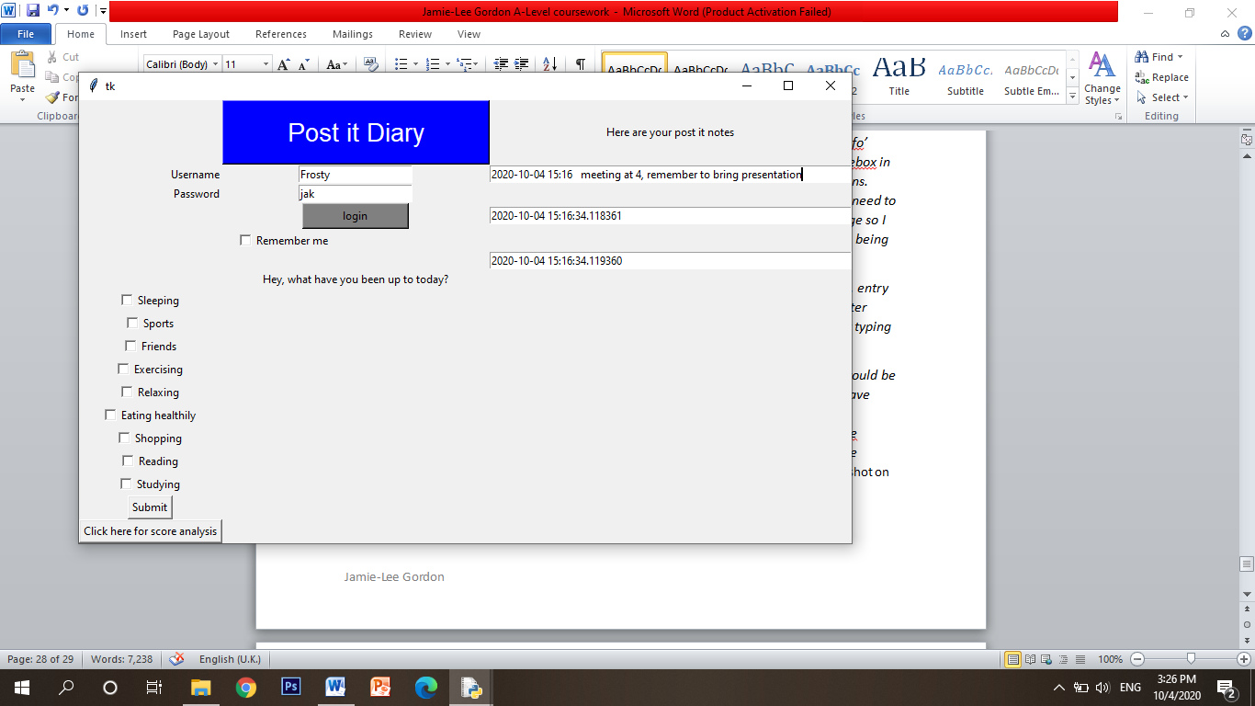*REVIEW: for extra functionality I thought it would be a great idea to add the current date and time, just like the other existing solutions I have previously looked at in analysis. I did this by importing the datetime module and then creating a variable called current_time and storing the current time. The current_time variable would then be used as an insert for the entry box by displaying to the user the current date and time within the box. And again I’ve used the grid system.* The screenshot on shows an example of how it can be utilised.

*Stage review – activities module*

***Implementation***

*I have implemented this module by using tkinter check boxes and buttons. The buttons will be used to generate an average health score which will then be displayed to the user. I have also provided information to the user of a ‘score analysis’ which will tell them what their calculated score shows.*

***How it has been tested***

*I have of course given relevent values to all the checkboxes so I have tested the calculation of the average by selecting a few check boxes and pressing submit to calculate the average. However, It didn’t initially work and figured out that I needed to add variables to the checkb boxes using on and off values. I again tested it after making imoprovements but it still wasn’t able to work and I am unsure on what went wrong. Because of these erroes I have not been able to implement the feature where I wanted to save every accumilated score in a week to caculate an average score for the week and then month and year.*

***How I have met user requirements***

*A criteria of mine was to create a feature that allows the user to enter what activities they have participated and to also calculate a mean average ‘health score’. I have successfully been able to implement the check boxes and buttons using tkinter however the implementation of the calculation hasn’t come to fruition.*

***Criteria met***

* *Check boxes of activities*
* *Health score values implemented*
* *Score analysis info box*
* *Tkinter GUI*

***Prototype***

*Again, I have added another feature to my previous prototype; the activities module, however it does not completely work with parts of functionality not working.*

*To test that my average actually works I need to test this seperately wothout the GUI to make sure the code correctly increments the number of boxes and also increments the values to calcualte the mean average using totalValues/numBoxes.*

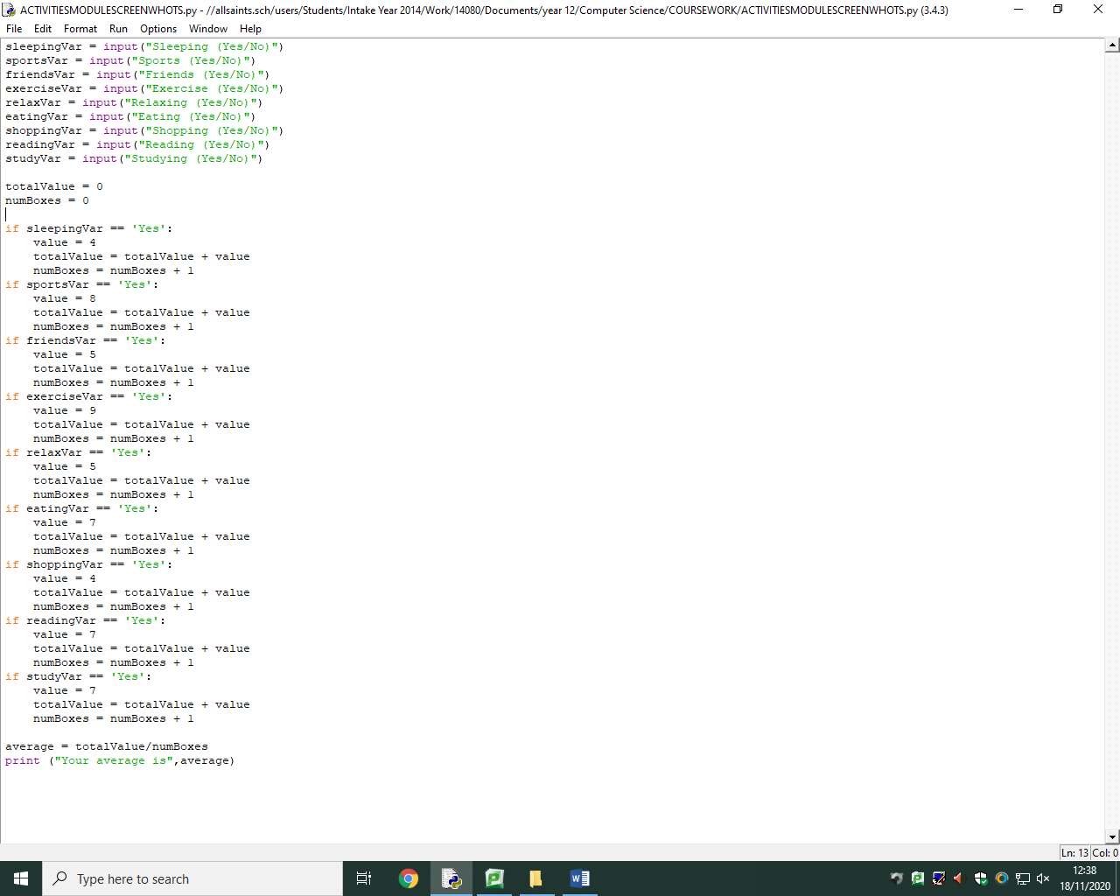*I have asked the user to input yes or no if the activity applies to them.*

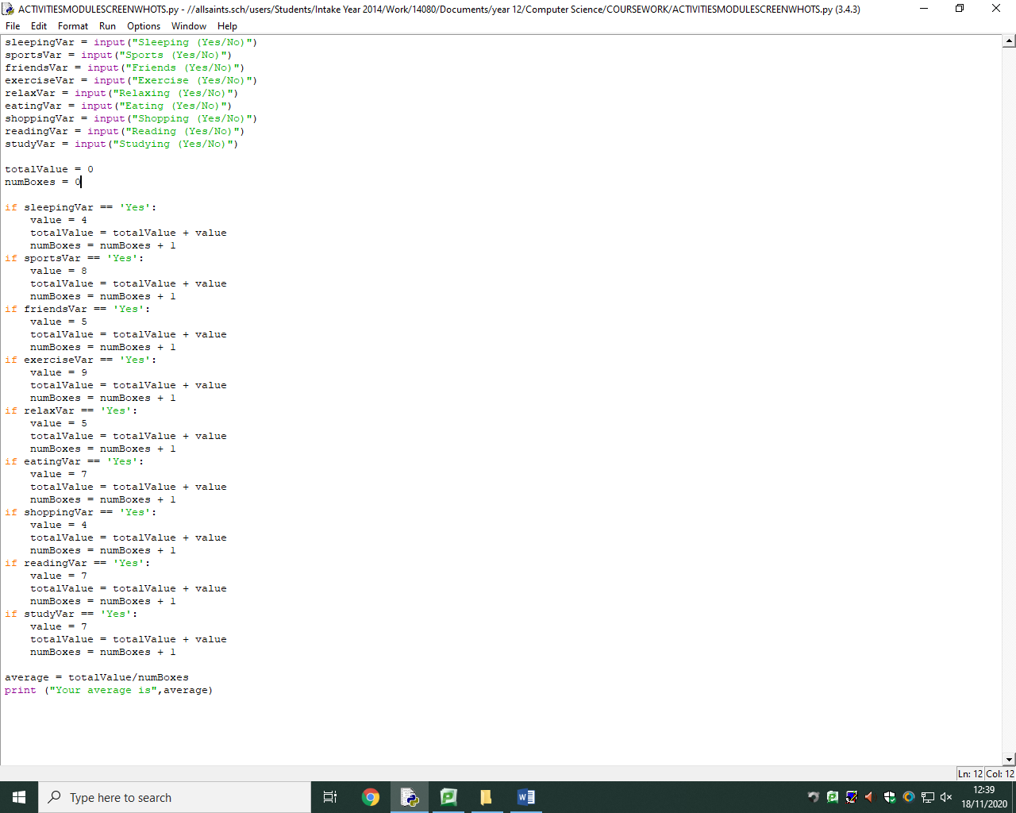

*I have then used the same code but changed the conditions so that when the user inputs ‘yes’ the folliwing code will run and the values and bvoxes begin to be incremented.*

*I then used the formula to calculate the average and print it to the user.*

*As you can see below, my code succesfully calculates an average health score and can display it to the user.*

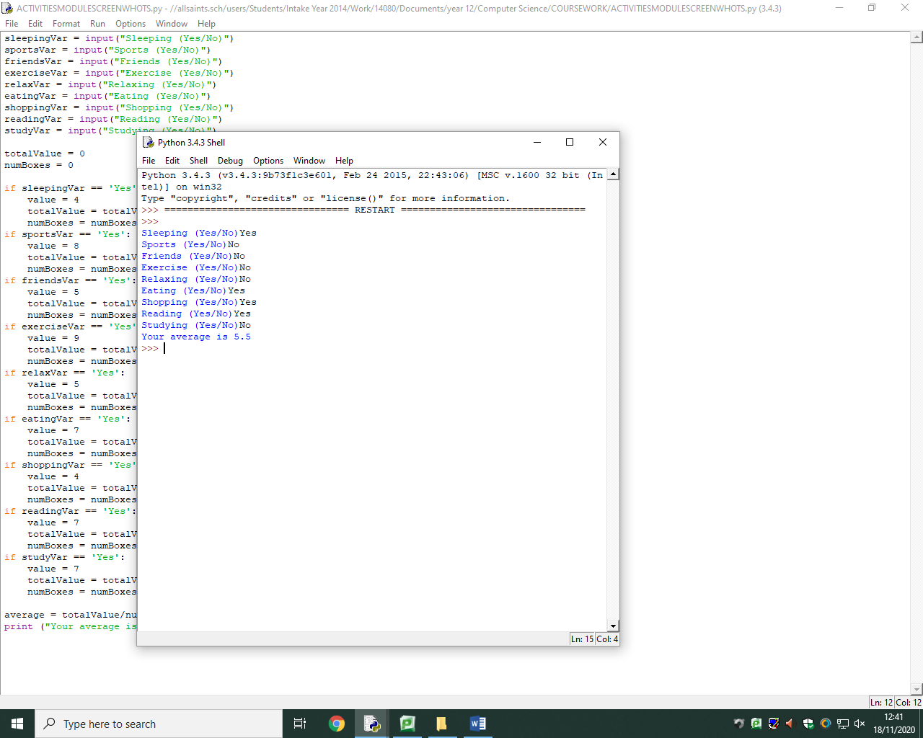

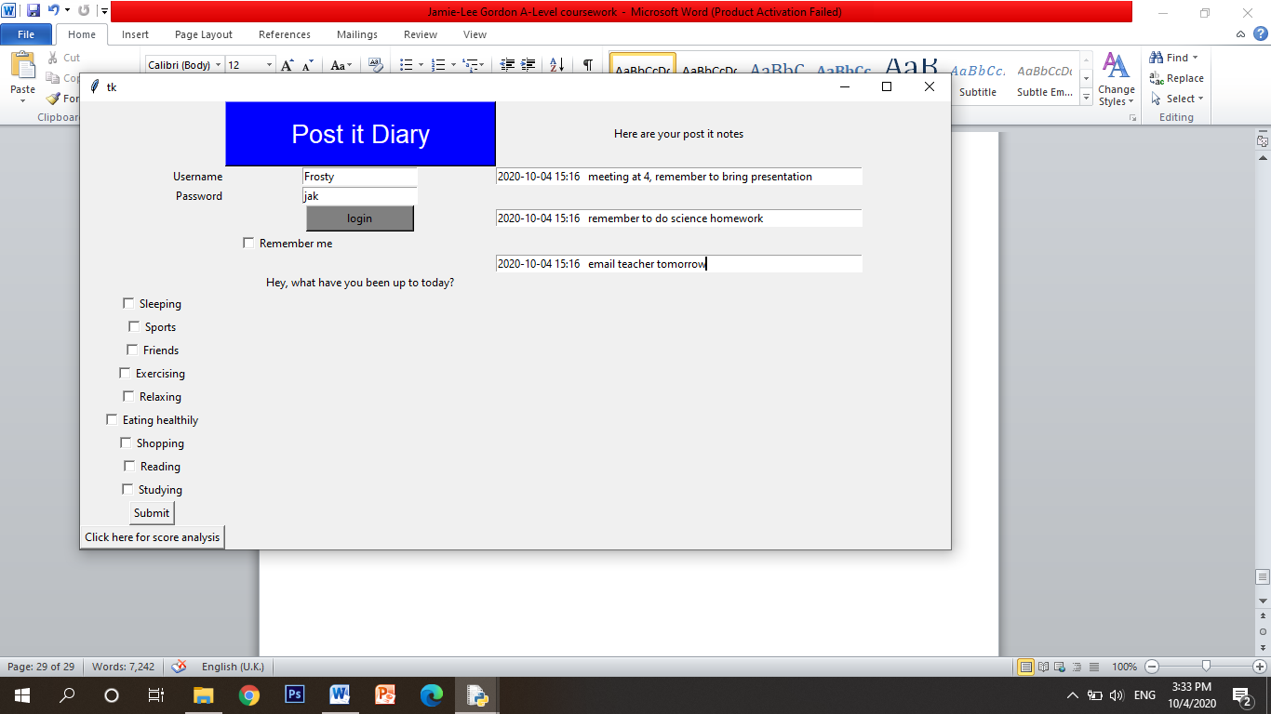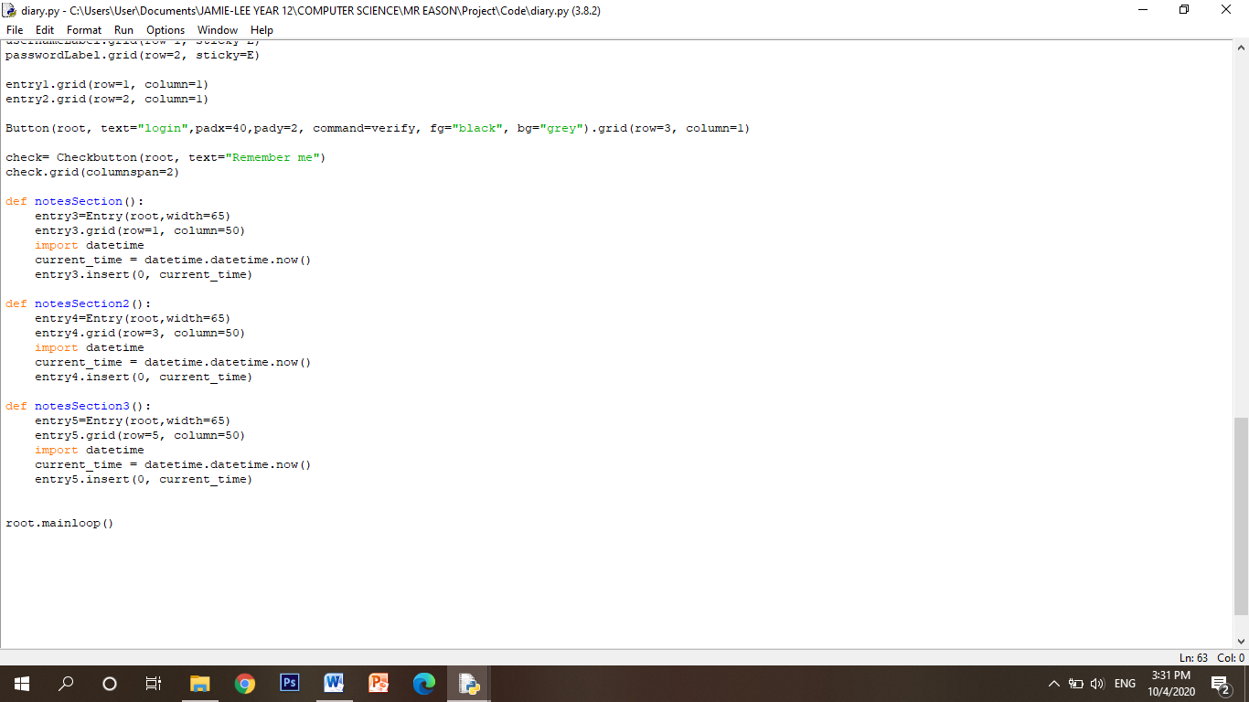

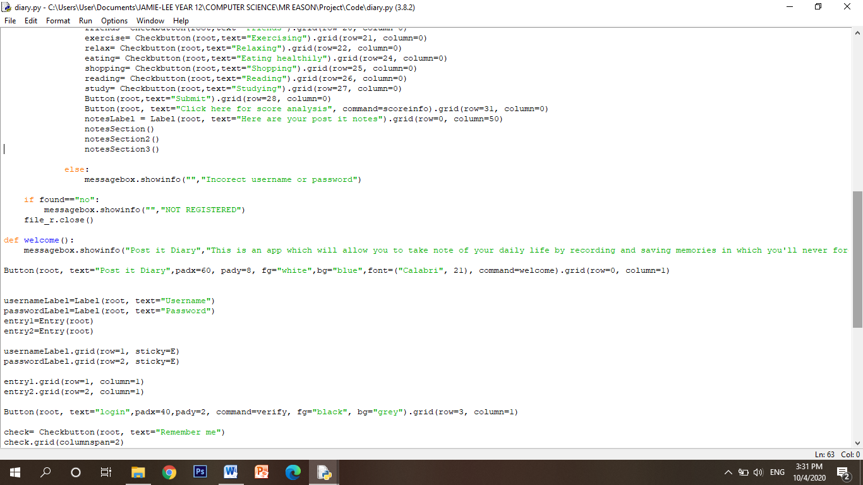*REVIEW: having only 1 post it note box, I realised, was obviously not enough, so I have added an extra 2 post it note boxes using the grid system and placing them one underneath the other. The screenshot above again shows how this feature can be utilised such as reminders for students by reminding them about homework.*

*The screenshot on the left shows the function calls.*

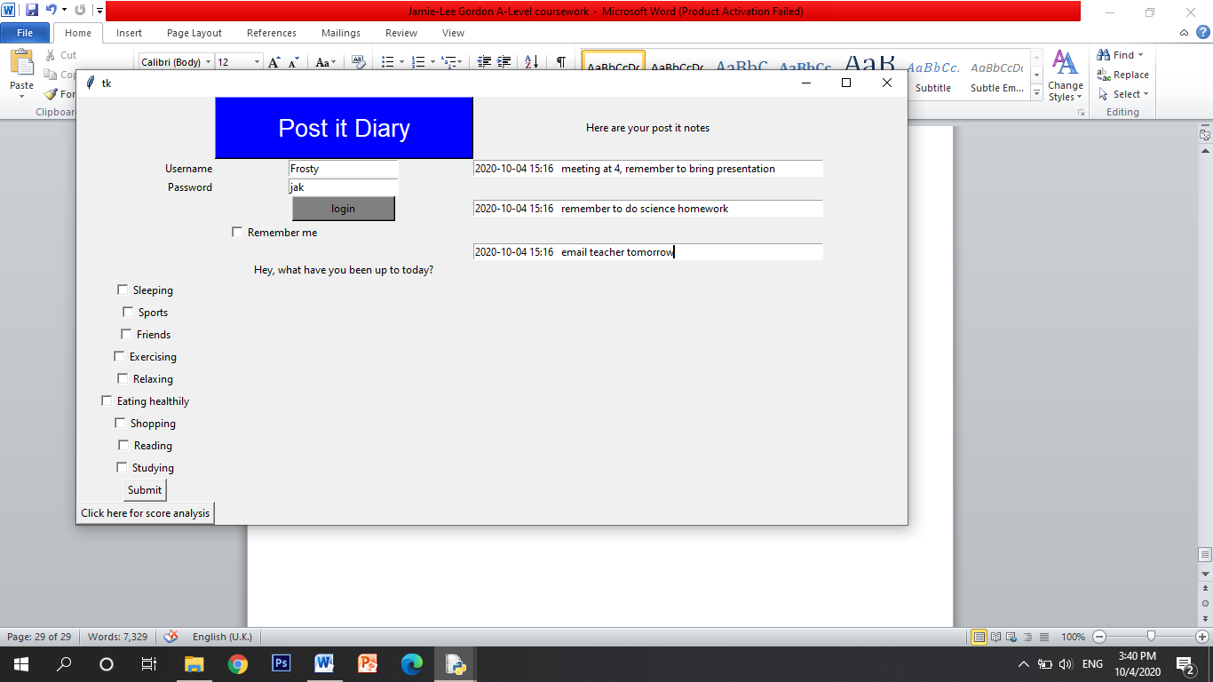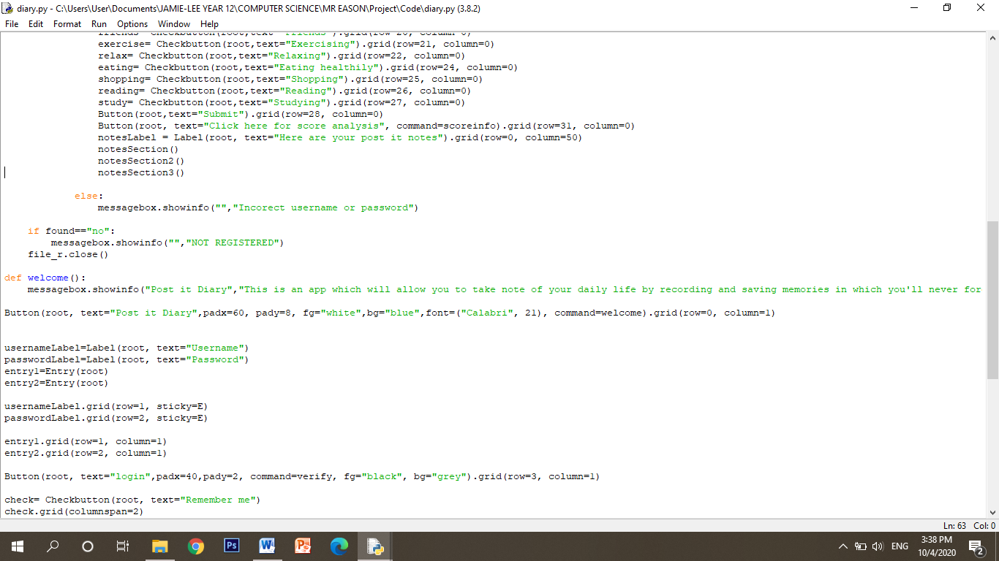

*The notesLabel variable is used to create a label that displays to the user that these are their post it notes.*

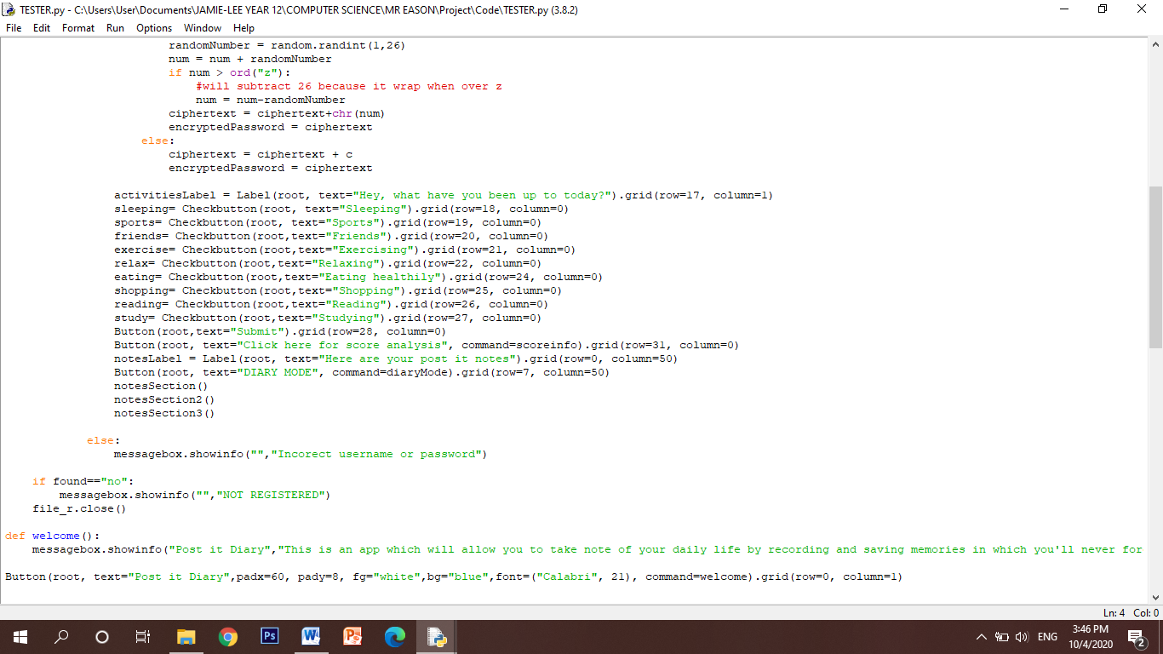

*The next feature I need to add is the diary mode which allows users to type in large amounts of text in the form of an actual diary so I have created a new button showing ‘Diary mode’ that when pressed it runs the diaryMode function.*

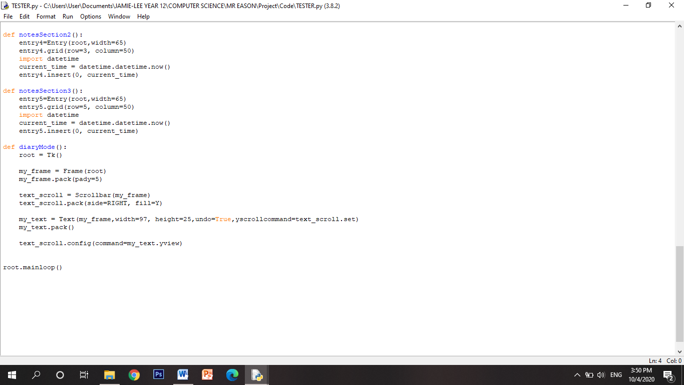*This is the code for the diaryMode function where I wil need to import a texbox and have done this by using the Frame module and I have packed it on the screen.*

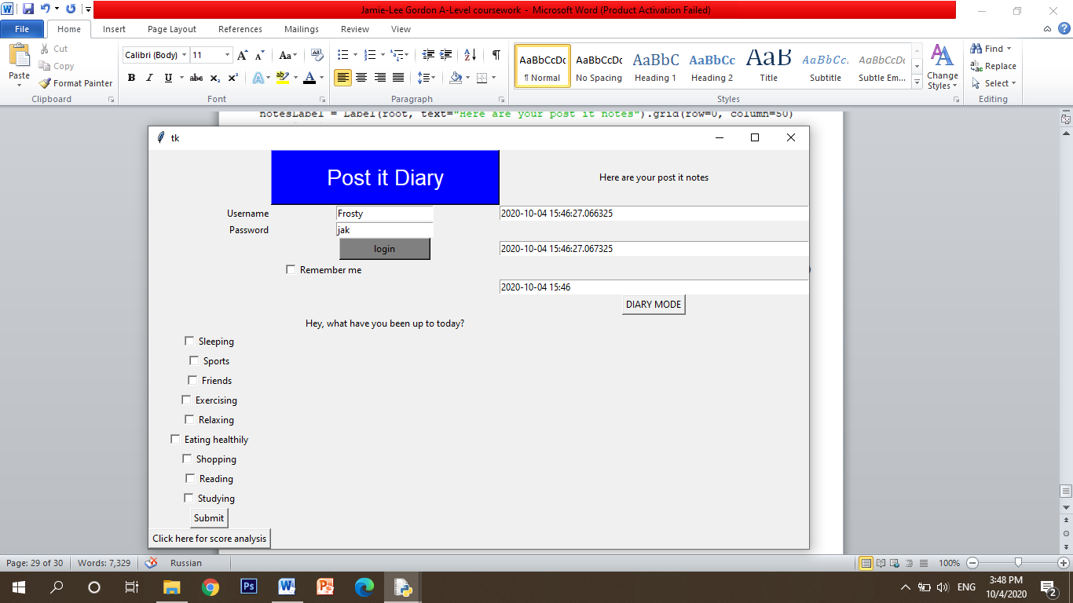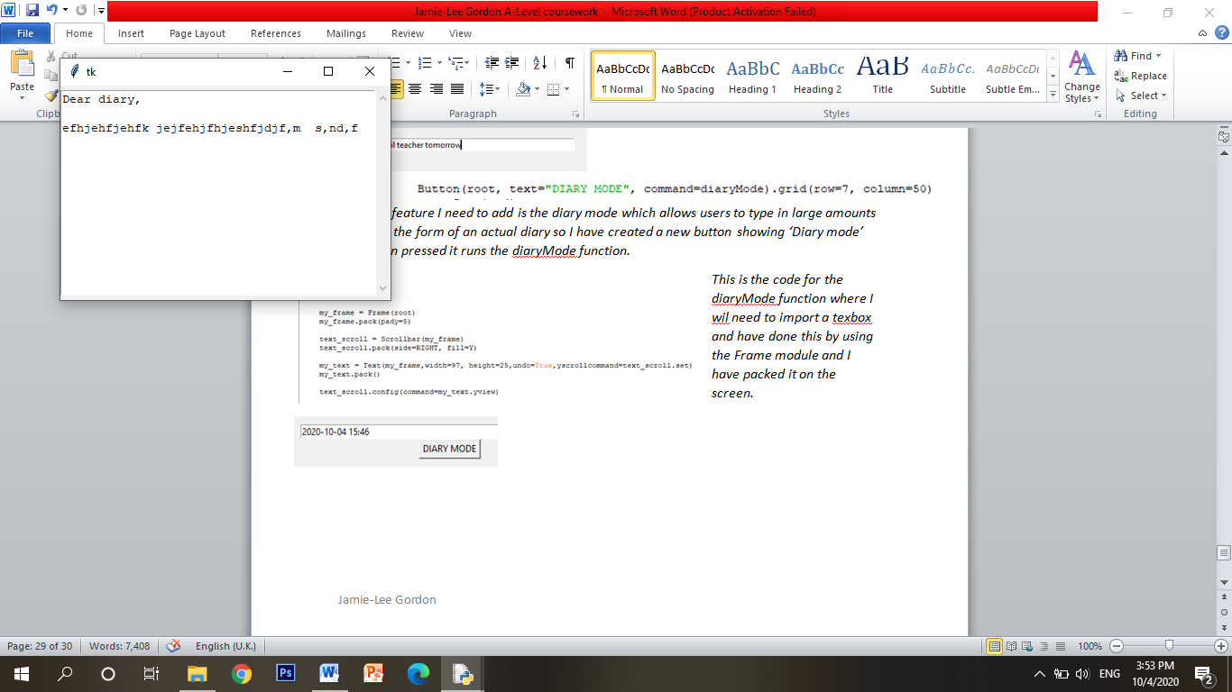*As shown on the left, I have shown the textbox in use and how it can be used to write a traditional ‘Dear diary’ and allow larger amounts of text in the textbox.*

*Stage review – Post it notes*

***Implementation***

*The next feature that I needed to implement was the post it notes which are a small and quick form of entering any reminders and small notes. The main feature of this, which I have improved, is implementing the current time into the post it notes like a traditional diary and I have done this by importing the datetime module.*

*I have produced this using tkinter and displaying it on the GUI for the user to interact with it. I have used entry boxes for the post it notes.*

***How it has been tested***

*I have tested the feature by simply running the user interface and making sure that I am able to type into the entry boxes and that the current date is displayed.*

***Criteria met***

* *Post it notes*
* *Reminders*
* *Allow for small quick notes*
* *Display the current date and time*

***How I have met user requirements***

*Another one of my user requirements was to have a section on the app which allows them to enter small reminders and notes but to also be able to display the current time. This has been successfully implemented as I am able to enter notes in the entry boxes and the current time is successfully displayed.*

***Prototype***

*I have added this feature and functionality to the previous prototype and now my solution is beginning to take shape.*

*Stage review – Diary mode*

***Implementation***

*I have created a button where, when pressed, will display a text editor which will be used as my ‘diary mode’. I have used tkinter again to implement this. The text editor allows for large amounts of text such as for the use of a traditional diary where the user may want to write a large amount on for example, how their day went.*

***How it has be tested***

*I have tested the functionality of the diary mode by making sure I am able to type in large amounts of text.*

*However, I have been unable to figure out a solution on how to save notes or add pictures such as JPEG or any videos (MP4).*

***Criteria met***

* *Diary mode*
* *Allow for large text*
* *Accessed through use of a button (meets criteria of simple GUI)*

***How I have met user requirements***

*The user will require a section in the app which allows them to type in large amounts of text and I have been successful in implementing this feature. However, I haven’t been able to find a solution on how to save notes, but I think I should take the contents of the text editor and save it as a csv file in notepad and then save it, however, I am unsure of how I will be able to actually save it so that the next time the user logs into their account, the contents will still be there from the previous login. Another one of my requirements (R5) was to implement code in which will categorize the notes, however I am unsure of how to implement this feature in terms of sectioning the text editor so that one section for example may be used for reminders and another section to be used for maybe a shopping list.*

***Prototype***

*This has been added underneath the post it notes of the previous prototype.*

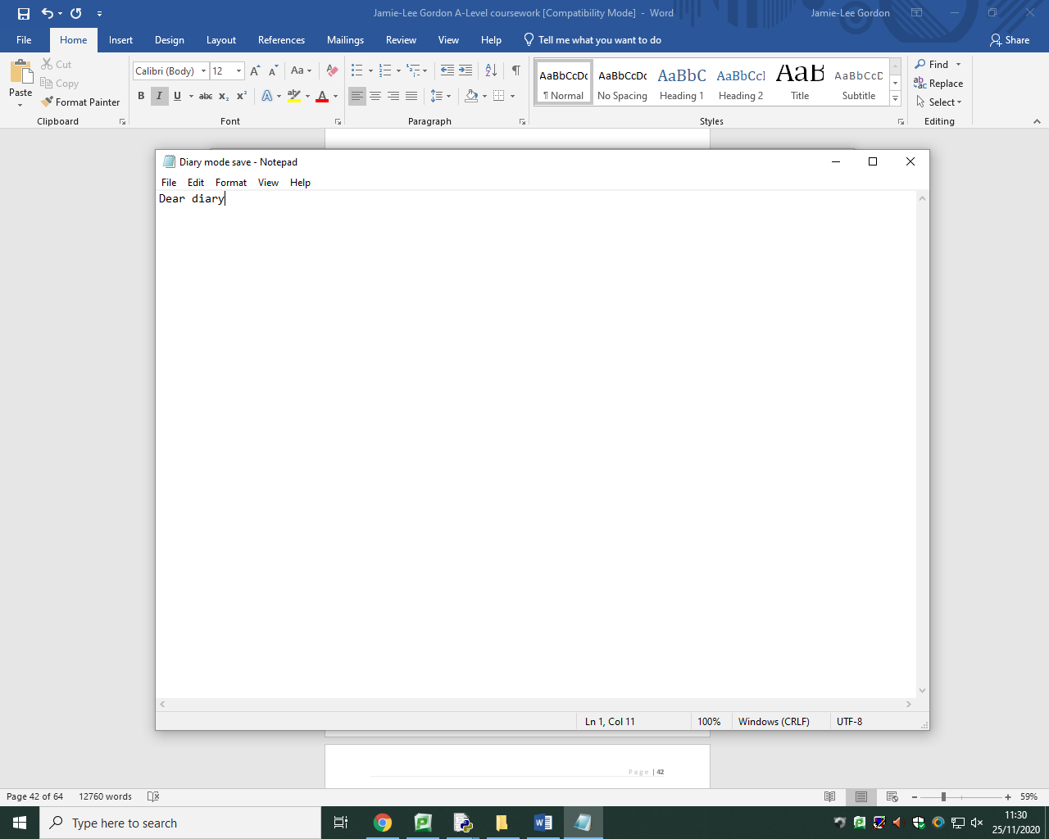*I am currently in the process of finding a solution to saving user diary notes. To implement this, I will use notepad to save notes to so I need to use file handling techniques to write the contents of the text editor into notepad which saves the notes.*

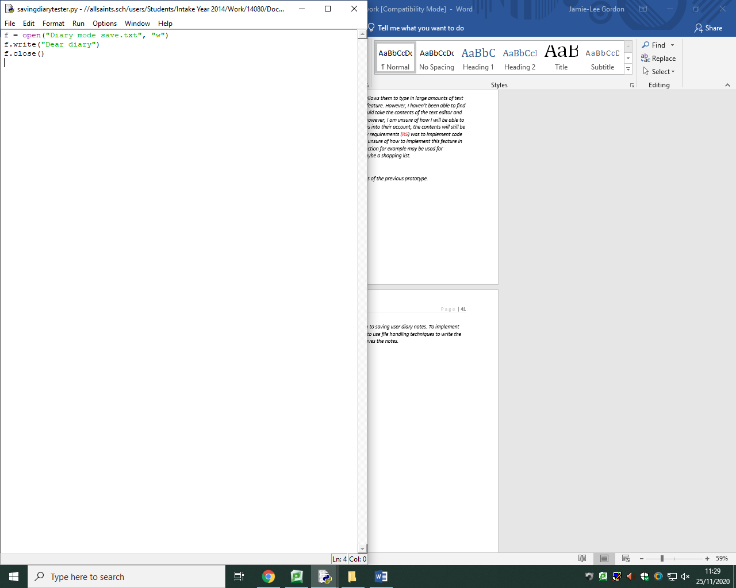

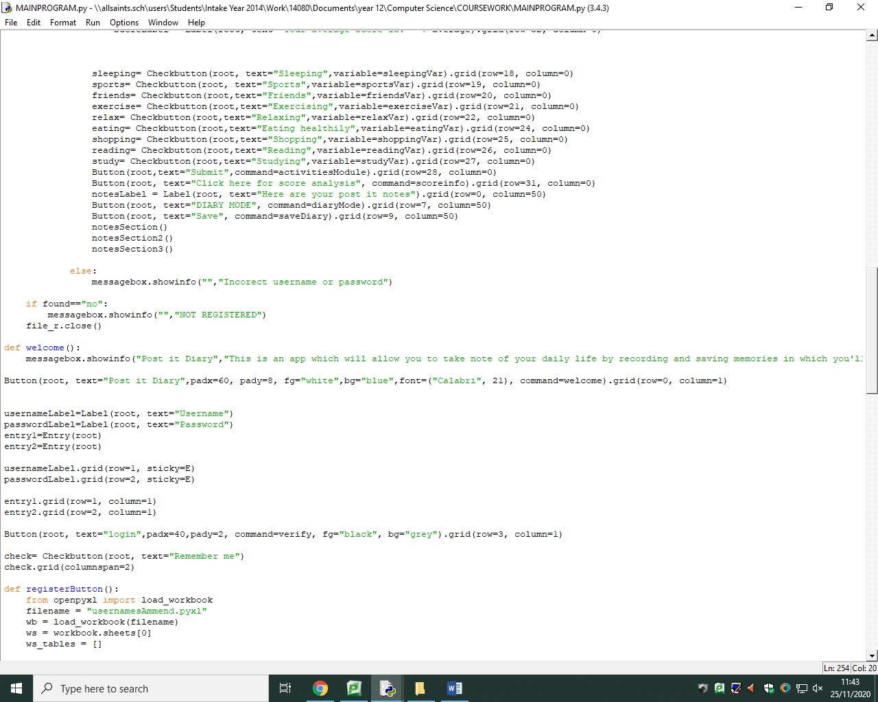*As shown above, I have successfully been able to use ‘write’ to write into the notepad in which notes will save, I will now go on to create a button in which when pressed, the contents inside the diary text editor will be written into this notepad file.*

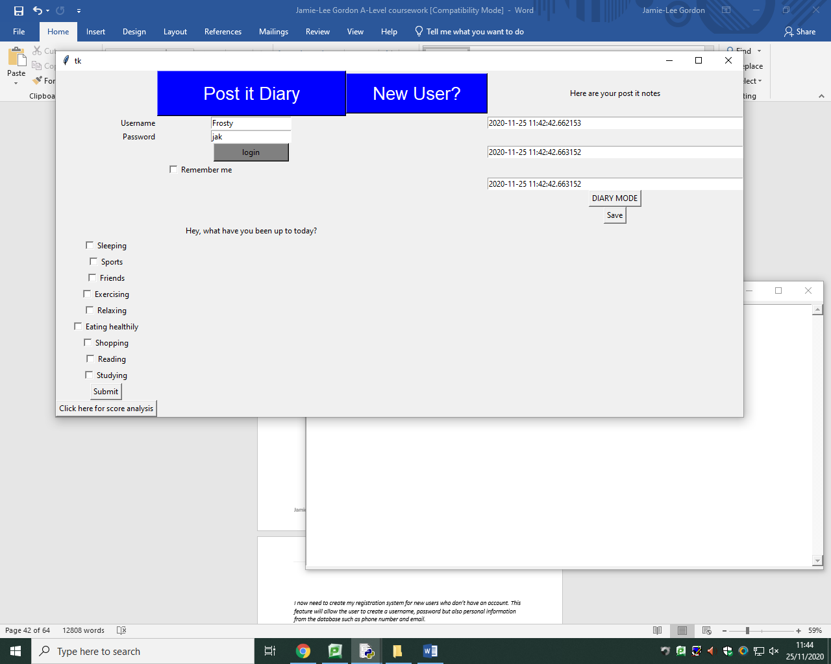

*I have successfully created a button called save and have assigned the command ‘saveDiary’ which is a function which I will go on to create the command to write the contents of the file into the notepad to save the notes.*

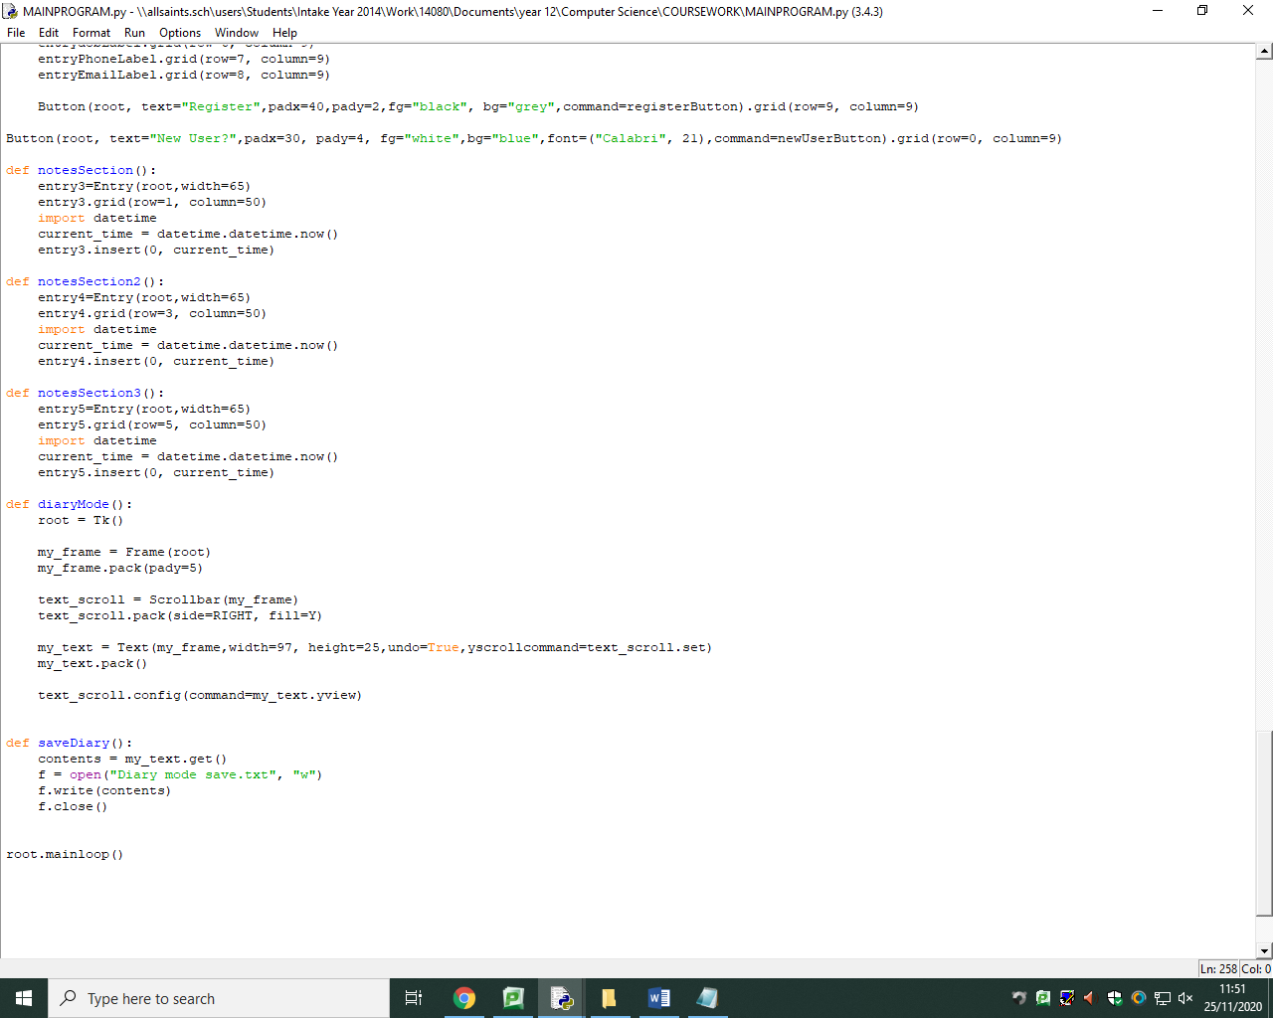*I have then implemented the file handling technique of ‘w’ to write into the text file. I have retrieved the contents of the text editor by using* ***.get()*** *because of encapsulation.*

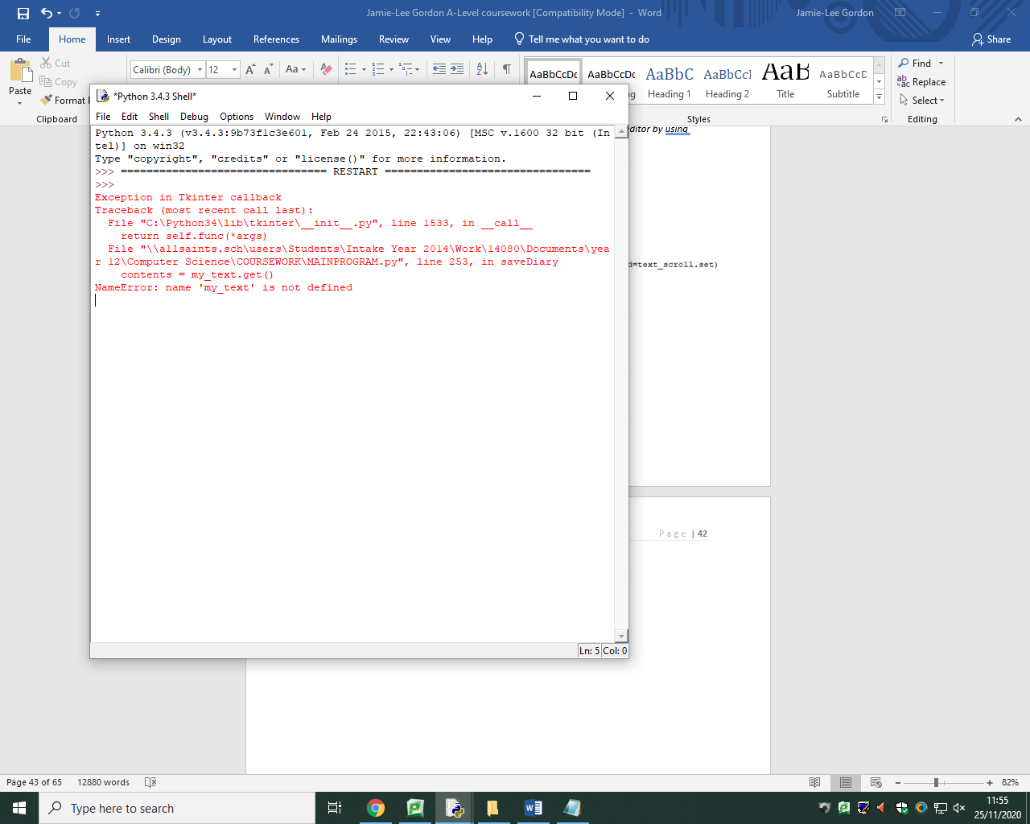

*However, this didn’t seem to work as I cannot seem to find a way to access the contents of the text editor or not being able to access the variable* ***my_text*** *which holds the text. This could possibly due to not accessing the variables in* ***diaryMode()*** *properly. However I have tried multiple ways of trying to access it such as passing* ***my_text*** *through the* ***diaryMode()*** *command and returning it, and have also tried* ***diaryMode.my_text.get()*** *but nothing seems to work. I must be doing something wrong.*

*I now need to create my registration system for new users who don’t have an account. This feature will allow the user to create a username, password but also personal information from the database such as phone number and email.*

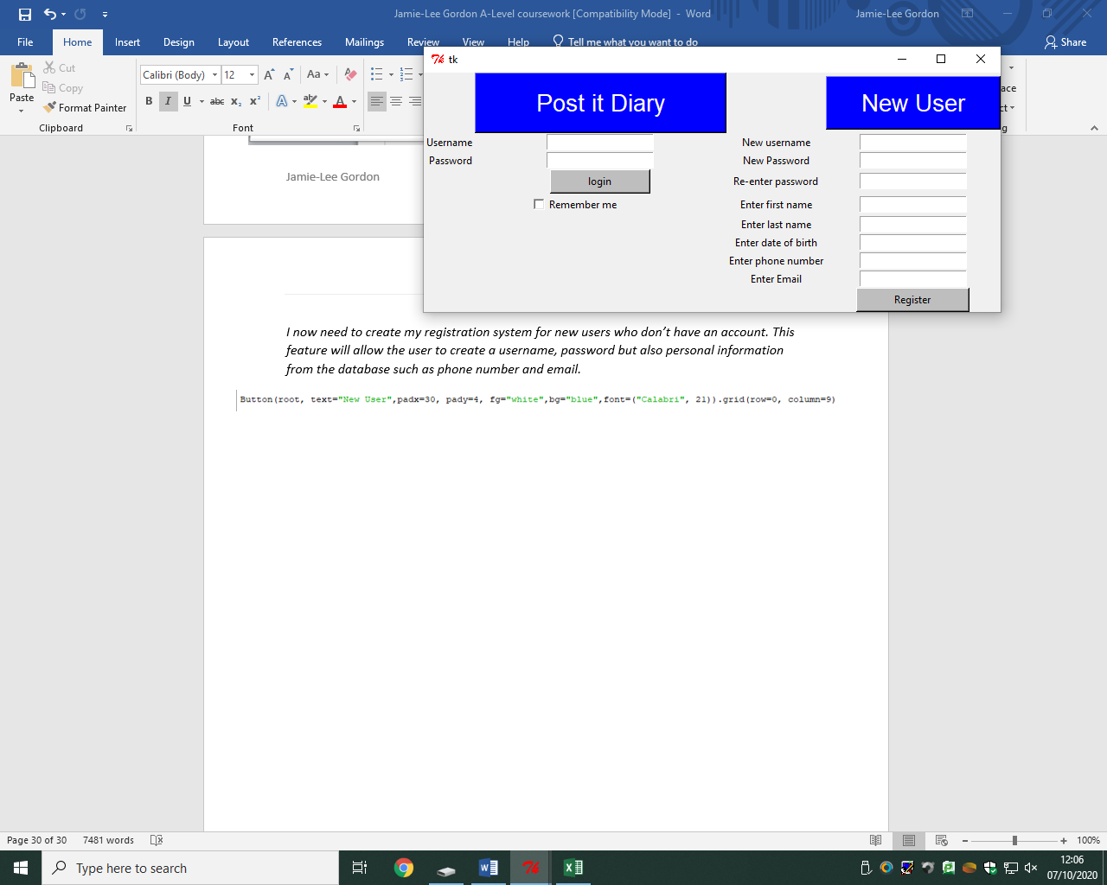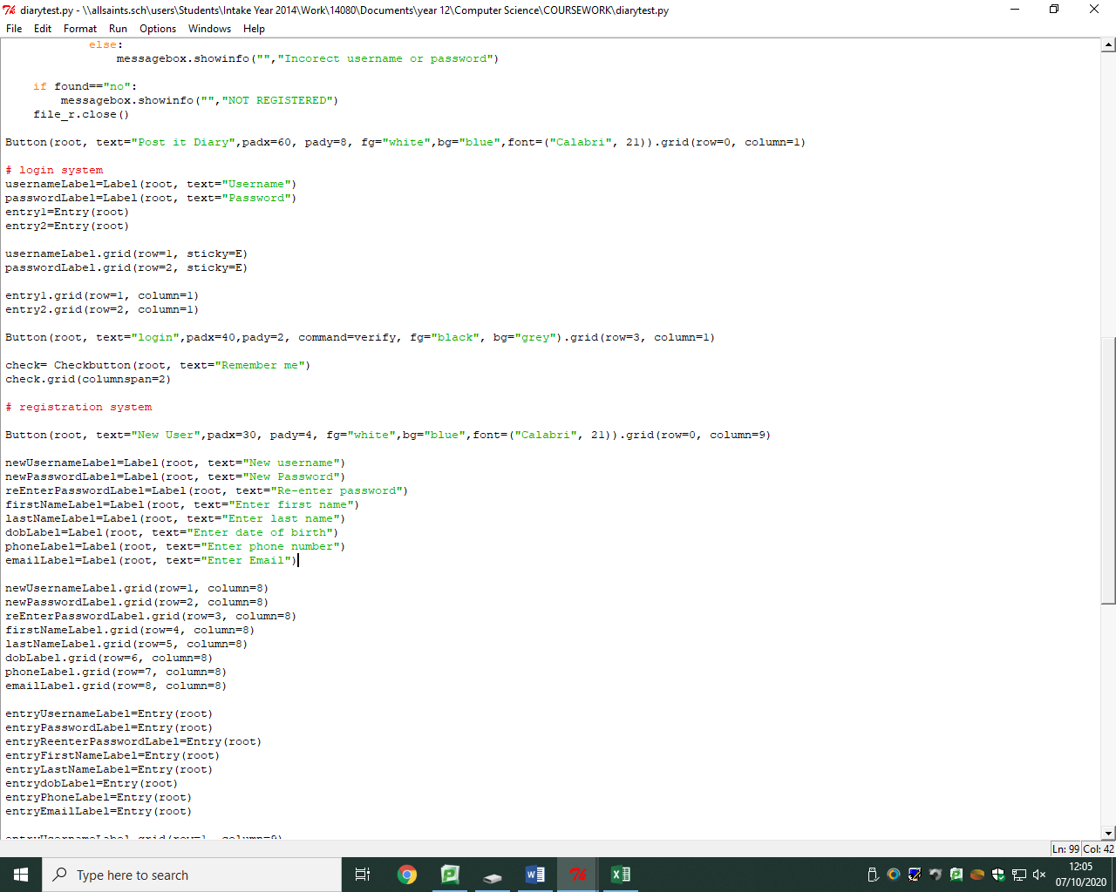*I firstly need to make another heading similar to the post it diary heading and I have again made the background blue and the text white. This new heading will be located above the entry boxes for the registration interface and clearly says in text ‘New User’ showing that if they are a new user they use this feature to make an account.*

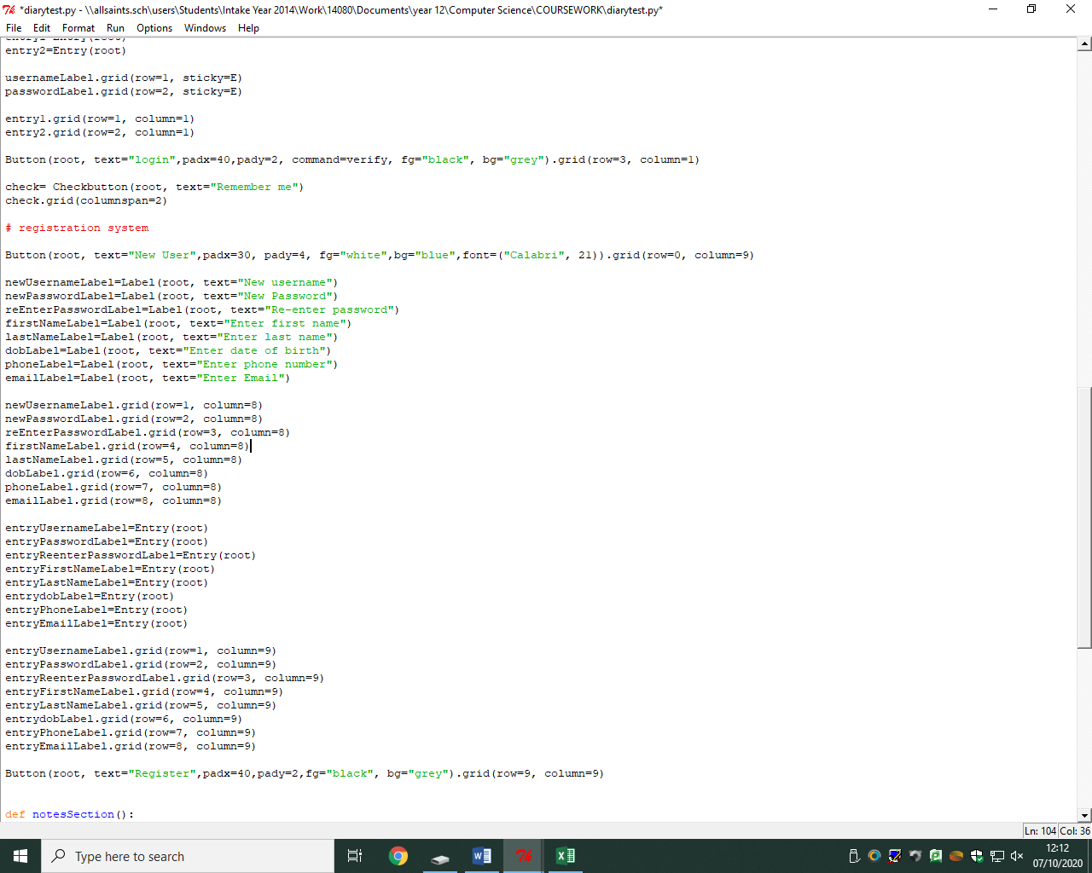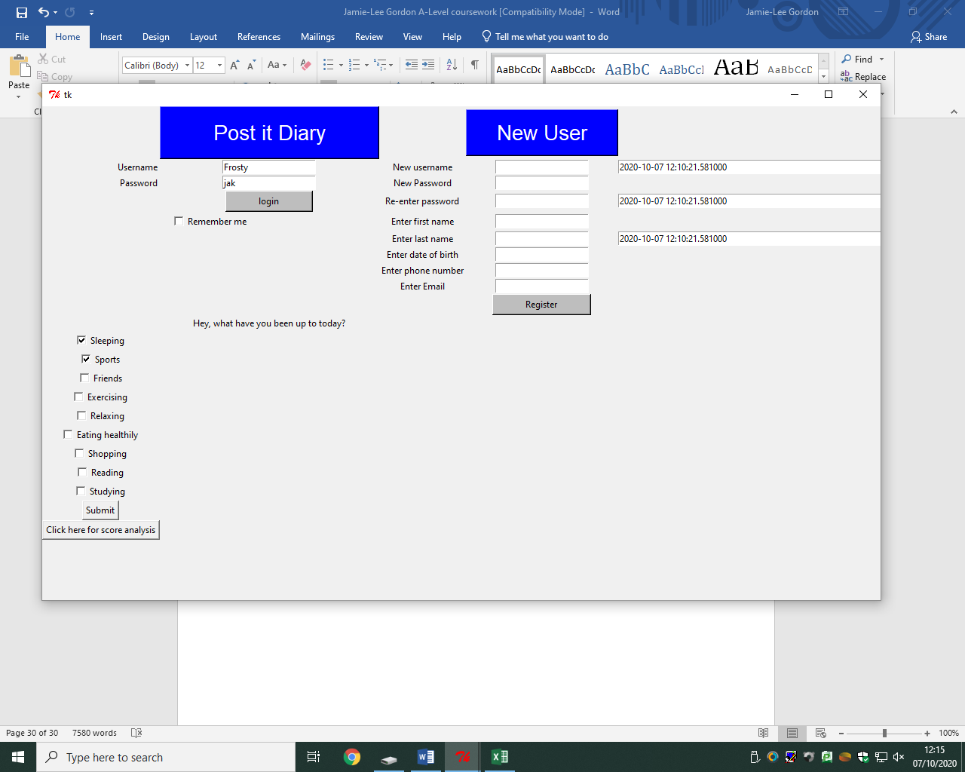*This block of code will create the labels for the user and display what the user has to enter in the entry box. I gave these labels appropriate names such as ‘New username’ and ‘Enter email’.*

*The code on the right shows how the labels are displayed to the user one underneath each other and I did this by using again the grid system with rows and columns.*

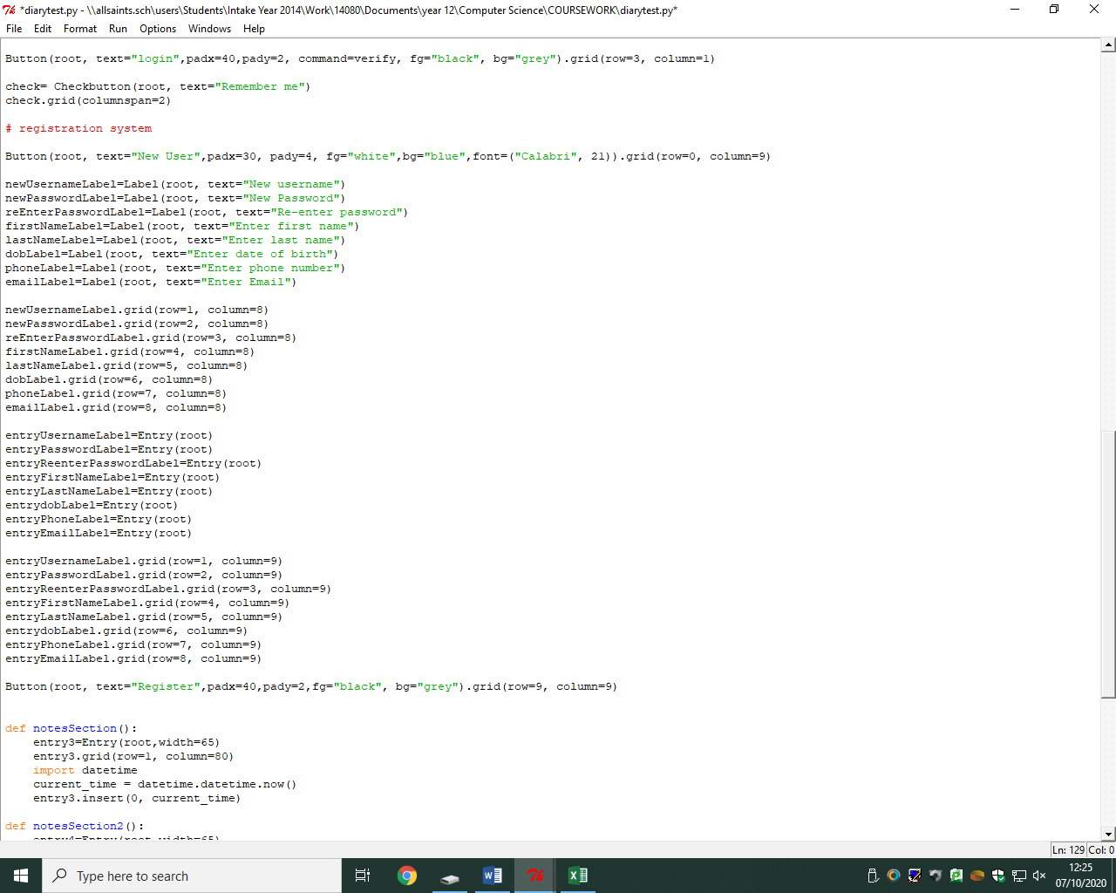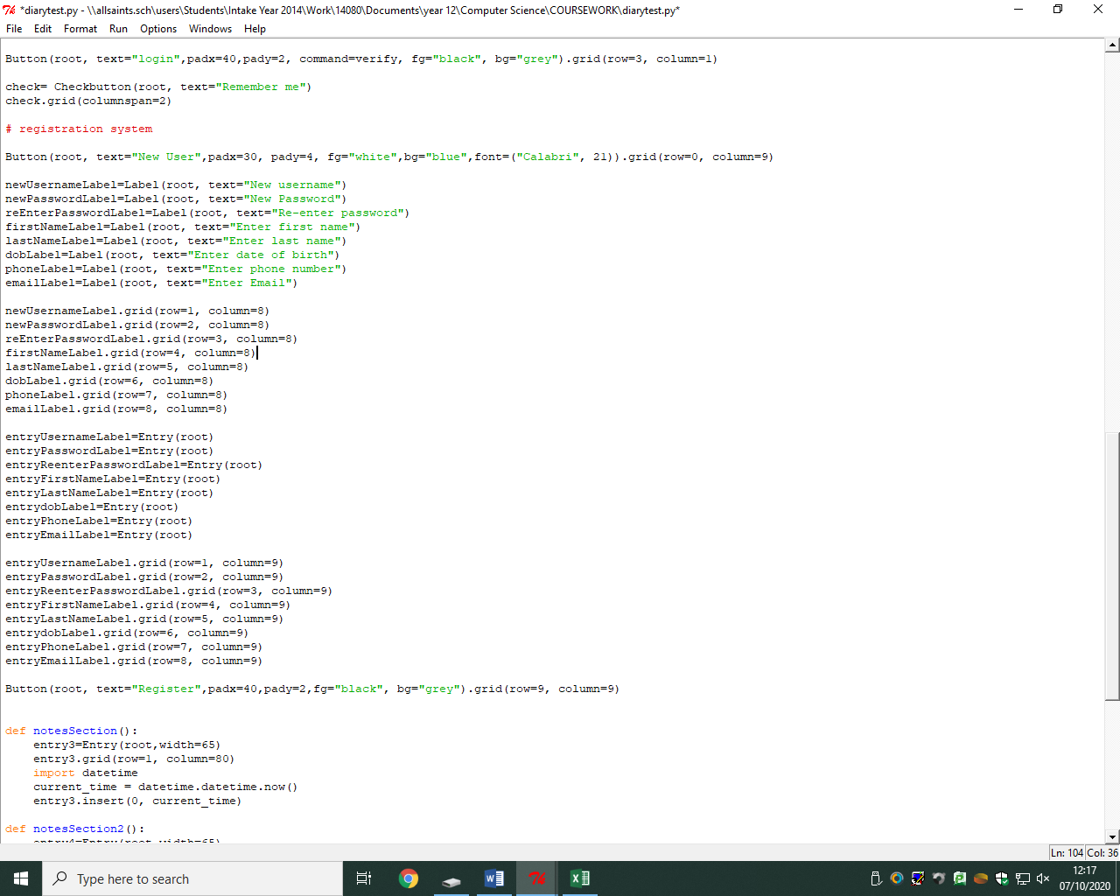*This block of code is used to create the entry boxes to allow the user to enter new registration information. I created names for each of the entry boxes such as entryUsernameLabel and put them all in root which allows the boxes to be displayed on the tkinter window. I then used the grid system to organise the GUI and placed the entry boxes next to the appropriate labels such as placing the username label and username entry box on the same row and adjacent columns.*

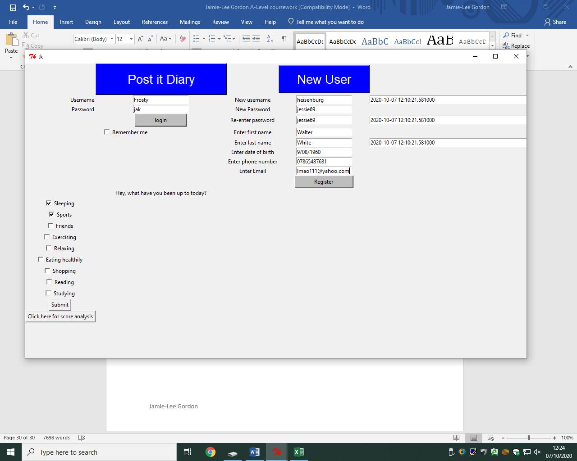

*The button created is used to submit the registration but at the moment doesn’t do anything.*

*The left screenshot shows an example of how this can be used and the next task is for me to put all the data entered by the user into the entry boxes and put into the csv excel database.*

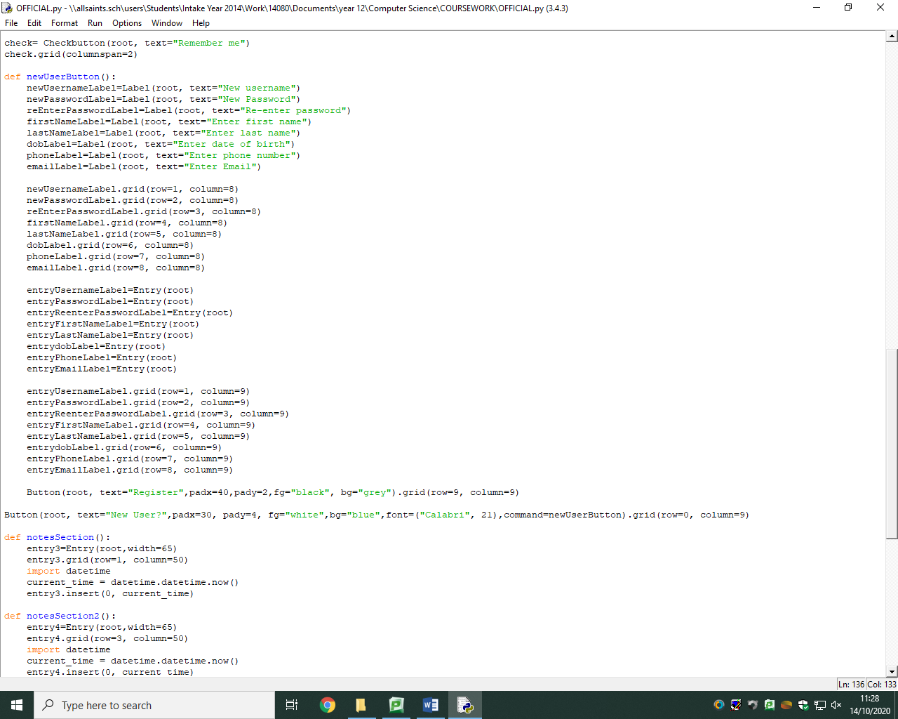*REVIEW: If the user already has an account, they obviously have no need for the registration module, where all the entry boxes for creating a new user is shown, this will take up a lot of space on the screen which may be seen as irritating to users, so I need to make my graphic user interface as user friendly as possible. To solve this, I have used to button ‘New User?’ where, if the user is new, they will press this button and the entry boxes will appear for the user to register. To implement this, I have to create a command within the parameters of the new user button and names it ‘newUserButton’.*

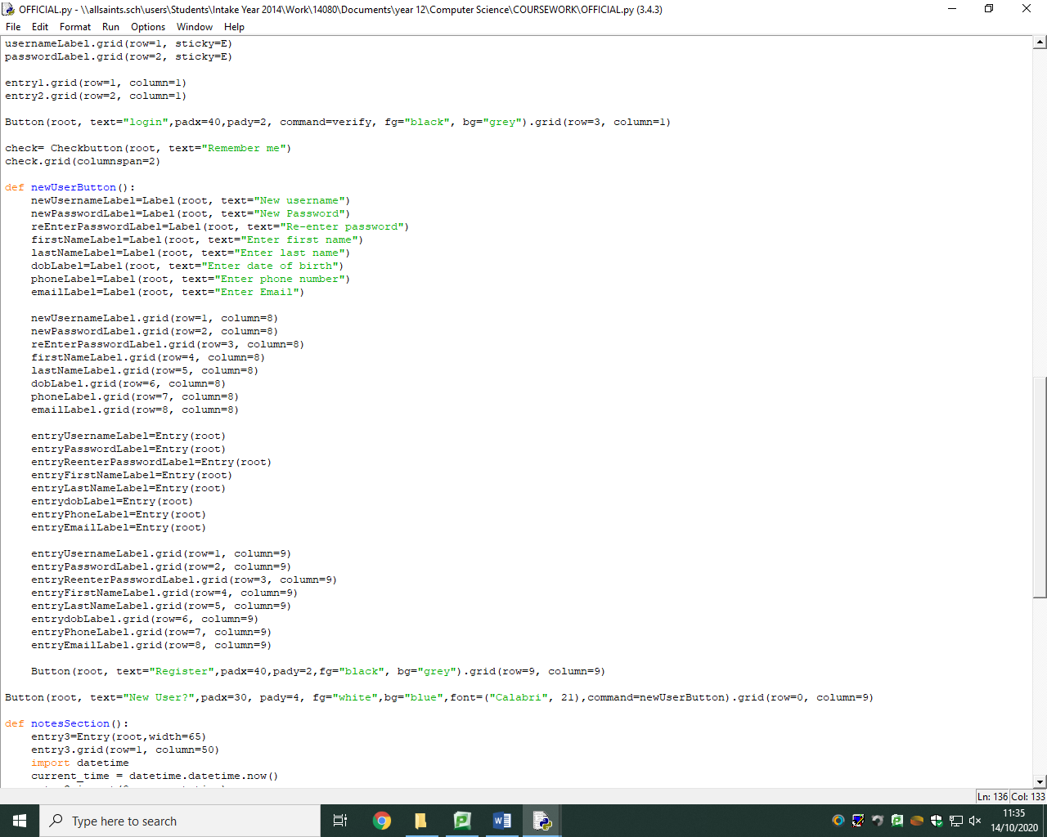

*the command I have inserted, must be a function, so I simply just defined the function and indented all the entry box code inside it. The screenshot below shows how the GUI has become much more user friendly as there is less space being taken up on display.*

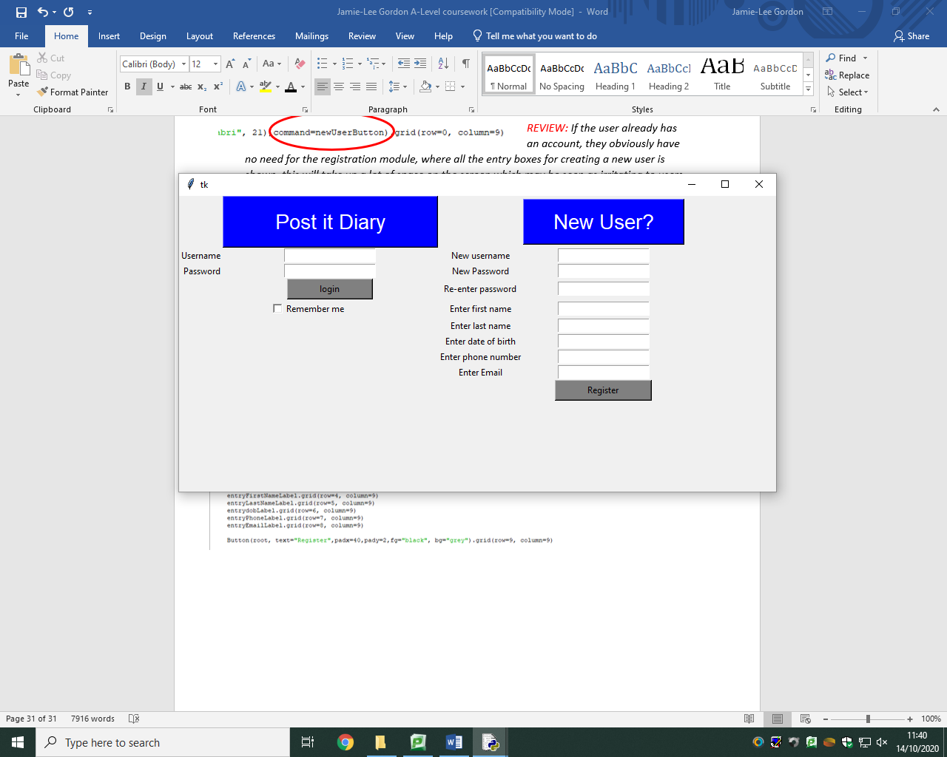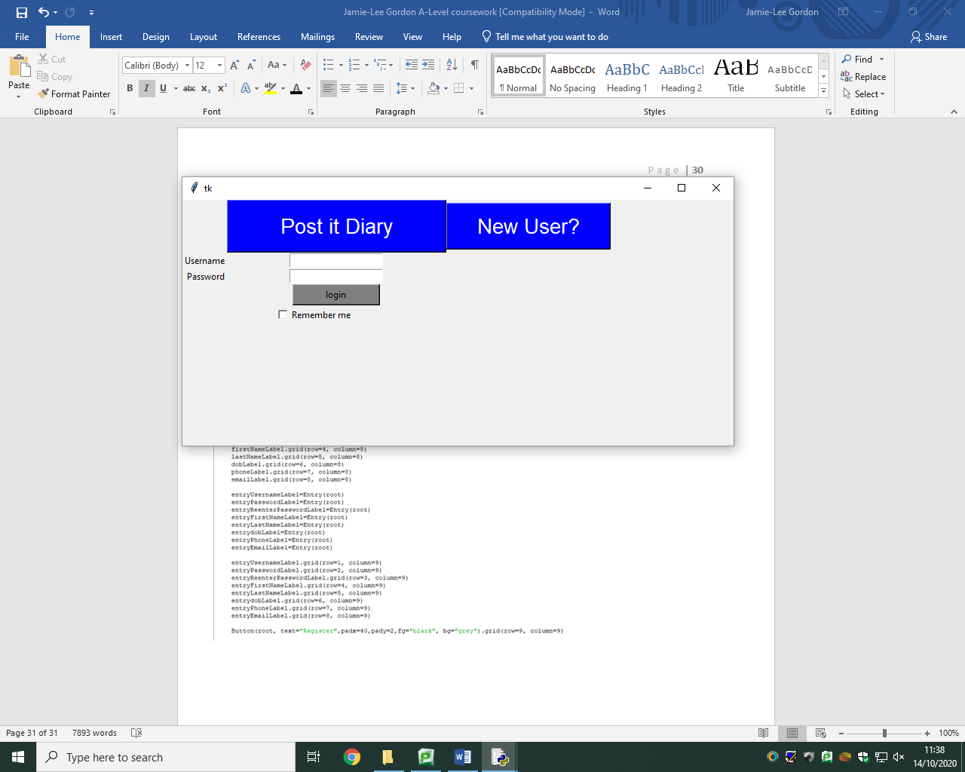

*As shown on the left, if the user is new and doesn’t have an account, they will click on the blue ‘New User?’ button and this will drop down all the entry boxes for the registration module.*

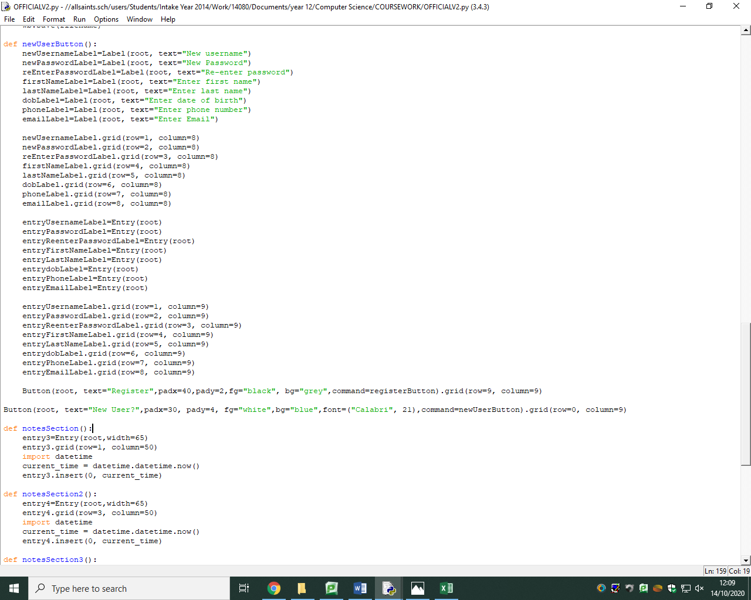*The next part of the registration module is to create a new record within the database and I will do this by amending the database. Firstly, I added a command to the register button called ‘registerButton’ where when pressed it will amend the database a crate a record.*

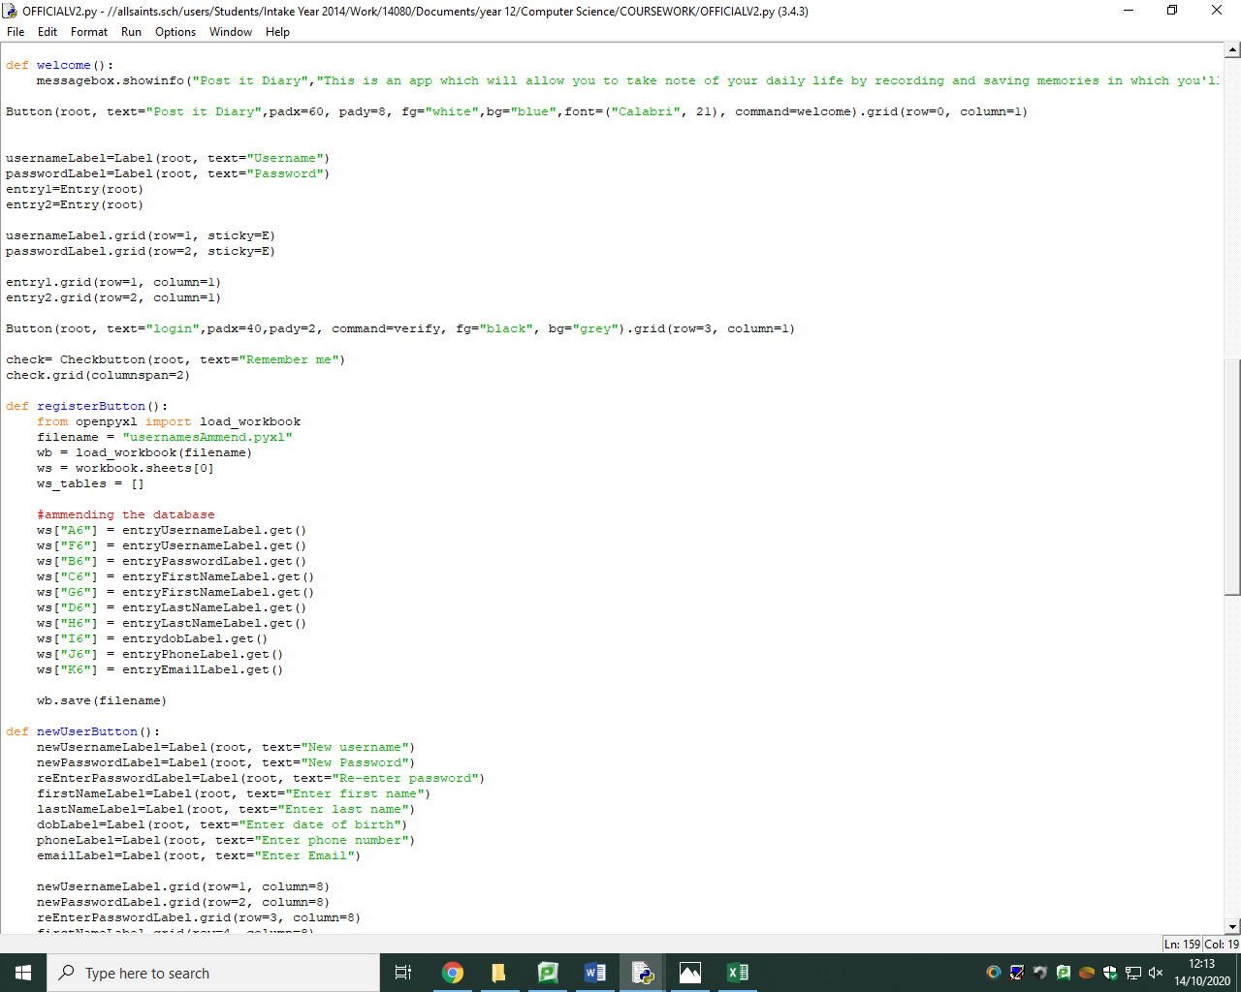*To do so, I need to open my database using workbooks where I opened my database by putting it inside the variable name ‘filename’.*

*I have used the coordinates on the excel database to add my records underneath the existing table where for example, the new username created will be amending into box A6 and the new data will be added.*

*The buttons are encapsulated so I need to access the data inserted by the user by using the getter function such as ‘entryUsernameLabel****.get****()’. The wb.save line will save the database with the new amended data.*

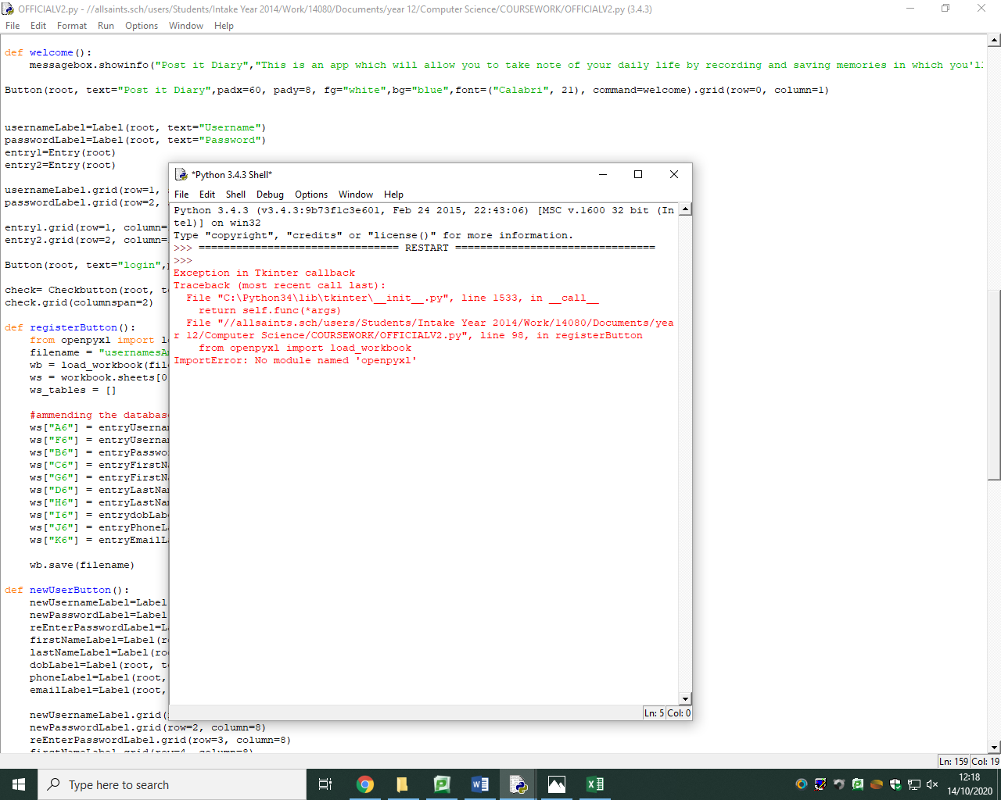*However, once I attempted to use this functionality, an import error appeared showing that it doesn’t recognise ‘openpyxl’. I am now to believe that this has occurred because of my version of python and that I need to install the module, which I am not able to do. I therefore also wont be able to amend the encrypted password into the database.*

*If this were to work, I would have added the code:*

*(pseudocode)*

*IF password == reEnterPassword:*

*Access = INFOBOX (text = “Welcome”)*

*Welcome()*

*ELSE:*

*Access = INFOBOX(text = “Password doesn’t match, please try again”*

*ENDIF*

*END*

*Stage review – registration*

***Implementation***

*Another functionality on my criteria was to create a module allowing new non-existing users to register an account by entering their details, creating a username and password and appending this data inserted by the user, into the database by creating new records underneath the existing users on the database.*

***How it has been tested***

*The way this module has been tested was by first of all making sure I am able to type data into the given entry boxes, which the user will use to enter their registry information, but to also test that when I press the ‘New user?’ button, that there is a drop down of all the entry boxes that appear to make the graphical user interface more user friendly and organised by using up less space for users who wont use this feature. I then had to test that I am able to append this data into the database.*

*I have been successful in being able to produce the entry boxes and labels which asks for the user’s input of personal data and have also been able to implement the command to the ‘New user?’ button. However, I have failed to find a solution on how to append this data into the database as I have found issues importing the* ***openpyxl*** *module and/or using ‘a’ to append using file handling techniques. Thus, I cannot append the previously encrypted password into the database.*

***Criteria met***

* *Registration (New user module)*
* *Implemented using tkinter (graphical user interface)*
* *The creation of a new record in the database*

***How I have met user requirements***

*With my main criteria being security, I have been successful in designing and implementing a module in which new users will use to type in (using the graphical user interface) their personal information and to also create a username and password. However, failing to append the user information into the database.*

***Prototype***

*This has been added to the previous prototype and should be the last functionality that is to be added and I have now produced my final prototyped solution.*

*As I have went along in the implementation process after every module that I have produced I have then gone on to put them together to produce multiple prototypes. I have used decomposition to break down my post it diary app into small tasks and modules which I have implemented individually instead of concentrating on the solution as a whole and have successfully devised a solution.*

**Testing to inform evaluation**

*I will now go onto testing each condition, input and scenario of my solution. All conducted tests will be written in the table below. I will test the solution in chronological order.*

|  |  |  |  |  |
| --- | --- | --- | --- | --- |
| Test Number | Test | Input/Condition | Expected Result | Actual Result |
| 1 | Program is run and a GUI is displayed | Start/run program | Once run a GUI is displayed and allow user interaction | As expected |
| 2 | Button is displayed showing the name of the app ‘Post it diary’ |  | Button packed on screen and displayed | As expected |
| 3 | Post it diary button displays info box on what the purpose of the program is. | Press ‘Post it diary’ button | Info box displayed | As expected |
| 4 | Entry boxes are displayed asking for username and password to login | User can input characters into entry boxes | Entry boxes displayed | As expected |
| 5 | Database is produced containing tables with existing user information and usernames and passwords |  | Records of users produced | As expected |
| 6 | Main program is able to read database | Read | Read database | As expected |
| 7 | ‘login’ button is displayed’ and if username and passwords match from app to database access is granted | User input username and password | Info box ‘Welcome’ and grants access once login button is pressed | As expected |
| 8 | Username and passwords don’t match | User input incorrect username and password | Info box ‘Not registered’ and access isn’t granted | As expected |
| 9 | Username matches but password is incorrect | Correct username and incorrect password | Info box ‘incorrect username or password’ | As expected |
| 10 | ‘Remember me’ checkbox that keeps user logged in if they exit and come back at a later date |  | Only have to login once as the app will remember me | Not working, code hasn’t been implemented as I am unsure of how to make this feature |
| 11 | New user button is displayed |  | Display button | As expected |
| 12 | ‘New user’ is pressed and new user module is run as a drop down of entry boxes are displayed asking for user input |  | Entry boxes and labels displayed asking for user input for a new user | As expected |
| 13 | User is able to input data into the entry boxes | User information | Can type into entry boxes | As expected |
| 14 | Register button is displayed |  |  | As expected |
| 15 | When register button is pressed, a new record will be appended in the database and all data inputted by the user is written under the appropriate columns and tables |  | New record created in database | Not working, unable to find solution on how to append database using user input from main program |
| 16 | Password is encrypted | Caesar cipher | Encrypted password | As expected |
| 17 | The encryption module allows for numbers to be encrypted | Caesar cipher | Encrypted password | Not working, can’t find solution on how to encrypt numbers. |
| 18 | The encryption module allows for all characters to be encrypted such as: ! ? / ‘ | Caesar cipher | Encrypted password | Not working, can’t find solution on how to encrypt every keyboard character. |
| 19 | The random module is working and produces a random number up to 26 which will be used as the key for encryption |  | Random number 1-26 | As expected |
| 20 | The new encrypted password is written into the database and appended under the appropriate column and table | Database | Encrypted password is appended | Not working, as I cannot find solution on how to append data into the database |
| 21 | Label text ‘Hey, what have you been up to today?’ |  | Label displayed on screen | As expected |
| 22 | Multiple check buttons displayed with corresponding names of activities such as ‘sport’ |  | Check buttons and corresponding labels displayed | As expected |
| 23 | ‘Submit’ button is displayed. The user will tick appropriate checkboxes and once pressed, algorithm will calculate an average score | User selects appropriate checkboxes | Average score is calculated | Not working, problem with my code |
| 24 | Once average score is calculated, the score is displayed on the screen with a message using a label |  | Average score is displayed to user with message | Not working, as average score code isn’t working |
| 25 | Score analysis button is displayed |  | Button displayed | As expected |
| 26 | When score analysis button is pressed, an info box will display what each score means from 1-3, 4-6 and 7-10 | Button pressed | Info box displayed | As expected |
| 27 | ‘Here is your post it notes’ label is displayed |  | Label displayed | As expected |
| 28 | 3 entry boxes displayed for use of post it notes | User can type in entry boxes | Entry boxes displayed | As expected |
| 29 | Current time module |  | Current type is produced | As expected |
| 30 | The current time is displayed inside the post it not entry boxes |  | Current time is inside entry boxes | As expected |
| 31 | ‘Diary mode’ button is displayed |  | Button is displayed | As expected |
| 32 | When ‘diary mode’ button is pressed, large text editor pops up and displayed to the user | User can type in the text editor | Text editor displayed | As expected |
| 33 | Text typed by the user inside the text editor can be saved |  | Saves text in text editor | Not working, as I am undergoing issues implementing this |
| 34 | Can add voice notes | voice | Voice notes can be recorded | Not working, as I am unsure on how to implement this feature |
| 35 | Can add JPEG images and pictures | images | Images can be inserted | Not working, as I am unsure on how to implement this feature |
| 36 | Can add an MP4 video | Video | Videos can be inserted | Not working, as I am unsure on how to implement this feature |
| 37 | Can access app using the cloud or via internet |  | App can be accessed via cloud or internet | Not working, as I am unsure on how to implement this feature |

***User testing***

Now that I have tested my solution I need to find out if my solution was successful and served its purpose of a diary app. I will do this by creating a questionnaire for users to complete which will help me identify if it was successful and any necessary user feedback. Is also important that I find out if users believe the application was user friendly and secure as one of my main targets were to make sure it is viable for children but also guaranteeing security using a username and password.

|  |  |  |  |
| --- | --- | --- | --- |
| *Test number* | *Question* | *Answer (Yes/No)* | *Comments and recommendations* |
| *1* | *Are you able to open the application?* |  |  |
| *2* | *Does the graphic user interface run and display?* |  |  |
| *3* | *Are you able to type in entry boxes?* |  |  |
| *4* | *Are you able to login to your existing account?* |  |  |
| *5* | *Does the ‘remember me feature work?* |  |  |
| *6* | *Are you able to register a new account?* |  |  |
| *7* | *Are you able to grant access?* |  |  |
| *8* | *Are you able to select check buttons to appropriate activities?* |  |  |
| *9* | *Is an average score displayed to you when you press submit?* |  |  |
| *10* | *Does a score analysis appear when you press the score analysis button?* |  |  |
| *11* | *Are there 3 post it note entry boxes for you to enter data?* |  |  |
| *12* | *Is the current time displayed inside the post it notes?* |  |  |
| *13* | *Does a text editor appear when you press ‘Diary mode’ button?* |  |  |
| *14* | *Can you save your notes?* |  |  |
| *15* | *Can you insert images?* |  |  |
| *16* | *Can you record voice notes?* |  |  |
| *17* | *Can you insert videos?* |  |  |
| *18* | *Is the GUI user friendly?* |  |  |
| *19* | *Did you find the application simple to use?* |  |  |
| *20* | *Is it easy to navigate through the app?* |  |  |
| *21* | *Do you think the app serves its purpose of a diary app?* |  |  |
| *22* | *Is the application secure?* |  |  |

**Final code**

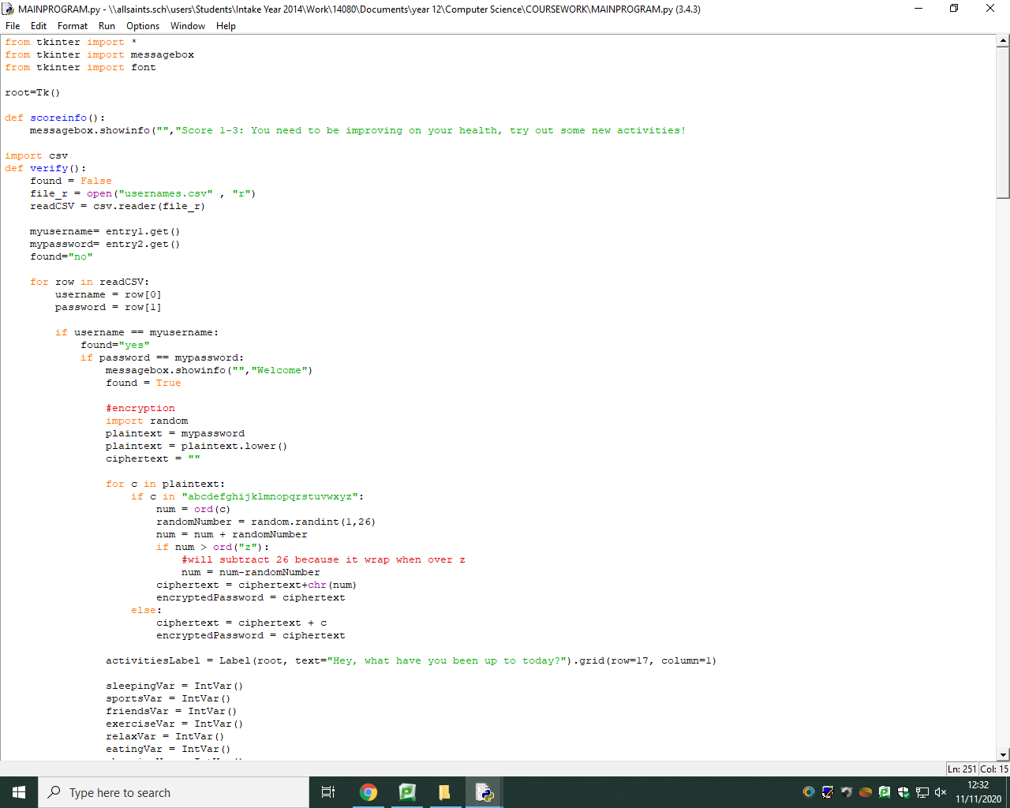

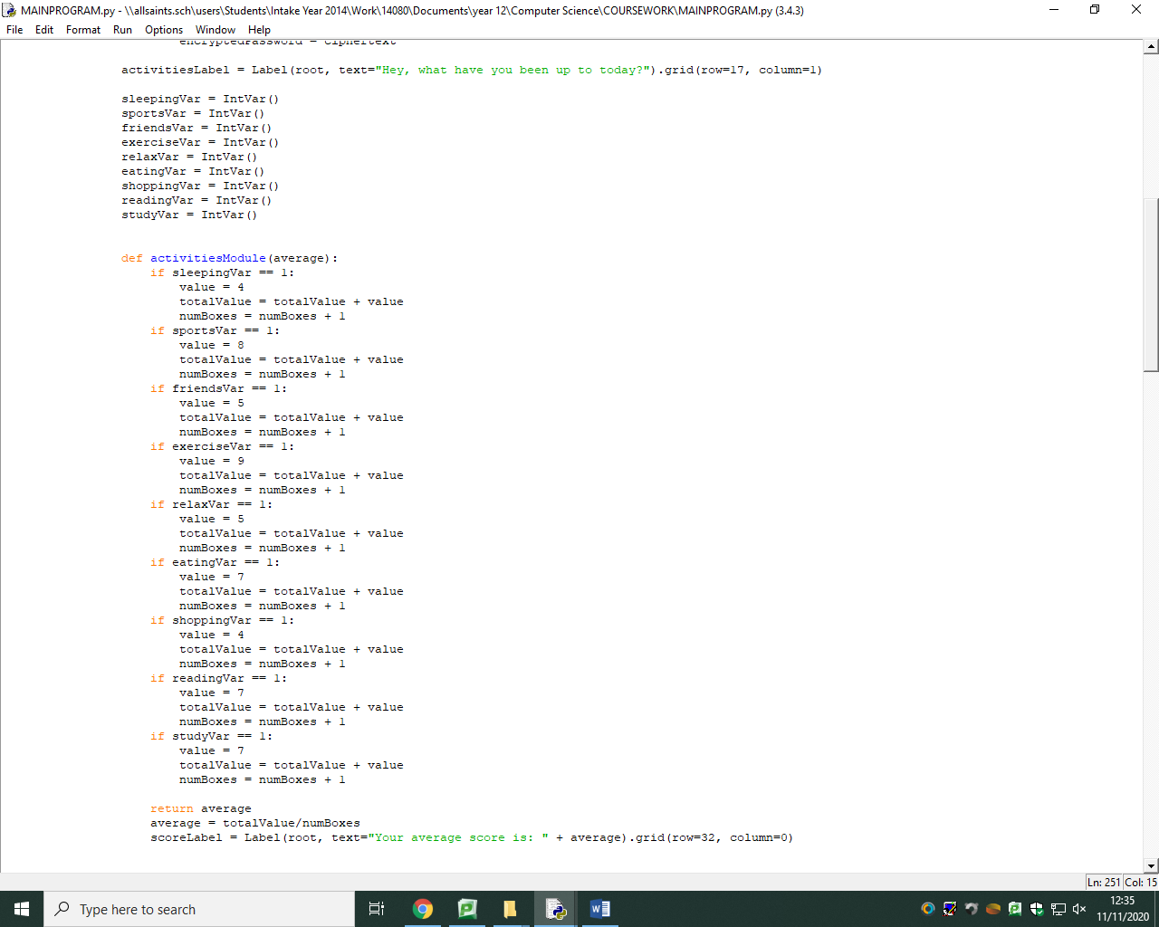

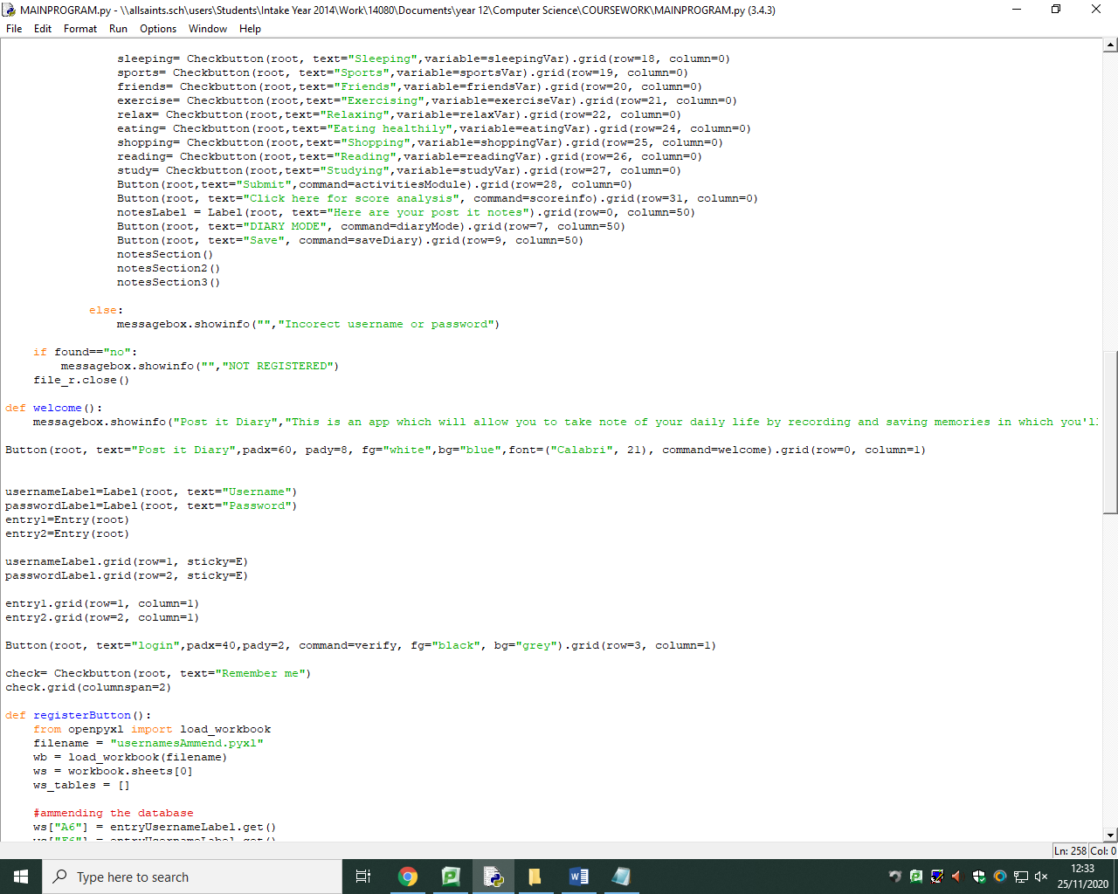

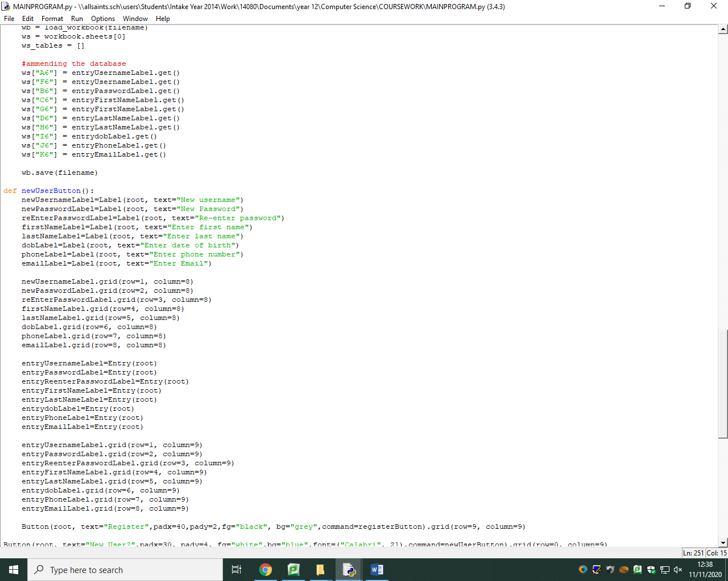

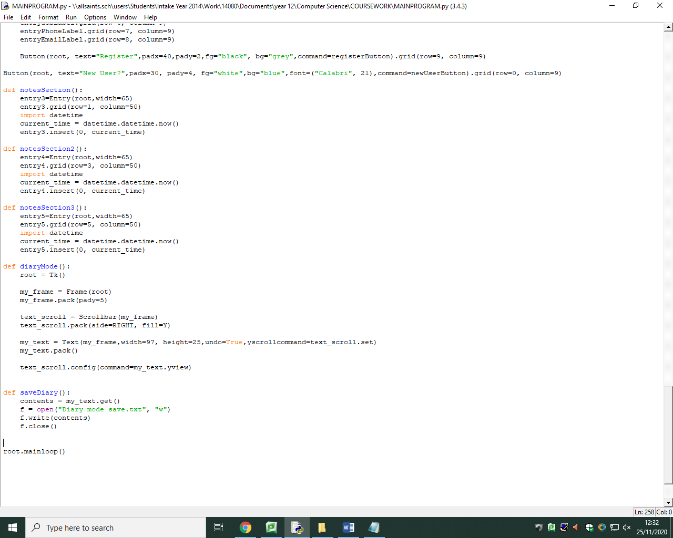

***Screenshots of final solution***

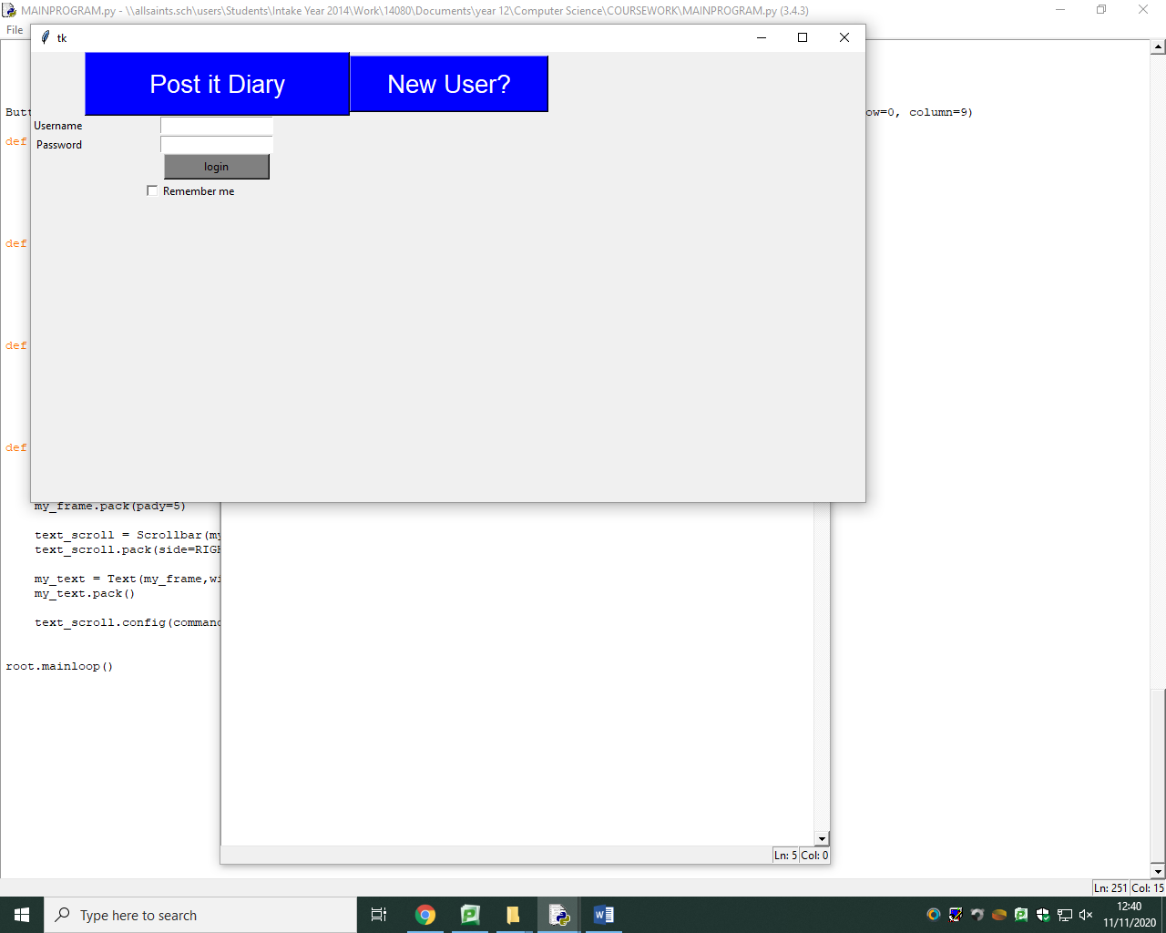

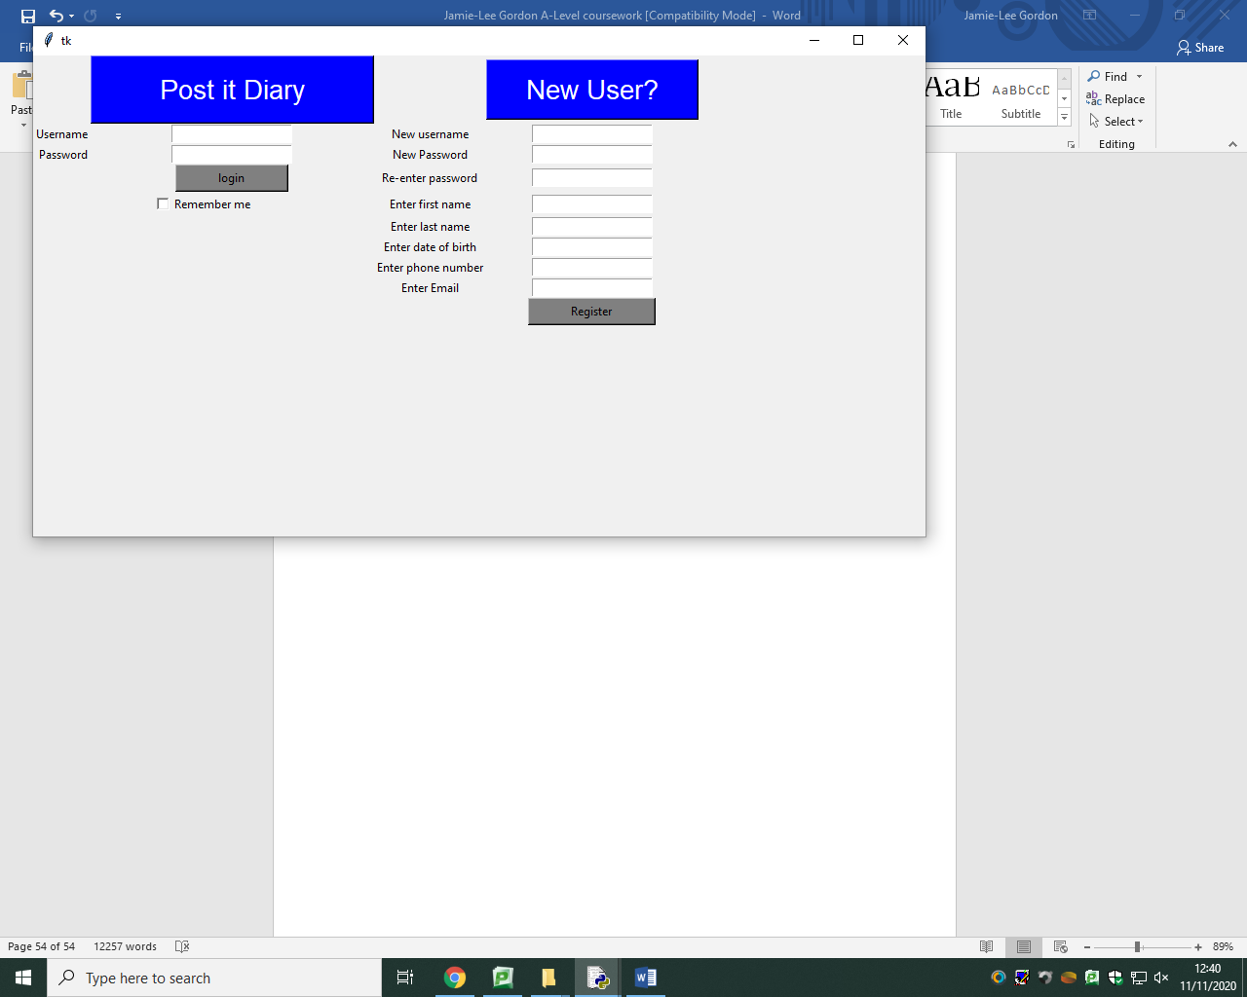

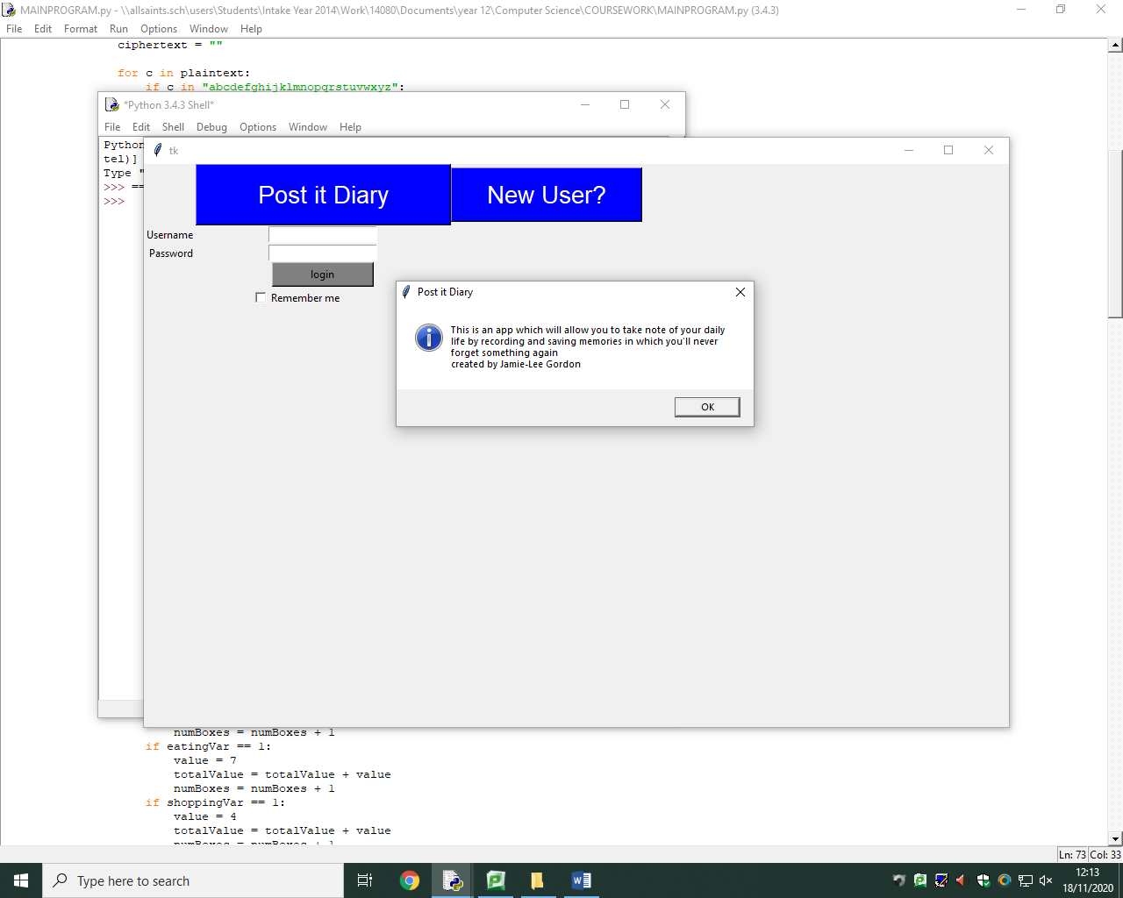

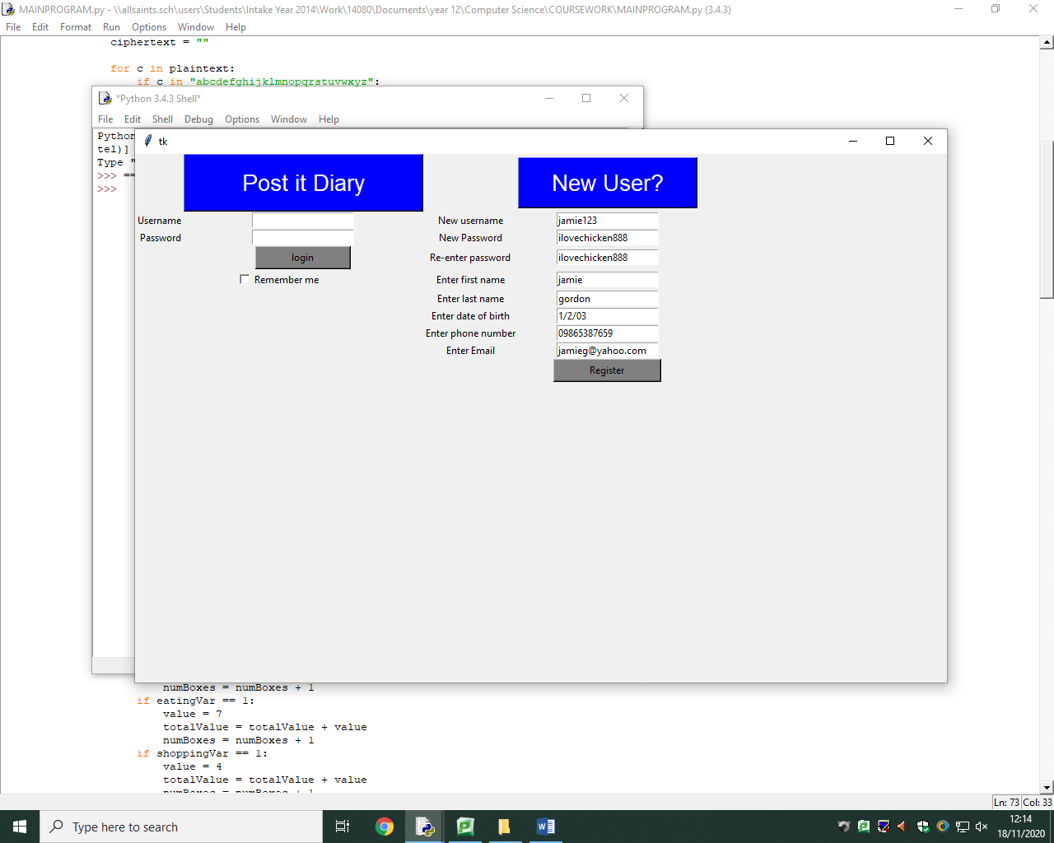

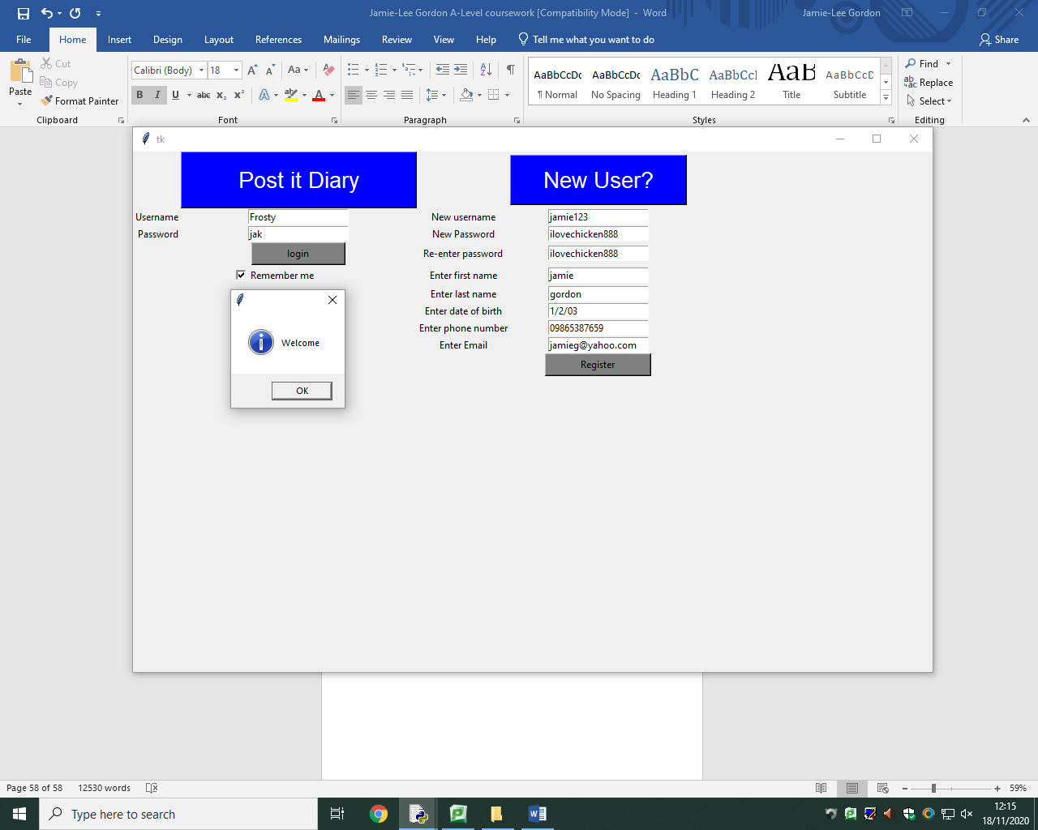

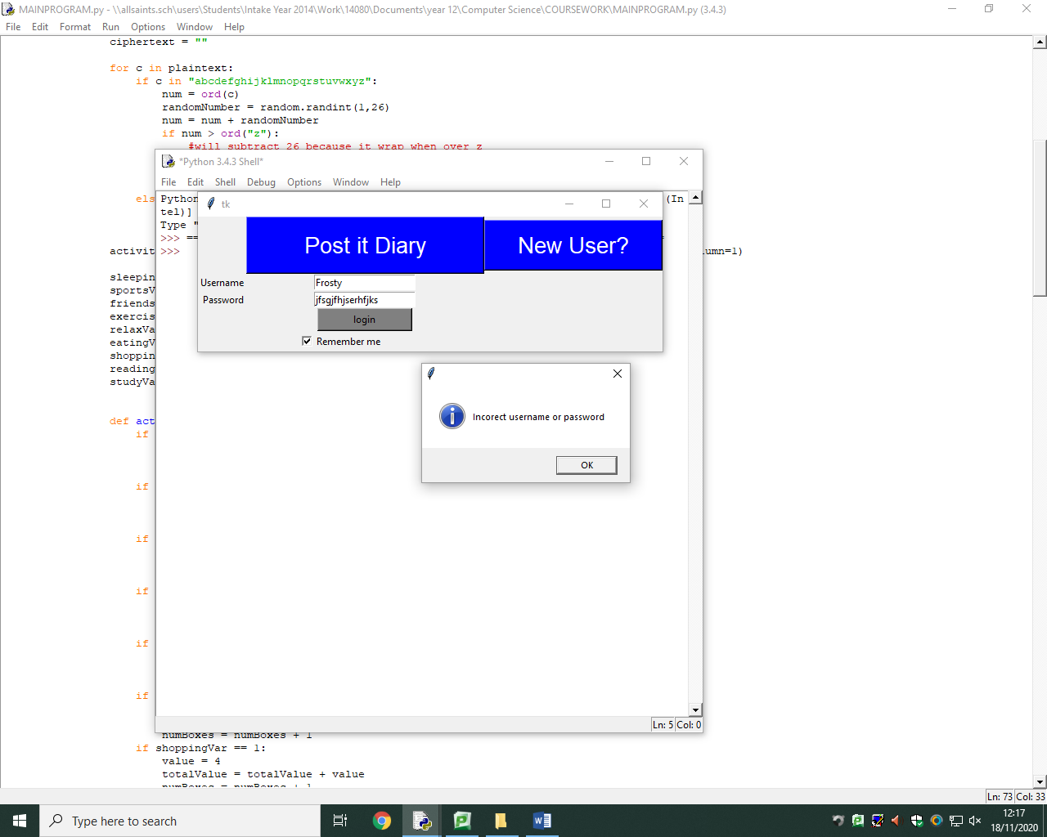

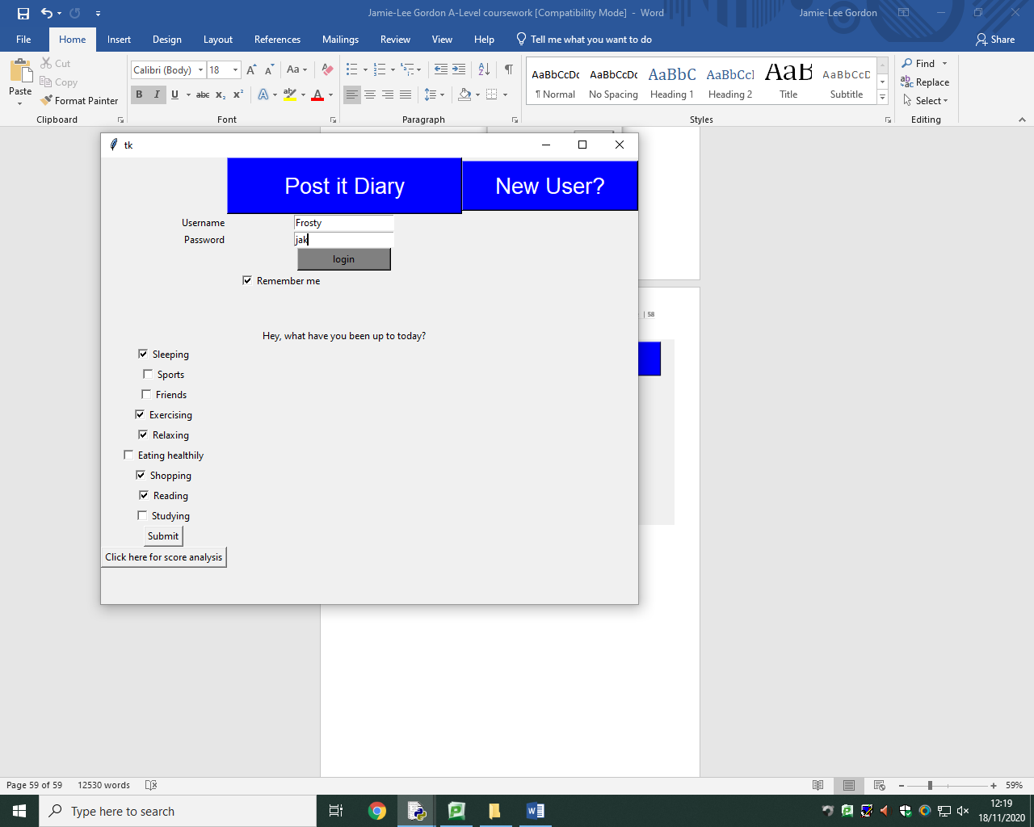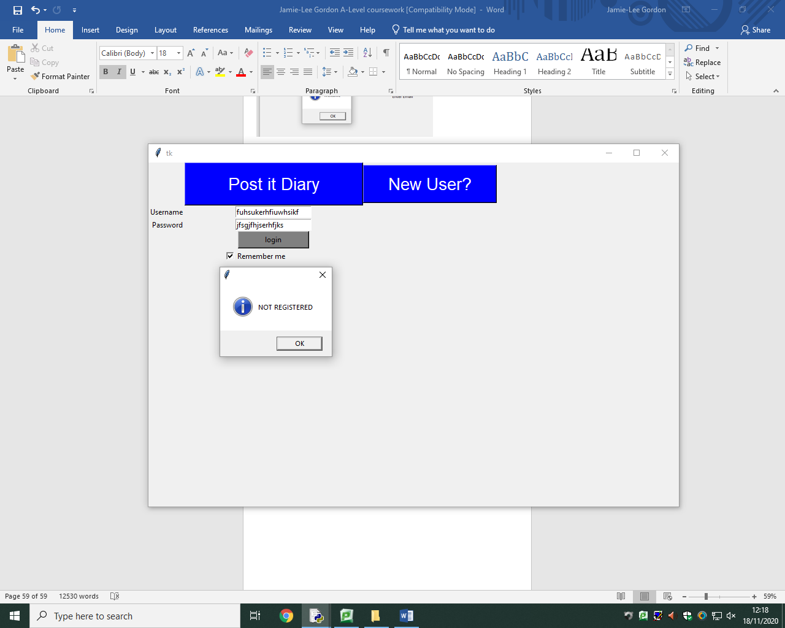

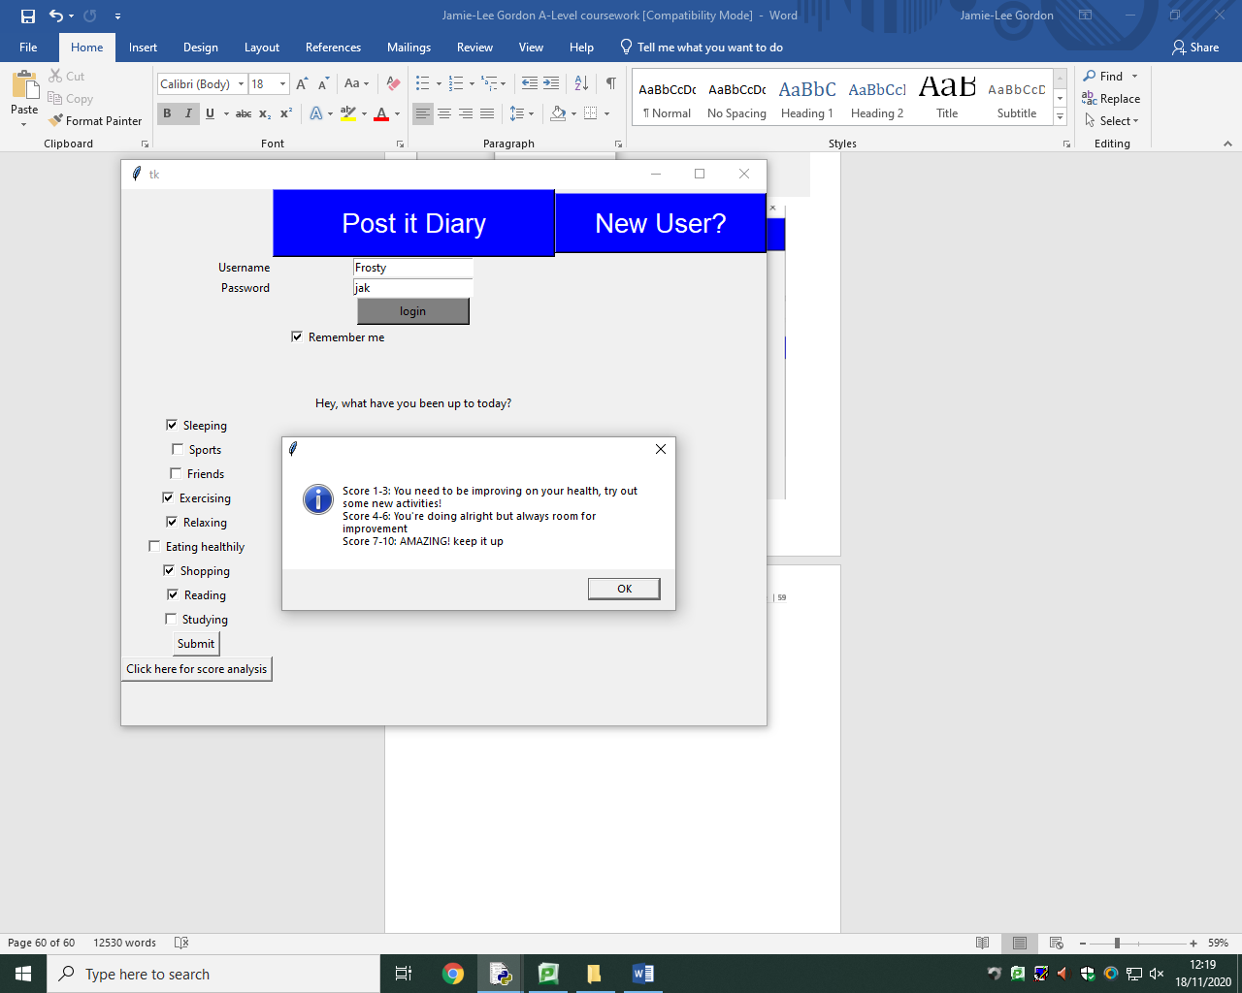

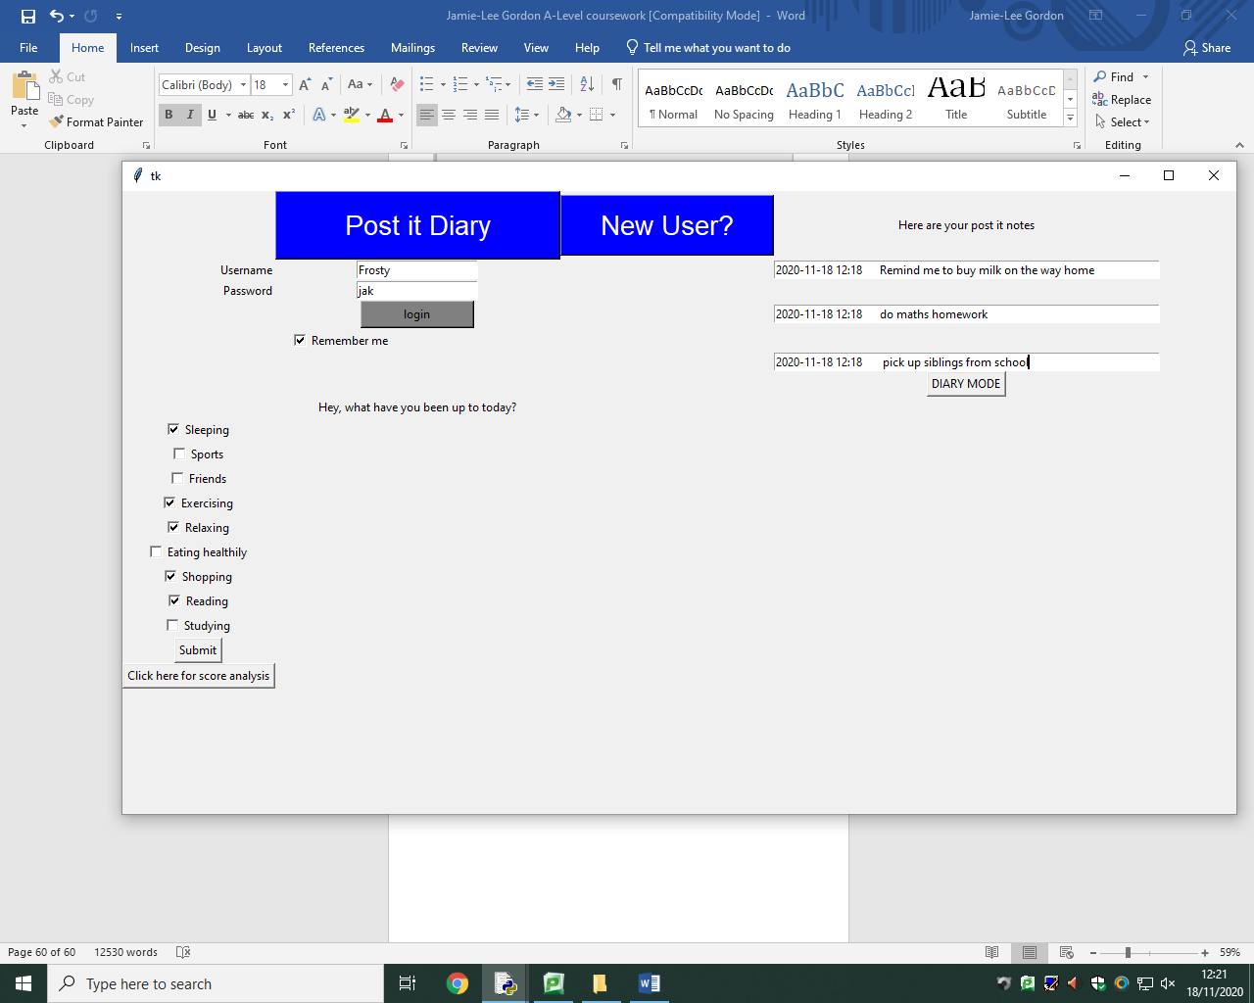

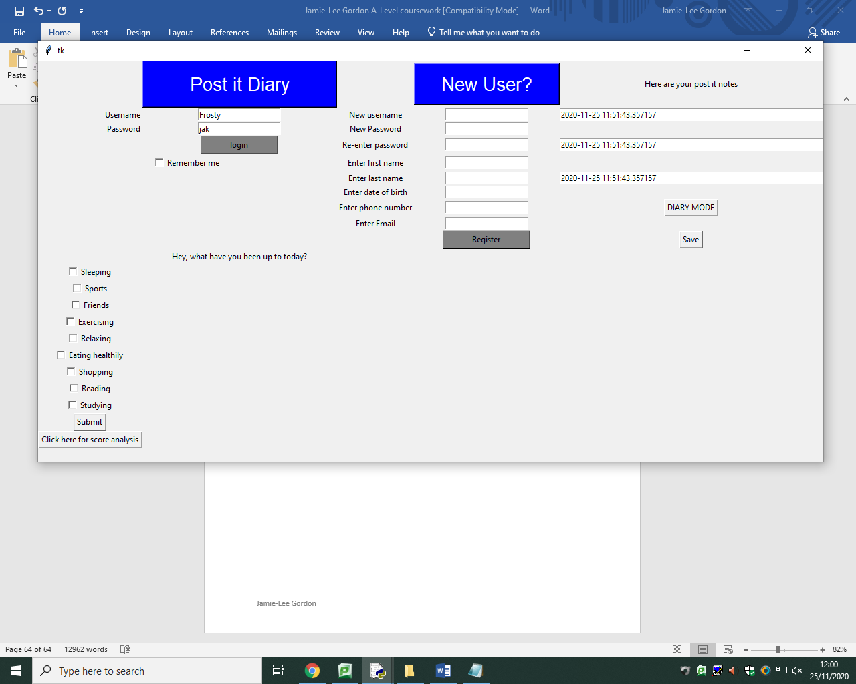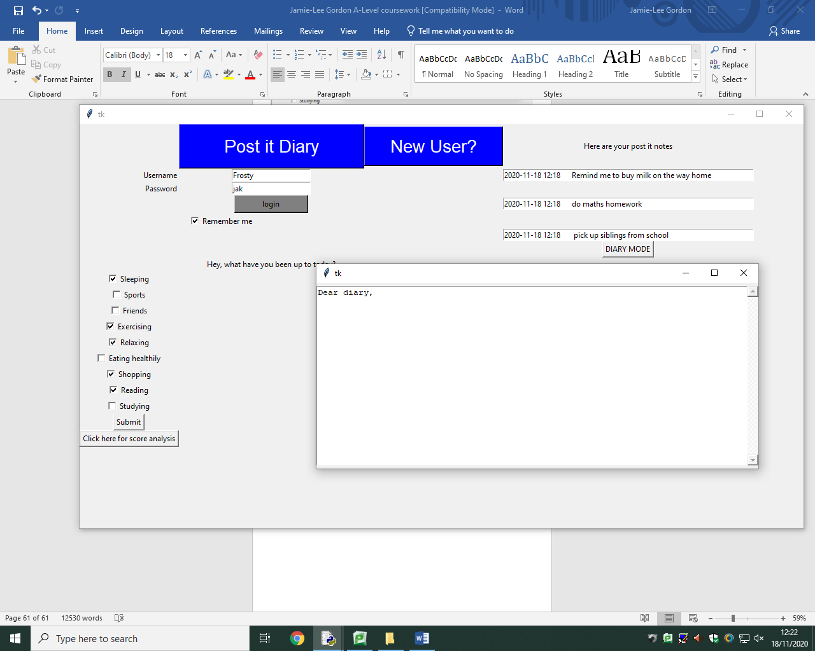

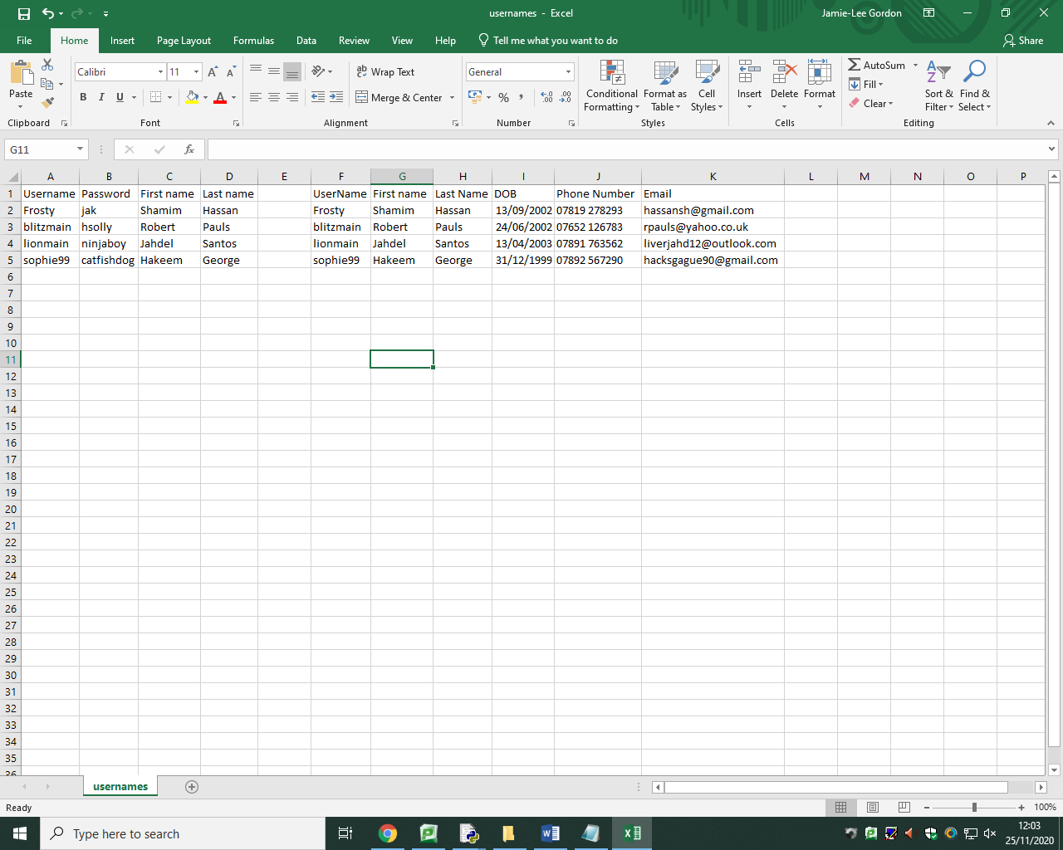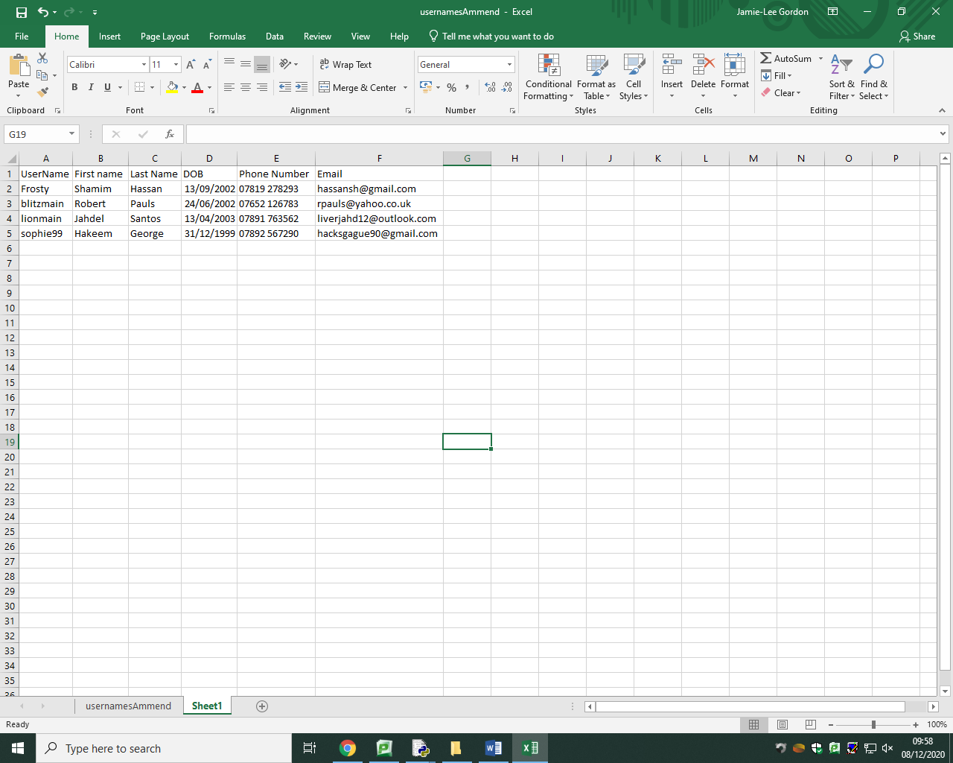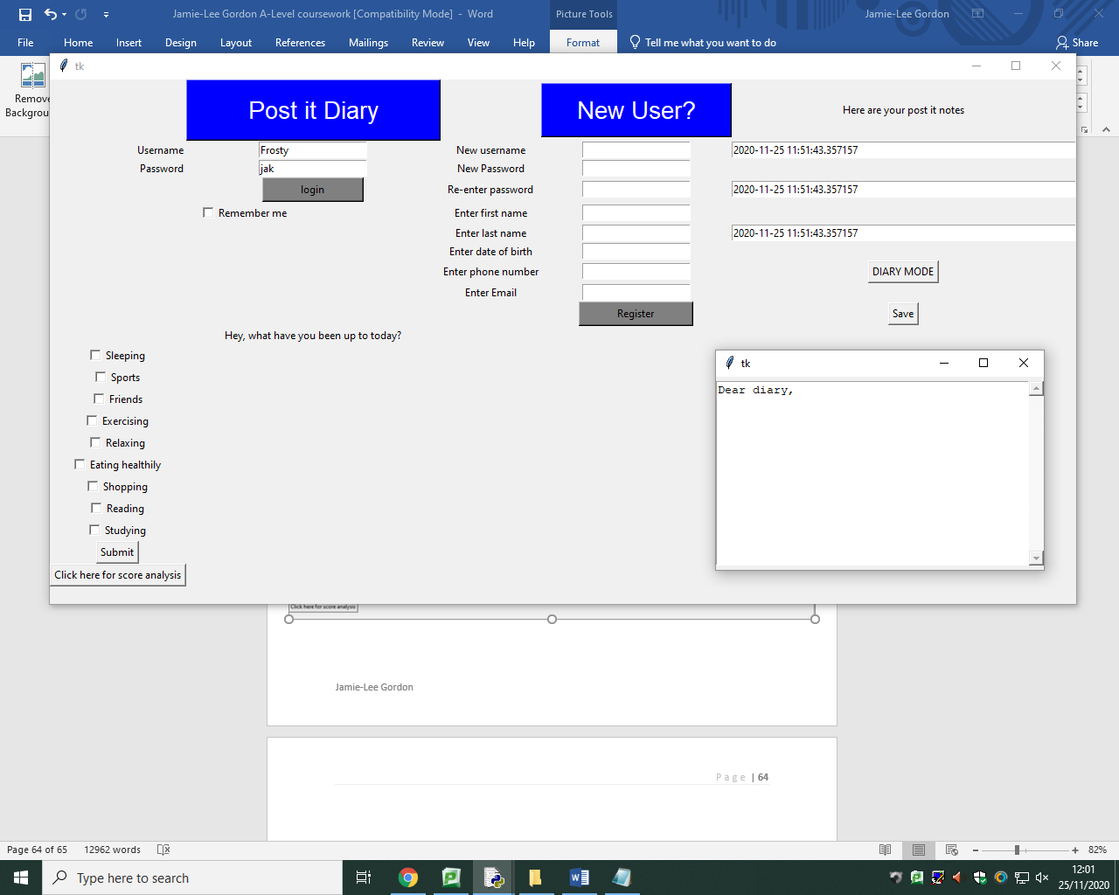

**Evaluation to solution**

**Meeting the success criteria**

|  |  |
| --- | --- |
| Criteria | Has it been met? |
| Graphical User Interface (GUI) | Yes |
| Database of user information | Yes |
| Database has been normalised | Yes |
| Login system | Yes |
| Login with existing account | Yes |
| Enter details for a new user | Yes |
| Create a new account by appending database | No |
| Allow three attempts of guessing password | No |
| Password is encrypted | Yes |
| ‘Remember me’ feature | No |
| Activities feature | Yes |
| Activities feature will calculate a mean average | Yes |
| Average score can be displayed | No |
| Activities feature can calculate a mean average for the week | No |
| Average score for the week can be displayed | No |
| Score analysis | Yes |
| Notes feature | Yes |
| Notes feature contains current date/time | Yes |
| Diary feature | Yes |
| Save notes from diary | No |
| Add pictures e.g. JPEG | No |
| Add videos e.g. MP4 | No |
| Record and insert voice notes | No |
| Categorise notes | No |
| Mood feature (how someone is feeling 1-10) | No |
| Simple GUI | Yes |
| Easy to navigate | Yes |
| Clear buttons and labels | Yes |
| Can add text to entry boxes | Yes |
| Save notes | No |

Evidence

**Login system**

This is the graphical user interface for my login system. I have used entry boxes, labels and buttons to produce this solution where the user will either enter their details in the entry boxes on the left if they are an existing user, or use the entry boxes on the right if they don’t have an existing account.

**Limitations**

With regards to the new user feature, I have not been successful in implementing a solution to appending the database with writing the entered details by the user, to rectify this I would need to possibly find another method of writing the data from the entry boxes into the database.

I have also not been able to implement the ‘remember me’ feature as I am unsure to how I would go about implementing this feature.

**Measurability of success**

My login system has definitely ended up successful as the fundamental requirement of the login system was achieved using the graphical user interface as the user had to insert the correct username and password that matched accordingly with the database to grant access and if they don’t match, user won.t be granted access. However, I was not successful in completing the new user feature and also the ‘remember me’ functionality.

**Activities module**

This is the final solution of the activities module. This feature allows the user to select relevant checkboxes which applies to activities they may have conducted throughout their day. The algorithm will then calculate an average score out of 10 to rank how healthy the activities have been. It has been successful and implemented this feature, again, using a graphical user interface.

**Limitations**

A limitation of my solution is that I haven’t been successful in being able to display the average score calculated by the algorithm. I have attempted to do this using labels but it can’t seem to work. Another limitation of this is that I have not been able to calculate an average score for the week; I would have done this by saving each average score each day and then divide by 7.

**Measurability of success**

The activities module was successful however the end result had many limitations due to issues in the code or algorithm with issues I have not been able to rectify such as displaying the average score and also calculating an average for the week.

**Post it note module**

This is the final solution to the post it notes feature of my application. I have been fully successful in implementing this feature where I have created entry boxes in which contains the current date and time.

**Limitations**

There are no limitations and have met all required success criteria for this feature

**Measurability of success**

This feature has been extremely successful and has met the success criteria of allowing users to enter small notes like a physical pot it note to type in for example reminders. I have been successful in providing the exact date and time which meets my criteria.

**Diary module**



The diary module has been successfully created using a text editor within the graphical user interface where the user is able to enter large amounts of text in the form of a traditional diary.

**Limitations**

A limitation of this is that I have not been able to develop a system in which will categorise user notes e.g. (notes, reminders, school notes, shopping list). I have also not been able to allow the user to customise the text editor and personalise their notes using formatting tools such as changing the font or colours.

**Measurability of success**

The diary module has been successful in meeting the success criteria of allowing the user to

insert large amounts of text where the user will use this feature for the use of a traditional diary.

Usability features





This is the first implemented usability feature which when the large blue ‘Post it diary’ is pressed, this information box appears.



Another implemented feature is that the drop down menu for the new user feature will only appear when the blue ‘New user?’ button is actually pressed. This will take up less space on the screen for users who won’t require this feature.





The next usability feature I have created is in the login system where if the username AND password match, the information box will display ‘welcome’ and grant access. If neither matches, the information box will display ‘Not registered’, and if only the username or password is wrong, the information box will display ‘incorrect username or password. And will deny access.

When the user presses the button that says ‘score analysis’, this information box will display on their screen and will explain the average score for the activities module they have achieved.

To access the diary feature, the user will need to press

the ‘DIARY MODE’ button and save the notes using

‘Save’.



**Limitations**

A limitation of my solution is that I haven’t been successful in being able to implement features such as being able to allow the user to add pictures and videos which I think would have made my solution much more unique to other existing solutions. I also haven’t been able to implement a feature which I really wanted which was the recording of voice notes as I am unsure of how to implement this feature.

Another limitation of my solution is the new user feature as I had issues writing data into the database.

I also wanted to add the feature of being able to save notes which I have not been able to do so. I have attempted writing the notes into a csv file which will later be retrieved when the user next logs in as a method of saving their notes, however this has been unsuccessful.

The application won’t be able to be accessed anywhere, in which originally I had the idea of being able to allow users to access the app anywhere via the internet so that they can access it on any device, however this idea ended up being too ambitious and unrealistic.

**How to avoid/rectify limitations**

I could rectify the writing into of the database by using SQL and SQLite opposed to being restricted to traditional file handling techniques using csv and excel which would also make it easier to modify the database using SQL statements and commands such as INSERT INTO and SELECT which I am familiar with.

I could accomplish the ability to save notes and being able to insert formats such as images, videos and voice recordings with more development time, this would give my solution a better USP and more unique to other existing solutions.

**Maintenance**

**Portability**

The idea of being able to access the post it diary app on any device via the internet may not be achievable at this point, however , it can still be accessed on other computers or laptops by making sure the computer has python versions 3.7 or above and that the code is downloaded and run. The program can be saved on the device.

**Required updates**

In terms of updates, it won’t be possible to do them automatically so, as the developer, I will continually update the code and when done, users will have to manually download the newest version which will be downloaded through an attachment in an email and they will delete older versions of the application.

**Storage and backup**

The data isn’t available online via the internet so it will be managed using the file management system on the user’s computer or device. A secondary form of storage or back up would be recommended such as a USB, or an extended SSD or Hard disk drive.

**Future technological developments**

Future innovation of technology such as both hardware and software may cause the post it diary application to become slow or even obsolete in the current market where the demand for the solution will decrease as other alternatives are constantly being developed and released. To rectify this, my solution needs to be assessed about every 6-8 months where new research of existing solutions needs to take place and I will need to again, update my solution by adding more features which meets the demand of the current world of technology and meet user requirements and needs as the needs of users will constantly change.